TLS Field Methods Manual
Written by Bruce Douglas (Indiana University), Chris Crosby (EarthScope), and Shawn Carr (UNAVCO), with contributions from David Phillips (UNAVCO) and Katherine Shervais (UNAVCO).

Introduction to TLS for Field Education
The purpose of the high-resolution topography field module is to introduce students to new technologies that are becoming widespread in geological investigations that make use of data collected by what are considered geophysical techniques (e.g., gravity or resistivity surveys; seismic reflection or refraction surveys). We will be focusing on the use of Terrestrial Laser Scanning (TLS) in this manual. This relatively new method of data collection has already been applied to a wide variety of geological and geophysical problems; the combination of data types (amplitude of reflection; X, Y, Z position, and RGB color) and the resolution of individual data points make this technique applicable to investigations of a variety of geological processes. The overall nature of the field deployment of instruments and the gathering and analysis of the data mimic studies employing seismic, gravity, or electrical resistivity surveys that have been traditional geophysical methods. Much of the information and figures used in this document have been taken from materials prepared by the CyberMapping Lab at UT–Dallas in conjunction with EarthScope and from EarthScope manuals developed for users of equipment provided by EarthScope. Participation by EarthScope in teaching outreach is supported by a grant from the National Science Foundation.

Introduction
Terrestrial Laser Scanning (TLS) is based on LiDAR (Light Detection And Ranging) technology and may also be called Terrestrial LiDAR or Tripod LiDAR (T-LiDAR). It is a ground-based, remote-sensing tool that is similar to Radar and Sonar, but uses visible to near-infrared light emitted from a laser instrument that then records the reflected light waves from its targets. These recorded light waves can then be converted into points with X, Y, Z coordinates that can be georeferenced with a GPS unit to produce highly precise and accurate three-dimensional images called point clouds, which can then be analyzed for scientific research. TLS is a tool that is quickly becoming very popular in the geosciences for topographic mapping as well as for detection of temporal and spatial geomorphic and tectonic change such as earthquakes, volcanoes, landslides, in addition to stream morphology studies, glacier mass balance, and snow depth measurements. TLS is also used widely for biomass investigations in forestry, and for numerous engineering applications.

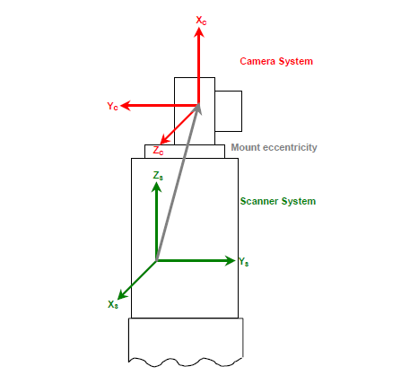
Because the laser scanner is a static instrument, it provides excellent coverage of objectives that range from several meters to over a kilometer in scale. EarthScope deploys a pool of Riegl and Leica TLS scanners with maximum ranges of 400–2000 meters with centimeter scale resolution (in ideal situations, millimeter scale is possible). This is compared to airborne and satellite LiDAR systems that have resolutions on the tens of centimeters to meters scales, respectively. When fitted with a digital camera, as is common, digital photographic images (RGB) can be merged with point cloud data to produce photorealistic three-dimensional images (Figure 1).
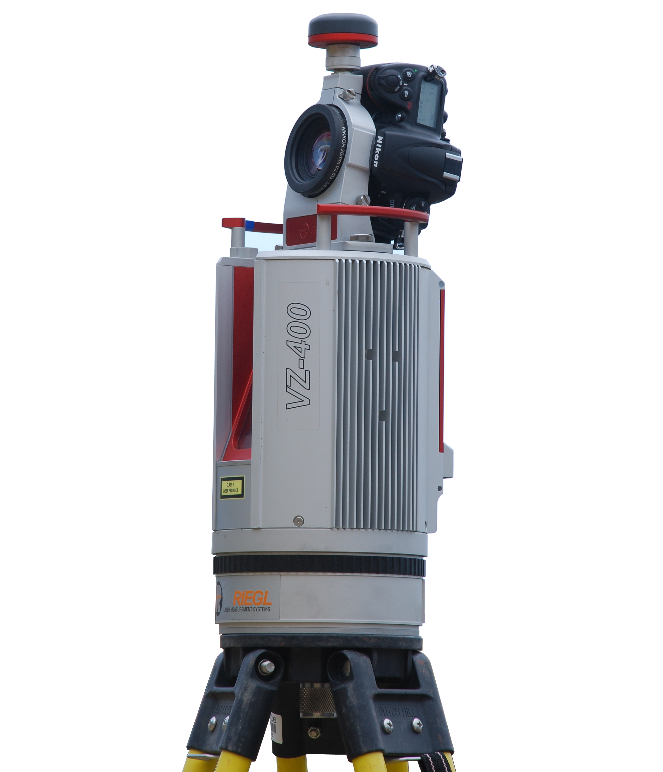
Figure 1. Left image shows the general schematic set up of a TLS scanner with laser housing and camera and the X, Y, Z coordinate system used to register points collected. The right image is of the Riegl VZ-400 scanner, an instrument commonly deployed by EarthScope for earth science research (Left image courtesy of Cyber Mapping Lab of UT–Dallas).
Georeferenced point clouds are produced by measuring (“ranging”) the distance between the scanner and the target. The process happens as the laser emits many short pulses of light that are reflected back and recorded by a receiver. Distance is then calculated by multiplying the round-trip time of flight of the initial pulse and return capture by the speed of light, then dividing that in half (Figure 2).
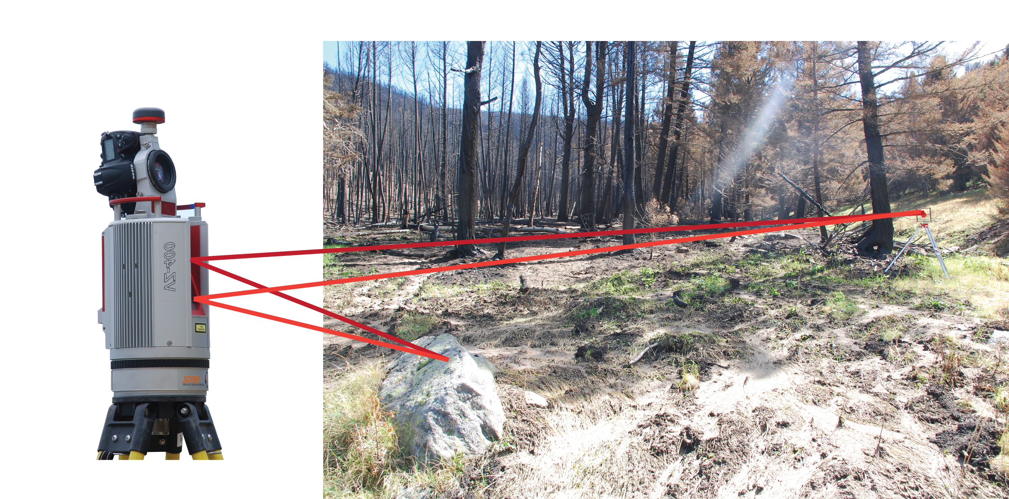

Figure 2. The scanner transmits a pulse of light (red line) that is reflected back (orange line) and recorded by a receiver. The distance between the scanner and the reflected object is then calculated. (EarthScope)

Scan Parameters

Beam divergence
An important consideration in TLS scanning is beam divergence. The laser beam is a cylindrical beam of photons (light) that slightly deviates when it is first emitted from the laser. As it travels from the TLS laser, the beam begins to widen as a narrow cone that increases in diameter the further it travels. This is called the “beam divergence” (Figure 3).
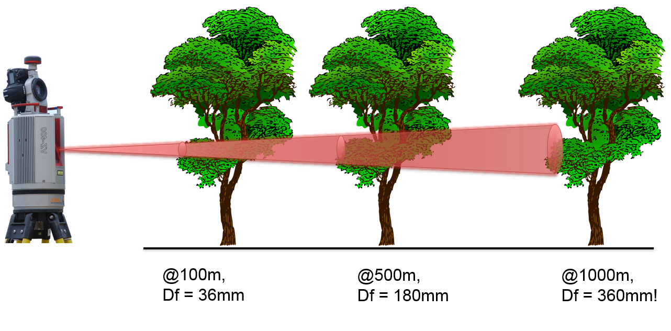
Figure 3. An idealized example of beam divergence as distance increases from laser. Df stands for beam diameter. (EarthScope)
Initial beam diameter and divergence varies by LiDAR instrument model and can range from 0.1–1.0 millirads (Gatziolis and Anderson, 2008). The Riegl VZ-400 has a beam divergence of 0.35 millirads and an initial beam diameter of 0.007 meters. Therefore, the spot size on a target will be a function of the diameter of the initial beam as it exits the laser, the beam divergence, and the distance it travels until it hits a target. This corresponds to the beam widening ~3 cm per 100 m. The resolution of the scan will be affected by this parameter as the final spot size of the beam that intercepts its target illuminates a certain area. The attributes within the spot are averaged and recorded by the receiver. Thus, the wider the spot size diameter, the less overall detail you will gain on a scale smaller than the spot size (Figure 4).
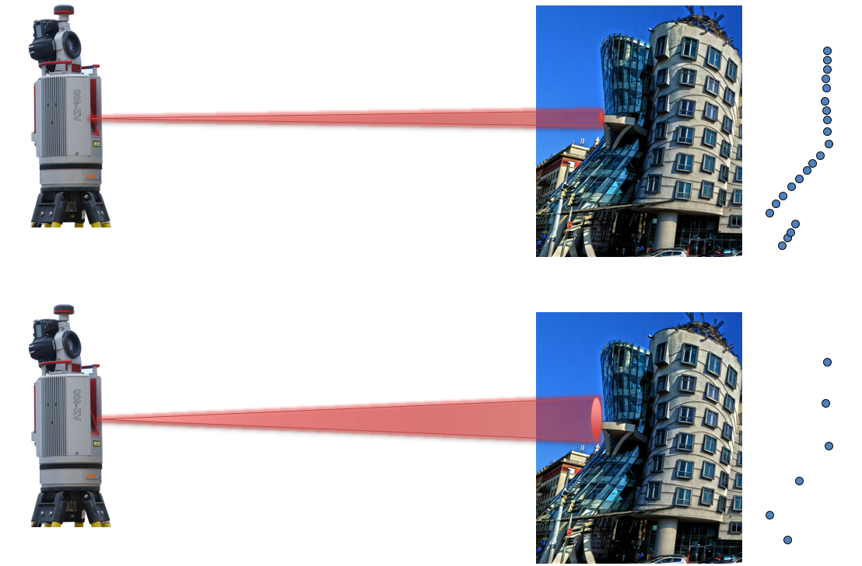
Figure 4. The lasers in this example are both hitting the same target(s) traveling the same distance, but the top laser has a smaller beam divergence resulting in smaller spot sizes that allow for increased resolution and a finer detailed image (blue dots) of the irregularities of the rock outcrop. The bottom example produces a lower resolution, less detailed, and averaged (blurry) image. (Pixabay; CC license)

Angular step
A second important scan parameter that will affect the resolution before you start scanning is spot spacing (aka angular resolution). A function of the stepping angle (increments for each set of pulses) of the laser and range (distance) to the target, spot spacing can be reduced or increased by adjusting the stepping angle (aka angular step) in the scanning software. This will result in increasing or reducing the resolution, respectively, and the corresponding density of spots or points collected by the scanner (Figure 5). Increasing distance increases spot spacing; so angular step would need to be reduced to obtain a high resolution scan at long ranges. Angular step can be adjusted for both the vertical and the horizontal, as the Riegl VZ400 scanner has a scanning range of 360° in the horizontal and 100° in the vertical (60° up/ 40° down). TLS point clouds are very dense, with the scanner collecting tens of thousands to hundreds of thousands of points per second. Depending on your project resolution requirements and the amount of data you want to compile and analyze, angular step can be adjusted accordingly. Extremely dense point clouds require more storage space and processing power on computers, and take a longer time to scan. This will impact the time spent out in the field collecting data and also how long data processing will take, so should be factored into the project design.
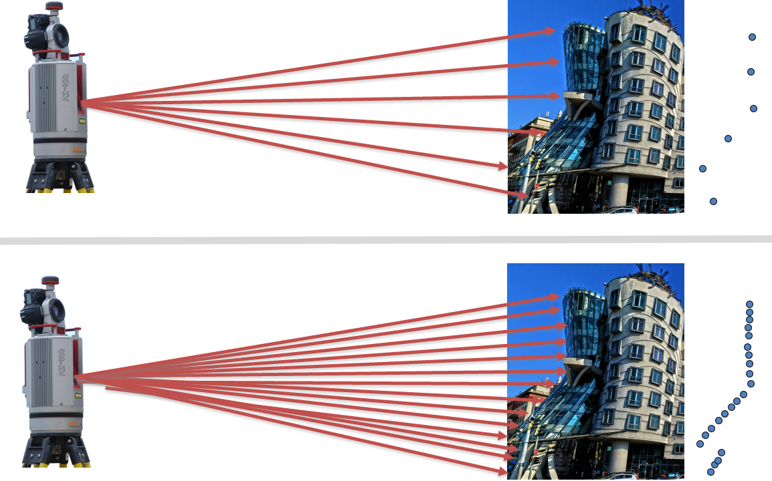
Figure 5. As the angular step of the scanner from its target is increased, the result will be a greater spacing between spots as is shown in these two examples. The upper example has a greater step angle, resulting in increased point spacing and a less detailed, lower resolution image. (Pixabay; CC license)

Scan partitioning
In reality most large-area topographic scans will contain varying ranges within the target scan that can affect point density and resolution. If the same resolution and point density is desired over a wide range of distances at one scan location (say, a river channel and adjacent terraces and hill slope), the scan will need to be broken up into several scans at determined mean distance intervals. Then, the stepping angle will need to be adjusted as a function of that mean distance to achieve the same resolution and point density. If this is not done, the extremes of the scan distances—“r1” and “r3” in Figure 6—will be either too dense with points or too sparse. Since the TLS scans in the vertical and horizontal orientations, vertical and horizontal partitioning needs to be taken into consideration during a complex project. Remember, beam divergence still plays a role in desired resolution and will also determine the location of scan positions.

Figure 6. Scan partitioning in the vertical field of view showing sectioned ranges for scans using different stepping angles to achieve the same spot spacing (resolution) and spot density (point density) in each of the three sections. For this example, if the same stepping angle used for “r3” was used for “r1,” then the spot density for “r1” could be 10–15x that of “r3,” requiring an extraordinary amount of time to scan and eating up memory on the computer (Image courtesy of Cyber Mapping Lab of UT–Dallas).

Setup and Workflow

1. Scan position
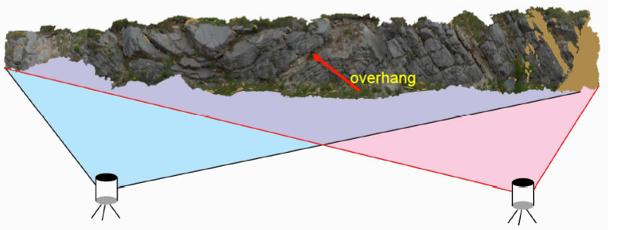
The first step is selecting effective scan positions that will maximize coverage of the target site and minimize occluded views that will lead to blank spots in the point cloud. A good practice is to pick at least two locations oblique to the target for scanning (Figure 7), but having a third is best, so you will have left, middle, and right viewpoints providing strong angles of incidence with targets. If you want a true 3D model of a feature (e.g., a building), then you must move the scanner around the structure to capture all sides.
Figure 7. Multiple scan positions are needed to obtain the maximum coverage of a feature, through overlapping illumination of the target. This minimizes the amount of unilluminated area and thus unmeasured features. (Courtesy of UTD CyberMapping Lab.)

2. Control target (tie point) setup
Control targets are essential to register multiple scans, as they are static markers that allow for easy merging of multiple scans to produce a three-dimensional image. The control targets should not be placed in a linear fashion or bunched up, but should be as evenly dispersed (both horizontally and vertically) around the entire scan site as possible (Figure 8). Targets should be level, so check each tripod before securing the target to the top. A bare minimum of three control targets can be deployed, but it is highly recommended to have at least five to account for uncontrollable sightline blockages from complex topography and other problems such as dense vegetation. The more targets in common between adjacent scans, the better the accuracy of the final point cloud data product (again, a minimum of three to five). Targets should not move during scanning, so secure placement is vital. Movement will introduce error and may be severe enough that you will have to restart the entire project; do not accidently bump into or move targets. Scan position and control target setup are the most important steps for a successful scan and should be planned out before scanning (Figure 9).
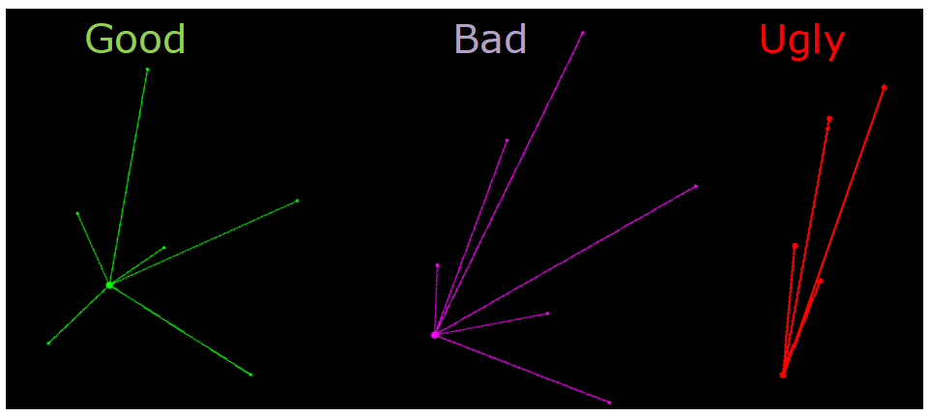

Figure 8. Examples of good to bad control target geometries represented by the vectors radiating from the center point (scanner) to control targets (outlying points). Avoid Bad and Ugly at all costs.
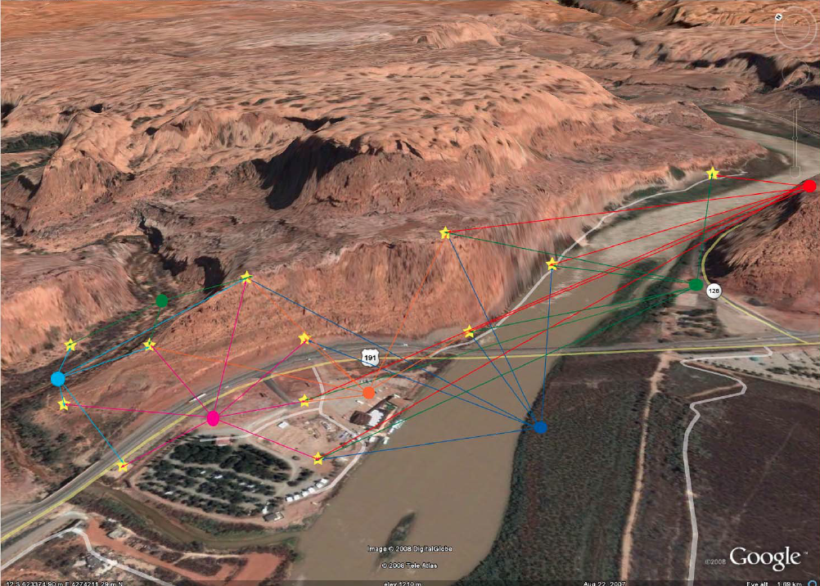

Figure 9. Above is a Google Earth image of a site near Moab, UT, and an ideal example of good scanner placement and control target setup. Six scan positions, represented by the colored circles, were used to capture the topography. The stars represent the control targets. Notice how each scan position contains several targets in common with each other to allow for proper registration of the multiple scans. (Courtesy UT–Dallas CyberMapping Lab and Google Earth).

3. GPS setup:
If georeferencing of scans is required by the project (as it is for nearly all projects), the two most common GPS techniques used in TLS are Static (long occupation) and Real Time Kinematic (RTK) GPS (short occupation). Which is used depends on the specific needs of the project and equipment availability. Both are forms of differential GPS that require a base station within range and clear sky views for accurate and precise measurements.
  - Static GPS: Static GPS surveying is the most accurate method. It involves at least three antenna receivers configured in a triangular geometry on top of specific control targets within the project location. Long occupations of up to eight hours are required to obtain an optimal position solution of centimeter to sub-centimeter resolution (the longer the better). A base station, placed on site (collecting data for the day/week/month duration of project) or an established one (ideally < 20km away), with known coordinates is also required to post-process and differentially correct the GPS data later in the lab.

  - RTK GPS: Real Time Kinematic GPS is useful as it is quick, providing real-time position solutions and potentially requires less equipment to carry to the field site. It involves a base station set up on site at the beginning of the project that collects data throughout the day; this base then provides “real-time” correction data via a radio link to a receiver called a “rover unit.” Therefore, occupation times can be seconds to minutes with no need for post-processing. Position solutions are on the centimeter scale ranging on average 2–5 cm. A disadvantage for RTK verus Static is the need for a clear line of sight for radio communication between the base station and the rover, which can be limited by dense vegetation and complex topography.

4. Parameters
As discussed above, it is important to consider several parameters such as beam divergence, spot spacing, and scan partitioning before beginning your scan. Other parameters to be aware of are angle of incidence, which is related to the angle of the beam that intersects the target. You want to make sure you have strong angles of incidence to maintain maximum coverage and overlap between scans. Environmental conditions will play a factor such as the position of the sun relative to the scanner. The albedo (reflectance) of the scanned material, visibility limitations due to clouds, dust, topographic relief, and vegetation also affect the quality of return data.

5. Collecting data
After the control target and GPS framework has been established to coincide with predetermined scan positions, data collection can begin. Start with a panorama scan of the area accompanied by digital photos. Next, fine scan all the control targets as part of the scan registering process. Once that is complete, fine scan an area of interest that is the focus of the project (if necessary). After the first scan is complete, move to the next scan position. For each successive scan position repeat above basic steps, then register (tie together) adjacent scans by finding “corresponding points.” Check the accuracies of scan registration in the field so there are no surprises when you are back in the lab, miles away from your site. GPS data can be imported into the scan project following scanning. Once all scanning is complete make sure you save all data!

TLS Coordinate Systems
Data collected from a terrestrial laser scanner can be tied to one of three coordinate systems (Figure 10):

- Scanner Own Coordinates (SOCS): the first set of coordinates established for an individual scan related to the scanner’s position.
- Project Coordinates (PRCS): multiple scans registered (tied) together using stationary control targets (tie points) dispersed around the project area.
- Global Coordinates (GLCS): independent GPS coordinates are then imported and registered to the point cloud to create a georeferenced final product.

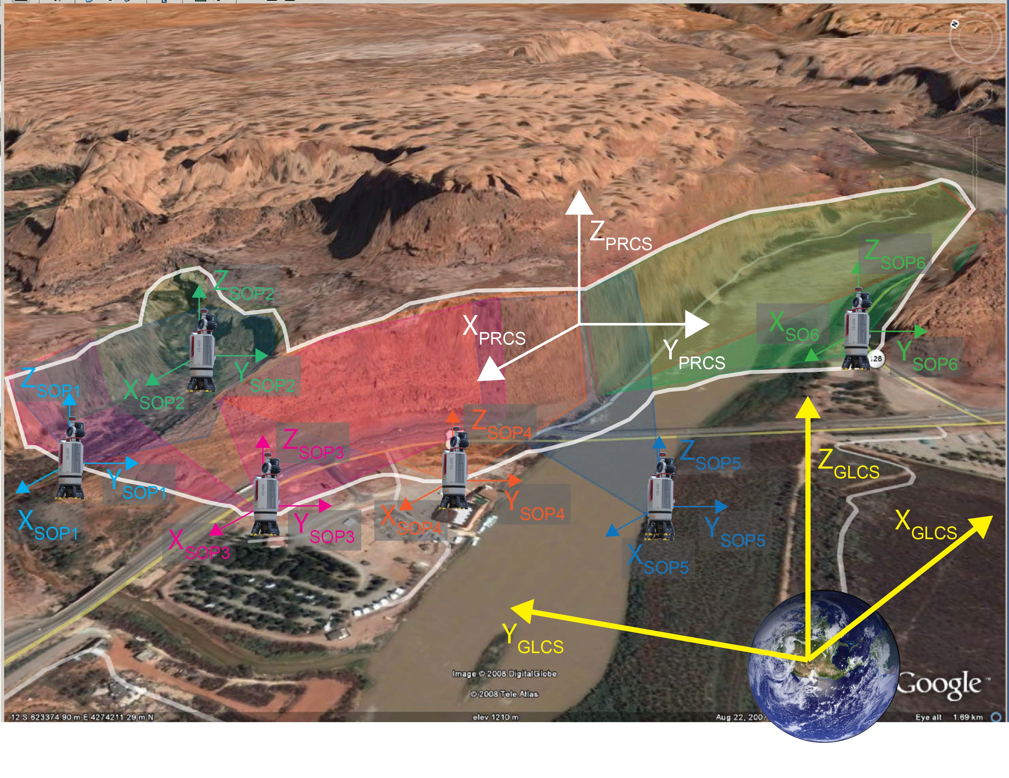
Figure 10. This diagram is a general schematic of the three coordinate systems and how they relate to one another. The six scan coordinates (SOP_{1–6}) involving a scan of the cliff, for example, are then registered together to create the overall project coordinates (PRCS). Until GPS data is applied to the point cloud, the project is floating in space. After the GPS data is applied, GLCS is created and the point cloud is now georeferenced. SOP (Scanner Own Position) is another version of SOCS. (Cyber Mapping Lab of UT–Dallas)

Products
After a day in the field collecting TLS data, you will be able to produce highly accurate three-dimensional, georeferenced point clouds of your field site and all specific targets involved that can be analyzed later in a lab. The digital photos that you took can also be merged with the point clouds to produce a three-dimensional, photorealistic point cloud. Below are some examples.

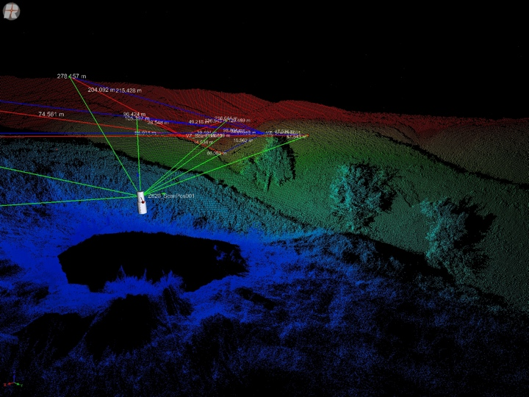
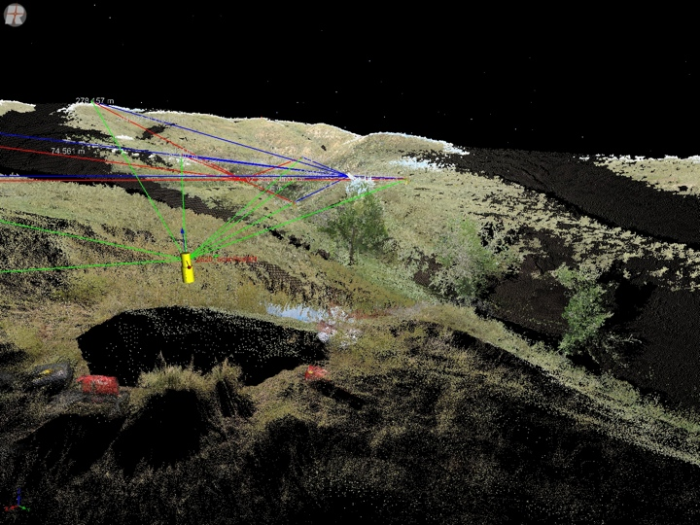
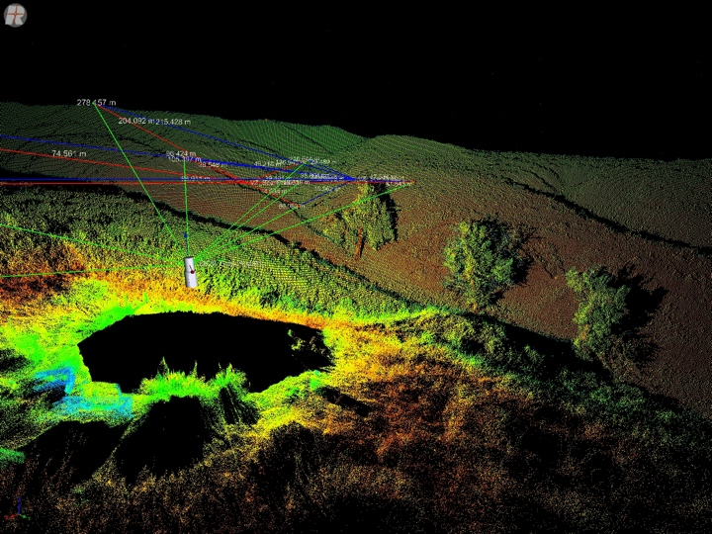
C
Figure 11. The three images are visualizations of point clouds from the same scan position but displaying different basic attributes. (A) Reflectance intensity. (B) Range (distance) from scanner. (C) True color image of the scan site after digital photos are merged with the point cloud. Notice that vectors are connecting with the various control targets dispersed around the scanner. The scanner has a minimum detection distance of about 1.5 m, hence the black spot underneath the scanner. (EarthScope)

B
A

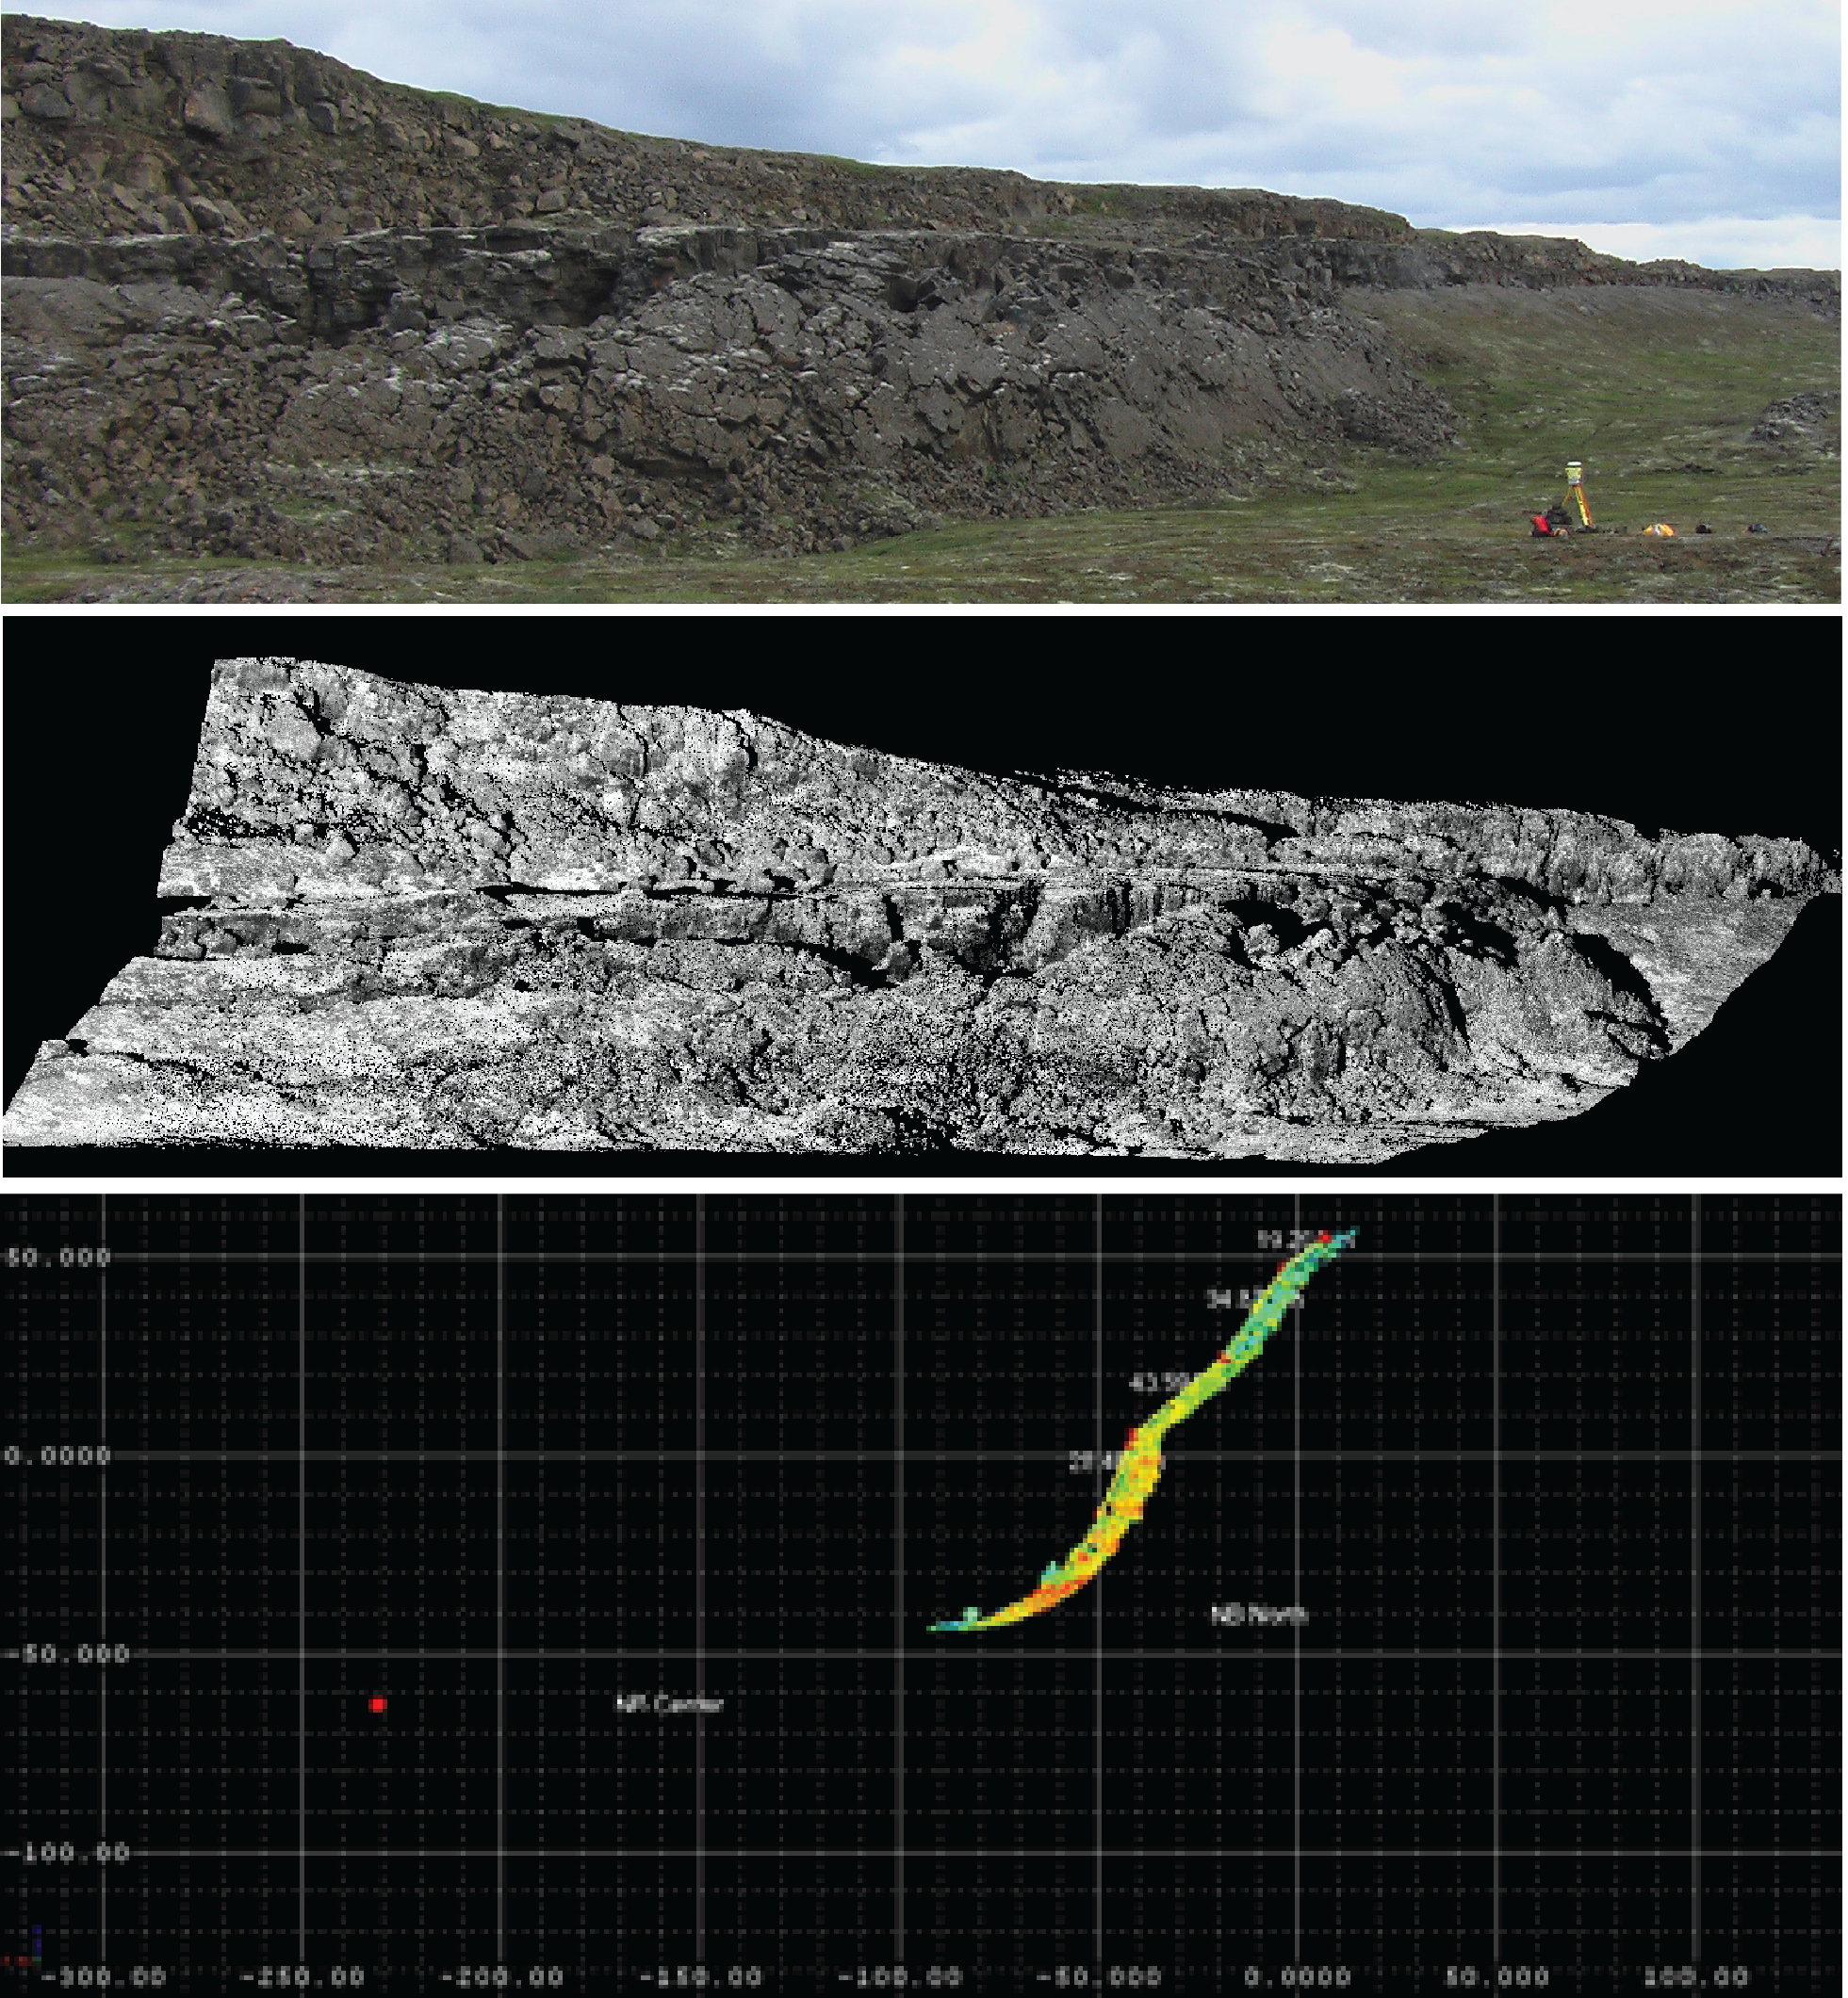
In addition to looking at the entire data set, select portions of the data may be isolated to provide a specific view that allows for specific measurement or to create a specific display of a feature for analysis. An example of a fault scarp profile, created from a point cloud (Figure 12, center), is shown in Figure 12 (bottom).
Figure 12. Masters student Caroline O’Hara of Penn State University, alongside advisor Peter LaFemina, was conducting part of a long-term geologic deformation study using TLS equipment supplied through EarthScope. The purpose was to investigate the formation and geometry of normal and strike-slip faults across the plate boundary in Iceland. At top is the digital photo of her study site with scanner in the bottom right, followed by the final point cloud image below the field photo, and an isolated profile of the fault scarp made by selecting a small strip of data within the larger point cloud and rotating the strip. This profile was used to analyze fault scarp rollback. (EarthScope)

Riegl Scanner Specs (VZ-400)
Rangefinder Performance | Long Range Mode | High Speed Mode
Laser PRR (Peak) | 100 kHz | 300 kHz
Effective Measurement Rate | 42,000 meas./sec. | 125,000 meas./sec.
Max. Measurement Range  for natural targets ρ ≥ 80%  for natural targets ρ ≥ 10% | 500 m  160 m | 300 m  100 m
Max. Number of Targets per Pulse | Practically unlimited | Practically unlimited
Accuracy | 5 mm | 5 mm
Precision | 3 mm | 3 mm

Other Specs
Minimum Range | 1.5 m
Laser Wavelength | Near infrared
Beam Divergence | 0.3 mrad

Scanner Performance
Vertical (Line) Scan
Scan Angle Range | total 100° (+60°/-40°)
Scanning Mechanism | Rotating multi-facet mirror
Scan Speed | 3 lines/sec. to 120 lines/sec.
Angular Stepwidth ΔΨ | 0.0024° ≤ ΔΨ ≤ 0.288°
Angle Measurement Resolution | better 0.0005° (1.8 arcsec)
Horizontal (Frame) Scan
Scan Angle Range | max. 360°
Scanning Mechanism | Rotating head
Scan Speed | 0°/sec. to 60°/sec.
Angular Stepwidth | 0.0024° ≤ ΔΨ ≤ 0.288°
Angle Measurement Resolution | better 0.0005° (1.8 arcsec)
Inclination Sensors | Integrated, for vertical scanner setup position
Internal Sync Timer | Integrated real-time synchronized time stamping of scan data

General Technical Data
Interfaces | LAN, 10/100/1000 MBit/sec. within head  LAN, 10/100 MBit/sec., integrated WLAN  USB 2.0
Data Storage | internal 8 GB flash memory
Power Supply Input Voltage | 11-32 V DC
Power Consumption | Typ. 65 W
Main Dimensions | 308 mm x 180 mm (length x diameter)
Weight | 9.8 kg
Temperature Range | 0°C to +40°(operation), -10°C to 50°C (storage)
Protection Class | IP, dust- and splash-proof

Riegl VZ-400 Max. Measurement Range (as a function of target material)
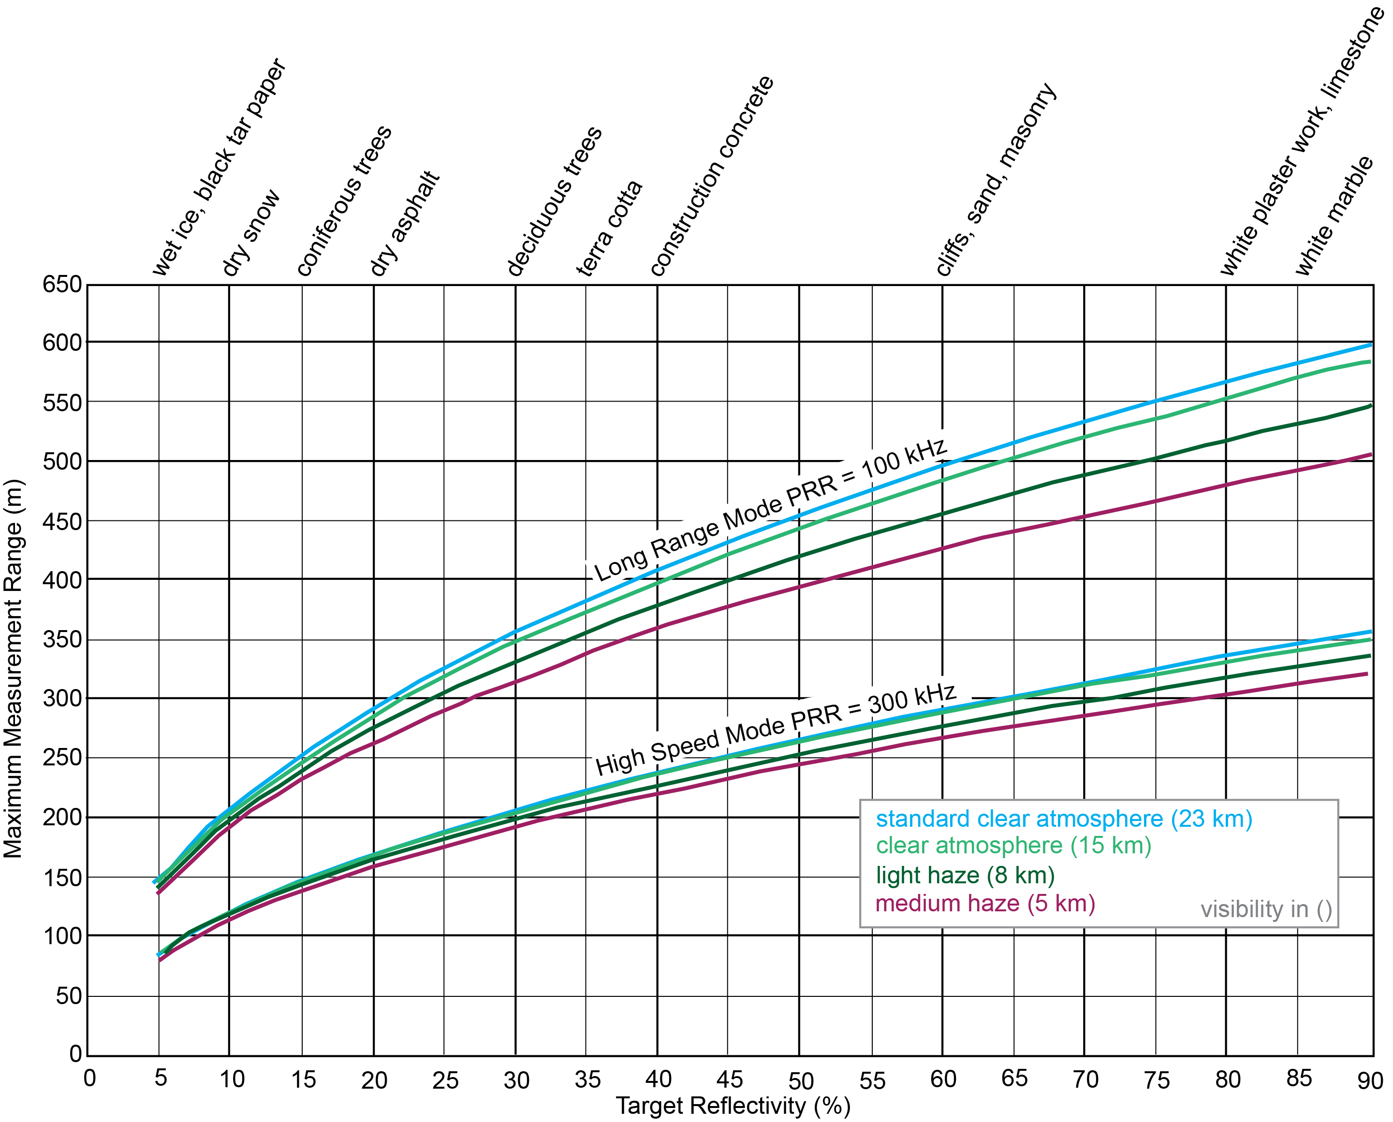
Modified from http://www.riegl.com/uploads/tx_pxpriegldownloads/10_DataSheet_VZ-400_2014-09-19.pdf

Riegl Scanner Specs (VZ-1000)
Rangefinder Performance
Laser PRR (Peak | 70 kHz | 100 kHz | 150 kHz | 300 kHz
Effective Measurement Rate | 29,000 meas./sec. | 42,000 meas./sec. | 62,000 meas./sec. | 122,000 meas./sec.
Max. Measurement Range  for natural targets ρ ≥ 80%  for natural targets ρ ≥ 10% | 1400 m  700 m | 1200 m  600 m | 950 m  500 m | 450 m  350 m
Max. Number of Targets per Pulse | Practically unlimited
Accuracy | 8 mm
Precision | 5 mm

Other Specs
Minimum Range | 2.5 m
Laser Wavelength | Near infrared
Beam Divergence | 0.3 mrad

Scanner Performance
Vertical (Line) Scan
Scan Angle Range | total 100° (+60°/-40°)
Scanning Mechanism | Rotating multi-facet mirror
Scan Speed | 3 lines/sec. to 120 lines/sec.
Angular Stepwidth ΔΨ | 0.0024° ≤ ΔΨ ≤ 0.288°
Angle Measurement Resolution | better 0.0005° (1.8 arcsec)
Horizontal (Frame) Scan
Scan Angle Range | max. 360°
Scanning Mechanism | Rotating head
Scan Speed | 0°/sec. to 60°/sec.
Angular Stepwidth | 0.0024° ≤ ΔΨ ≤ 0.288°
Angle Measurement Resolution | better 0.0005° (1.8 arcsec)
Inclination Sensors | Integrated, for vertical scanner setup position
Internal Sync Timer | Integrated real-time synchronized time stamping of scan data
GPS Receiver | Integrated, L1 antenna
Compass | Integrated, for vertical scanner setup position
Scan Sync (optional) | Scanner rotation synchronization

General Technical Data
Power Supply Input Voltage | 11-32 V DC
Power Consumption | Scanning, typically 82 W (max. 90 W)
External Power Supply | Up to three independent external power sources can be connected for uninterrupted operation
Main Dimensions | 308 mm x 200 mm (length x diameter)
Weight | ~9.8 kg
Temperature Range | 0°C to +40°(operation), -10°C to 50°C (storage)
Low Temperature Operation | -20°C: continuous scanning operation if instrument is powered on while internal temperature is at or above 0°C and still air  -40°C: scanning operation for about 20 minutes if instrument is powered on while internal temperature is at or above 15°C and still air
Protection Class | IP 64, dust- and splash-proof

