Activity 4.2 – Landscape Design and Water Use Estimation

Introduction
Outdoor landscape watering can comprise a substantial amount of the water used in urban areas, and as summer droughts become more frequent and as urban populations and related water demand increase, more efficient landscape watering practices become essential to sustainable use of water in urban areas. The amount of water used in urban areas for outdoor watering of landscape plants varies depending on the climate. Estimates of the amount of urban landscape water use vary from 9% for Atlanta, GA, to 48% in Salt Lake City, UT (Kjelgren et al. 2000) of total urban water use. The percentage of water used for residential landscapes is even higher. In residential areas, landscape water use averages 40 to 70% of residential water use in the United States (St. Hilaire et al. 2008).
Cool-season turf grass, such as Kentucky blue grass or some fescues, is major component of residential landscaping and is generally a large consumer of landscape irrigation water. Water-efficient landscape practices recommend wise use of turf grass in landscaping and use of efficient irrigation strategies in watering grass areas. Turf grass has some advantages in that it can withstand the stresses of traffic and mowing and it can mitigate high temperatures, noise and dust. Turf is useful in areas that receive high traffic and in recreational areas. Also, many people find turf aesthetically pleasing.
One of the strategies to reduce urban landscape water use is to replace unnecessary turf grass with landscape plants that are adapted to the climate and can survive on the available precipitation in the region. These plants are referred to as xeric, climate-adapted or climate-friendly, and usually need little or no supplemental irrigation to survive. While climate-adapted landscape plants can survive on the natural rainfall, many xeric plants will flourish with more water. As a result, homeowners and landscapers can be lured into watering more to produce more lush vegetation, so educating homeowners about irrigation techniques and management strategies is integral to successful water-efficient landscaping.
For this exercise, we will assume that the xeric, climate-adapted or drought-tolerant species are watered in an efficient manner using drip irrigation systems, which apply water at the base of the plant, and that evaporation from soil moisture is negligible. It should be noted that turf grass is often over-watered, and that it can be used in a water-wise or xeric landscapes, either in small areas, or by using certain species and varieties that have lower water requirements.

Goal:
The goal of this project is to compute the water use for the backyard (90 feet x 60 feet ignoring the back deck, outlined in red in Figure 1) of the property shown in Figure 1 for a turf landscape and for a water-efficient landscape of your design. You will calculate the amount of water required for irrigation during the growing season (May–Sept) if the landscape is 100% turf grass. Then you will estimate the amount of water for irrigation of a landscape design of your choice. You may include a combination of turf, very low, low, and moderate water use plants, and hardscape (gravel or rock with no plantings). Your goal is to decrease the landscape irrigation water demand by 40%.

Things to consider as you design your landscape plan:
- Total water savings
  - Must save a minimum of 40% water compared with a yard that is 100% turf grass.
- Irrigation efficiency
  - Do not design turf grass in small, narrow or oddly shaped areas that are difficult to irrigate efficiently
  - Hydrozone your landscape plan. Plan and design your landscape so that high water use plants are grouped together and low water use plants are together.
- Aesthetics
  - How much turf vs. how much hardscape? Some studies suggest that people are happy with 25% turf. Is that enough?
  - People like color and they like green landscapes.
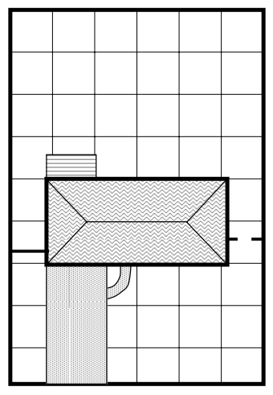
Backyard
Front yard
House
Figure 1 – Schematic of residence and property for landscape design. The lot is 90 feet wide and 135 feet deep (each square is 15 feet x 15 feet). The area outlined in red is the landscape area to be designed. Use the entire backyard area (90 feet x 60 feet).

Optional - Download ET and precipitation data
NOTE: The necessary reference ET and precipitation data are provided in the Student Worksheet, but if your instructor wants you to retrieve your own data, follow the following instructions:
- Go to http://www.northernwater.org/WaterConservation/WeatherandETData.aspx
- Select a weather station from the list.
- Click Step 2: Select Weather Categories
Click the check boxes for Rain (TB) (in) and ET_{os} Grass (TB = tipping bucket rain gage)
- Click Step 3: Adjust Time Interval
Select the Weekly tab
Choose the Start Week as May 1 (any year) and End Week as Sept 30 (same year). For example, select the week of May 1, 2013 through the week of September 30, 2013.
- Click Refresh Data
Your data should appear in the “Step 4: View Results” window at the bottom of the screen. You can download your data table to Excel, or enter your data into a table like Table 1 for Fort Collins (central), May 1–Sept 30, 2013.

Part 1 – Turf Irrigation Calculation
In this section you will compute the irrigation needs for a backyard that is 100% turf grass. Use Table 1 in the student worksheet, or perform your calculations with your downloaded data in a spreadsheet.
- Compute the area of the backyard (ft²)

- Use the Table 1 on the “Turf Worksheet” for the following calculations:

  - Compute the weekly landscape ET, ET_{L} (inches), for grass assuming a plant factor (PF) of 0.8 (or 80%) for turf (assuming that the lawn is well-watered and is maintained in optimum condition). The ET_{L} is the amount of water that the landscape will transpire. The reference ET, ET_{O}, is given in Table 1.
Weekly Landscape ET = ET_{L} = (ET_{O} x PF)
  - Determine the amount of irrigation (inches) necessary for each week. Subtract the measured precipitation from the landscape ET and apply a 70% irrigation efficiency factor (this accounts for the fact that not all of the irrigation water applied is used by the plant). If P > ET_{L ,} then no irrigation is necessary for that week.
Weekly Irrigation Demand = (ET_{L} – P) / 0.7
  - Calculate the weekly irrigation needs in gallons (inches of water applied over the backyard), and the total volume of water applied to the yard over the entire growing season. (1ft³ = 7.5 gallons)

Part 2 - Design a more water-efficient landscape for the backyard
- As a group discuss what your priorities are for your backyard. How much grass do you want? Where should there be landscape beds and how big? Do you want any areas in hardscape (gravel or rock with no plants)? Your goal for the design is to create a water-wise landscape that reduces the water use by at least 40% from the turf lawn, and also considers aesthetics and comfort of the homeowner. Use the Landscape Plant handout as a guide in plant selection.

- Use the schematic below for your design. Design the landscaping for the entire back yard area outlined by the dashed line. You may re-landscape the area identified as a deck. Block out areas on the diagram of the backyard on the worksheet for the following types of landscaping (Each square on the diagram is 15 ft. x 15 ft.):
Landscape Type | Plant Factor (PF)
Turf grass | 0.8
Moderate water use plants | 0.6
Low water use plants | 0.4
Very low water use plants | 0.2
Hardscape | 0.0

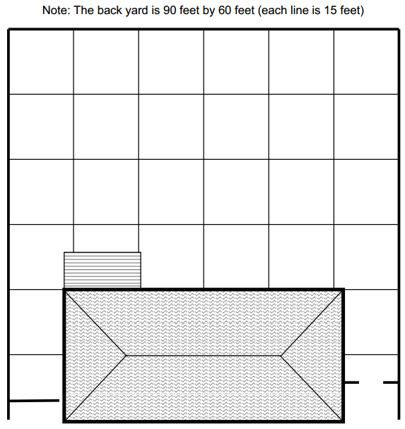

- Measure the area of the yard in each type of landscaping, and compute the percentage of the yard for each landscape type (Table 2 on the “Water-Efficient Design” worksheet)

- Compute a weighted plant factor (PF) for each landscape type by multiplying the percentage of the area for each landscape type by the PF for that landscape type. Sum the weighted PFs to obtain a weighted PF for your water-efficient landscape design (Table 2 on the “Water-Efficient Design” worksheet).

- Use Table 3 on the “Water-Efficient Design” worksheet for the following calculations:
  - Compute the ET_{L} (inches) for your water-efficient design using your weighted plant factor. The ET_{L} is the amount of water that the landscape will transpire.
ET_{L} = (ET_{O} x PF)
  - Determine the amount of irrigation (inches) necessary for each week. Subtract the measured precipitation from the landscape ET and apply a 70% irrigation efficiency factor (this accounts for the fact that not all of the irrigation water applied is used by the plant).
Irrigation = (ET_{L} – P) / 0.7
  - Calculate the weekly irrigation needs in gallons (inches of water applied over the backyard), and the total volume of water applied to the yard over the entire growing season.

Part 3 – Assess your design
Answer the following questions:
- How much water does your water-efficient design save compared to the turf grass backyard? Did you meet the goal of 40% reduction?
- How does your design meet the goal of an aesthetically pleasing design including the inclusion of color, green and variety?
- What is the average water use per month of your turf grass yard? Of your water-efficient design? Compute the cost of each landscape plan if water costs $3 per 1,000 gallons. Discuss.
- Many water providers charge for water on a sliding scale, where rates increase as you use more water. For example, the rate scale for the city of Atlanta, GA, is $3.40/1000 gallons for the first 2,200 gal/month, but goes up to $8.22/1000 gallons if you use more than 5,200 gallons per month. The city of Fort Collins, CO charges $2.53/1000 gallons for the first 7,000 gallons per month, and increases to $3.34 if you use more than 13,000 gallons per month. Discuss the effectiveness of this strategy for encouraging water-efficient landscaping in the humid east versus the arid western United States.

References
Kjelgren, R., L. Rupp and D. Kilgren, 2000. Water Conservation in Urban Landscapes, HortScience, 35(6): 1037-1040.
St. Hilaire, R., D.A. Devitt, B.H. Hurd, B.J. Lesikar, V.I. Lohr, C.A. Martin, G.V. McDonald, R.L., Morris, D.R. Pittenger, D.A. Shaw, and D.F. Zoldoske, 2008. Efficient Water Use in Residential Urban Landscapes, HortScience, 43(7): 2081-2092.

