Earthquake Seismograms and Spreadsheets
Part I: Seismograms
Part II: Earthquake Data
Part III: Introduction to Spreadsheets

An original laboratory exercise by
Eileen Herrstrom
University of Illinois at Urbana-Champaign
herrstro@illinois.edu
2018

Context

- The audience for this activity is an undergraduate class on introductory physical geology, natural hazards, or quantitative reasoning.
- Students must have basic knowledge about earthquakes: magnitude, depth, epicenter, P- and S-waves.
- This activity follows lectures on on earthquakes and is the first laboratory exercise in the course.

Goals

- The content and concept goals for this activity include reading seismograms, identifying arrival times of P- and S-waves, and using a travel time curve to obtain the distances from the seismometers to the epicenter.
- Higher order thinking skills for this activity involve calculating the time that the earthquake occurred, locating the epicenter by triangulation, and graphically determining the local magnitudes of the earthquake.
- Other skills for this activity consist of entering data and a formula in a spreadsheet, computing the average magnitude of the earthquake, and translating algebraic expressions to spreadsheet format.

Earthquake Seismograms and Spreadsheets
Part I: Seismograms

Overview

In this first part of the exercise, you learn how to read seismograms and use the data they record to determine the distance from a seismometer to the epicenter of an earthquake.

Learning Objectives

- Read seismograms
- Identify arrival times of P- and S-waves
- Use a travel-time curve to obtain distances from the seismometers to the epicenter

Earthquake!

On April 18, 2008, an earthquake rocked central North America, and the shaking was felt from Ontario, Canada, south to Alabama and from Nebraska east to West Virginia. Nevertheless, this was a relatively small earthquake.
Chile, located along the southwestern coast of South America, spans an area that is much more prone to earthquakes; in fact, the largest quake ever recorded struck this country on May 22, 1960, and produced a tsunami that traveled across the Pacific Ocean.
The two maps in Fig. 1.1 illustrate the intensity of shaking for these two earthquakes. Purple and blue colors indicate slight shaking, while orange and red mark areas where the tremors and the subsequent damage are much greater. The black and white edges indicate latitude and longitude.

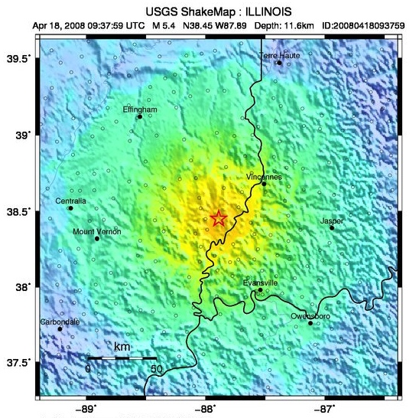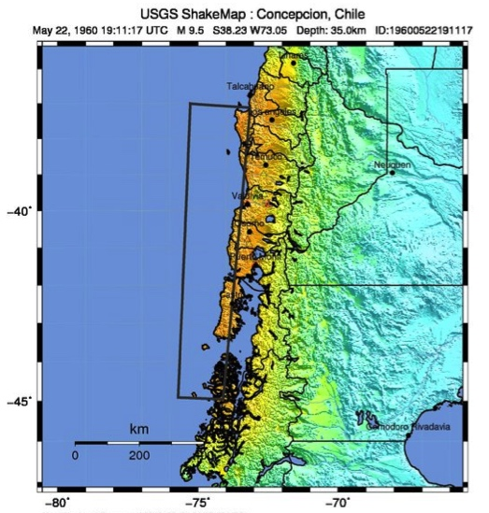
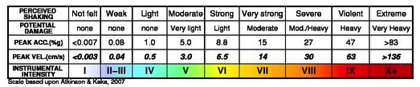

Figure 1.1 Shake maps of the 2008 Illinois (left) and the 1960 Chile (right) earthquakes. https://earthquake.usgs.gov/earthquakes/eventpage/nm606657 - shakemap https://earthquake.usgs.gov/earthquakes/eventpage/official19600522191120_30 - shakemap
Seismograms

A seismogram is a record of the vibrations caused by an earthquake at a specific measuring station (or seismometer). This record (Fig. 1.2) shows the separate arrivals of the P-wave and the S-wave generated by the earthquake. Note that the P-wave arrives first, but the S-wave produces more shaking. The arrival times for both waves, the interval between them (i.e., the time lag), and the maximum amplitude of the S-wave are important pieces of information on the seismogram.

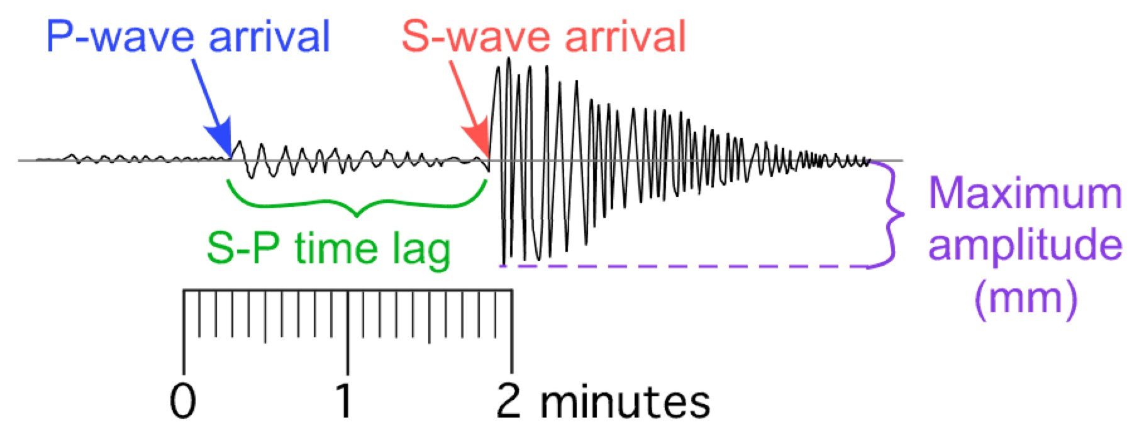

Figure 1.2 A representative seismogram

1. Open the PDF that accompanies this exercise, and examine the seismogram for Buenos Aires, Argentina. What time did the P-wave arrive in Buenos Aires?

2. What time did the S-wave arrive in Buenos Aires?

3. On the second page of the PDF is the seismogram for La Paz, Bolivia. What time did the P-wave arrive in La Paz?

4. What time did the S-wave arrive in La Paz?

5. On the third page of the PDF is the seismogram for Lima, Peru. What time did the P-wave arrive in Lima?

6. What time did the S-wave arrive in Lima?

Travel-Time Curve

Because P-waves travel faster than S-waves, the difference in arrival time between the two waves increases with increasing distance. As an analogy, imagine a car and a bicycle traveling along a highway – the longer they travel, the farther ahead the car will be. Seismologists use this relationship between distance and difference in P- and S-wave arrival times to determine the distance from an earthquake epicenter to a recording seismometer. The relationship can be summarized on a diagram called a travel-time curve.
A travel-time curve plots the time it takes a seismic wave to travel from the earthquake focus to a position on the Earth's surface a given distance away. Seismologists have calculated travel-time curves from many different earthquakes and found that the curves do not differ significantly from each other. Hence, the best average travel-time curve, computed from a large number of records, is approximately valid anywhere on the Earth.
Fig. 1.3 summarizes epicenter data from around the world. There is a travel-time curve for the P-wave (blue) and one for the S-wave (red); distance is plotted on the X-axis and time on the Y-axis. Suppose that for a certain earthquake, the S-wave is observed to arrive 3 minutes after the P-wave. Since time is measured in the vertical direction, find the place where the vertical separation between the two curves is equal to 3 minutes, as illustrated below (green). Then project downward to the X-axis to find the distance to the epicenter, or project horizontally to the Y-axis to find the time it took for either wave to arrive.
Based on Fig. 1.3, the earthquake under consideration occurred at a distance of ~1800 km from the seismometer, the P-wave traveled for 4.5 minutes after the earthquake occurred, and the S-wave arrived 3 minutes later, or 7.5 minutes after the quake occurred.

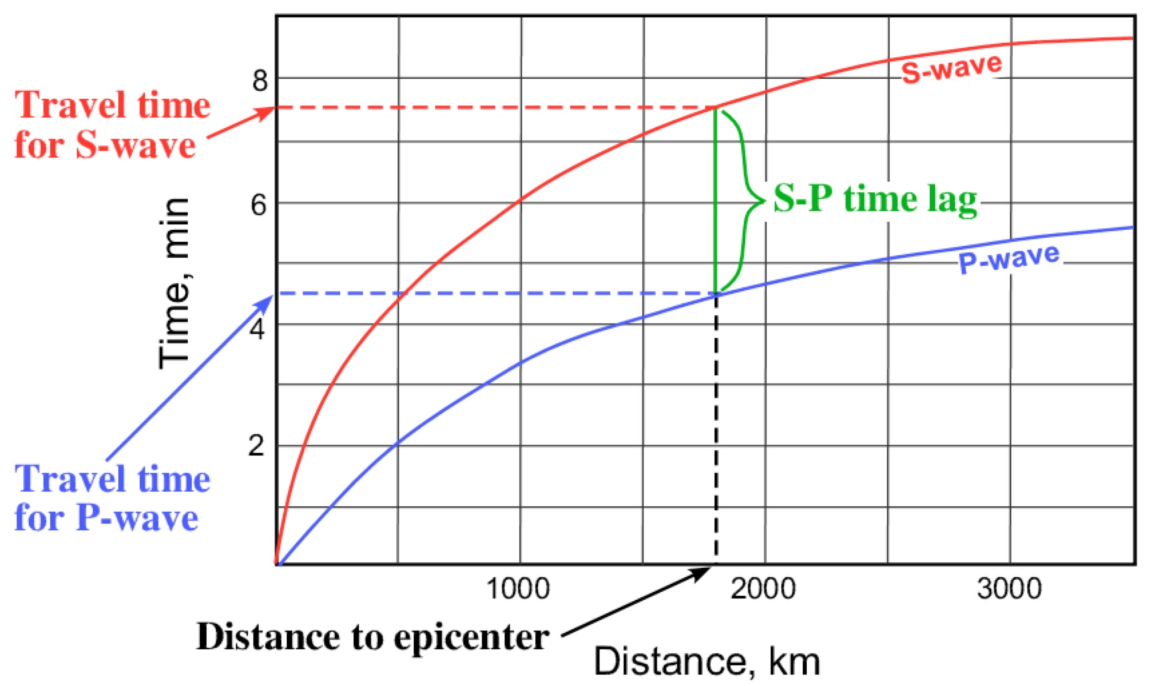
Figure 1.3 How to read a travel-time curve to determine 1) the distance from the epicenter to the seismometer and 2) how long each wave traveled.

7. Using the data from questions #1-2, subtract the arrival time of the P-wave from the arrival time of the S-wave. What is the S-P time lag in Buenos Aires?

8. Refer to the travel-time curve in the PDF (4th page). Find the place on this figure where the vertical separation between the curve for P-waves (blue) and the curve for S-waves (red) equals the time lag in the previous question. Then project downward to the X-axis. What is the distance between the seismometer in Buenos Aires and the epicenter of the earthquake?

9. Using the data from questions #3-4, subtract the arrival time of the P-wave from the arrival time of the S-wave. What is the S-P time lag in La Paz?

10. Refer to the travel-time curve in the PDF. Find the place on this figure where the vertical separation between the curve for P-waves (blue) and the curve for S-waves (red) equals the time lag in the previous question. Then project downward to the X-axis. What is the distance between the seismometer in La Paz and the epicenter of the earthquake?

11. Using the data from question #3, subtract the arrival time of the P-wave from the arrival time of the S-wave. What is the S-P time lag in Lima?

12. Refer to the travel-time curve in the PDF. Find the place on this figure where the vertical separation between the curve for P-waves (blue) and the curve for S-waves (red) equals the time lag in the previous question. Then project downward to the X-axis. What is the distance between the seismometer in Lima and the epicenter of the earthquake?

Earthquake Seismograms and Spreadsheets
Part II: Earthquake Data

Overview

In this section of the exercise, you refer back to the seismograms recorded in the three cities from Part I and use the records to determine further information about the earthquake.

Learning Objectives

- Calculate the time that the earthquake occurred
- Locate the epicenter by triangulation on Google Maps
- Graphically determine the local magnitudes of the earthquake

Where was that Earthquake?

News reports about any large earthquake usually include two pieces of information: where the temblor occurred and how large it was (i.e., the magnitude). Magnitude is measured according to the Richter scale and is assigned a number, usually between 1 and 10, although no quake with a magnitude of 10 has ever been recorded. The higher the magnitude is, the greater the amount of energy released during the earthquake, and the more intense the shaking is.
To find the location of an epicenter, geologists use a method called triangulation, which requires information from at least three different seismometers. The epicenter location also affects the intensity of the shaking because of variations in the local geology.

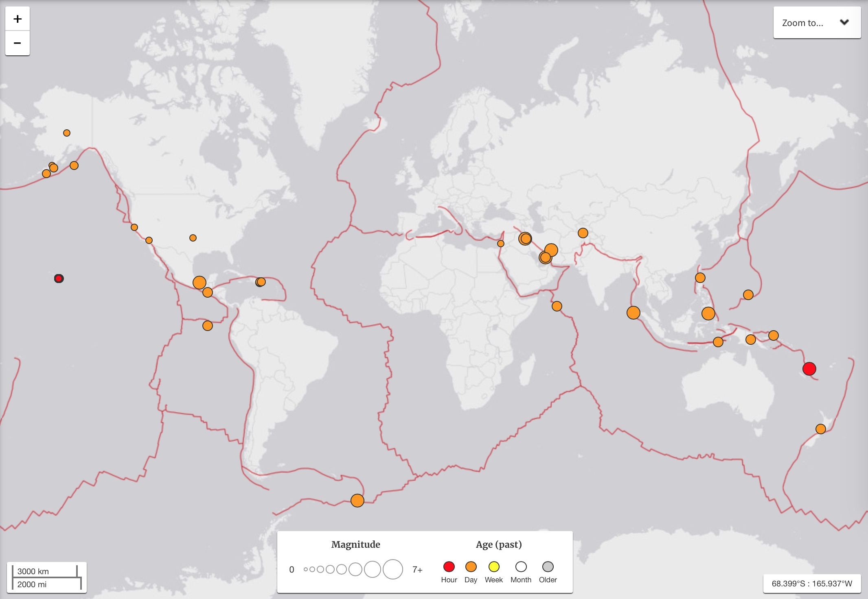

Figure 2.1 World map of epicenters as of July 22, 2018. Size indicates magnitude, and color shows age. https://earthquake.usgs.gov (Latest Earthquakes)
Earthquake Time

Suppose an S-wave arrived at a seismometer 3 minutes after the P-wave (Fig. 1.3). From the travel-time curve, the length of time for the S-wave to travel from the epicenter to the seismometer can be found by projecting left to the Y-axis, which produces a value of 7.5 minutes. If the actual arrival time of the S-wave is known, e.g., 10:00 AM, then subtract travel time from arrival time to find out when the earthquake occurred: 10:00:00 AM – 7.5 minutes = 9:52:30 AM. Note that you could also determine the time of the earthquake by using the P-wave instead of the S-wave.

1. Follow the procedure described above to calculate the time when the earthquake occurred. You may use either the P-wave or the S-wave arrival time from any of the three seismograms. Show your work.

Triangulation

In order to find the epicenter of an earthquake, you need information on arrival times from at least three different seismic stations. If you know the distance to the epicenter from only one station, then the epicenter could be anywhere on a circle centered on that station. With distance data from a second station, you can narrow this down to either of two points of intersection of the circles. Finally, with three stations, you can pinpoint the location accurately. When using three or more stations, the circles would theoretically meet in a single point, as shown in Fig. 2.2. However, in practice, you choose a location close to the intersection of all the circles, and label this as the epicenter.

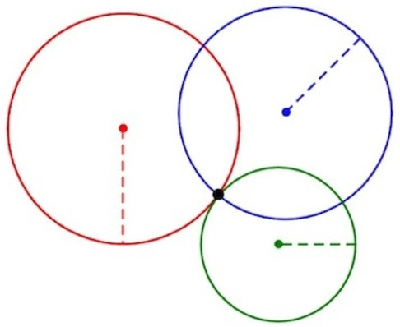
Figure 2.2 Triangulation with three seismometers.

You can triangulate by hand using a paper map and a drawing compass to make circles. Alternatively, you can use one of a number of online applications for drawing circles on Google Maps or Google Earth. This exercise uses Google Maps to pinpoint the earthquake epicenter.
The first step is to build a data file with information needed to plot the circles. Specifically, this file must contain the name of the point at the center of a circle (e.g., Buenos Aires), the location of the point in terms of latitude and longitude, the color to be used for the circle, and the radius of the circle. The latitude and longitude for each city are given in the table on the next page. For latitude, positive values are north of the equator (0° – 90°), and negative values are south of the equator (0° – -90°). For longitude, positive values go east from 0° – 180° (i.e., the prime meridian, which runs through Greenwich, England), and negative values go west from 0° – -180°.

2. Choose three colors from the following list, and enter them in the fourth column of the table below: pink, red, maroon, orange, yellow, olive, lime, green, aqua, teal, blue, navy, violet, purple, magenta, white, silver, gray, black, tan, brown.

Name | Latitude | Longitude | Color | Circle_radius
Buenos Aires | -34.6033 | -58.3817
La Paz | -16.5000 | -68.1500
Lima | -12.0433 | -77.0283

3. You have already found the values to use for “circle_radius” in the last column of the table above. The radius for each circle is the distance between the epicenter and each seismometer (questions #8, 10, and 12 in Part I). Note that you MUST include the unit for distance, which is kilometers. For example, if the distance from the travel-time curve is 500 km, then enter “500 km” in the fifth column of the table. Do include a space between the number and the unit, but do not use spaces or commas to separate thousands for longer distances.

Go to <http://www.gpsvisualizer.com/map_input>. You should see the screen pictured below (Fig. 2.3). This screen looks complicated, but you have to use only the parts within the red rectangle.

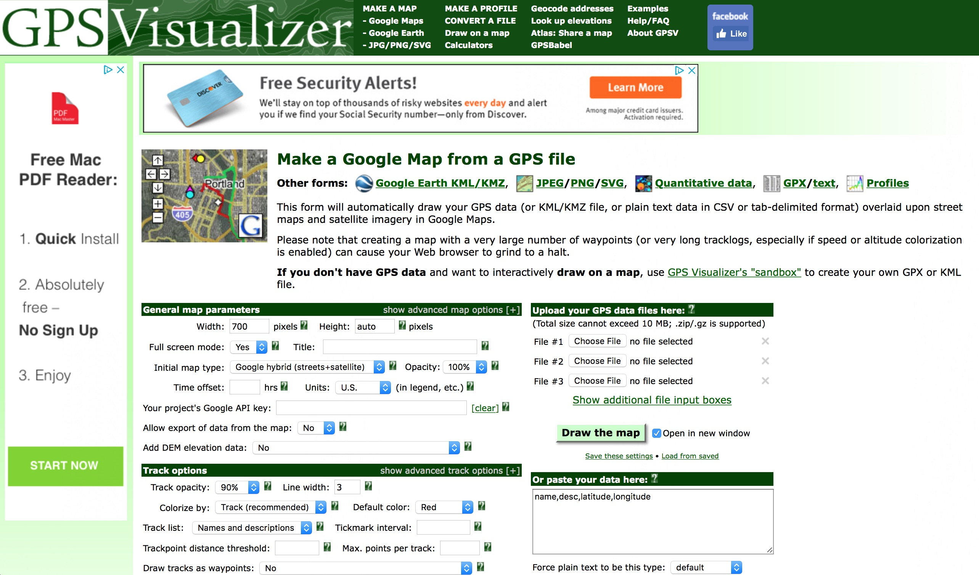

Figure 2.3. Screen shot of the GPS Visualizer map page.
http://www.gpsvisualizer.com/map_input

To use the GPS Visualizer, perform the following steps:
- Make sure the “Open in new window” box is checked. This box is immediately to the right of the green “Draw the map” button.
- Highlight the table on the preceding page (after question #2). Be careful to highlight only the table, not lines above or below it, and to highlight the entire table.
- Copy the highlighted data.
- In your web browser, paste the data in the box below the green “Draw the map” button. The heading of this box is “Or paste your data here”.
- Finally, click on the green “Draw the map” button.

4. In the new window, close the popup window that asks for a Google Maps API key and click “OK” in the popup window that says “This page can’t load Google Maps correctly”. Now look at the map. Do your circles intersect in a single point, or do they form a small triangle of intersection points?

5. Zoom in on the intersection until the scale bar in the lower right corner of the map reads “50 km”. Now do your circles intersect in a single point, or do they form a small triangle of intersection points?

6. The intersection point or the middle of the small triangle represents your epicenter. Is your epicenter in Argentina, Bolivia, Chile, or the Pacific Ocean?

7. The following cities should be visible (from north to south): La Serena, Ovalle, Illapel, Valparaiso, and Pichilema. Which of these cities is closest to the epicenter?

Magnitude of an Earthquake

The magnitude of an earthquake measures the amount of energy released, as described by the Richter scale. This formula is based on the largest S-wave amplitude recorded on a seismogram, with a correction for the distance between the seismometer and the epicenter. You can determine the magnitude of an earthquake graphically by using a nomogram (Fig. 2.4). Draw a line connecting the epicenter distance (on the left scale) with the largest amplitude of the S-waves. The center scale gives the magnitude. For example, if a seismogram recorded 500 km from the epicenter showed a maximum amplitude of 2 mm, then the magnitude of the quake was approximately 5.
To use the nomogram, first refer back to the seismograms in the PDF. For each seismogram, measure the height of the highest S-wave using the amplitude scale on the seismogram. Do not use a ruler to measure amplitudes. In addition, please note that you should use the nomogram in the PDF, not the one in Fig. 2.4, to determine the local magnitudes.

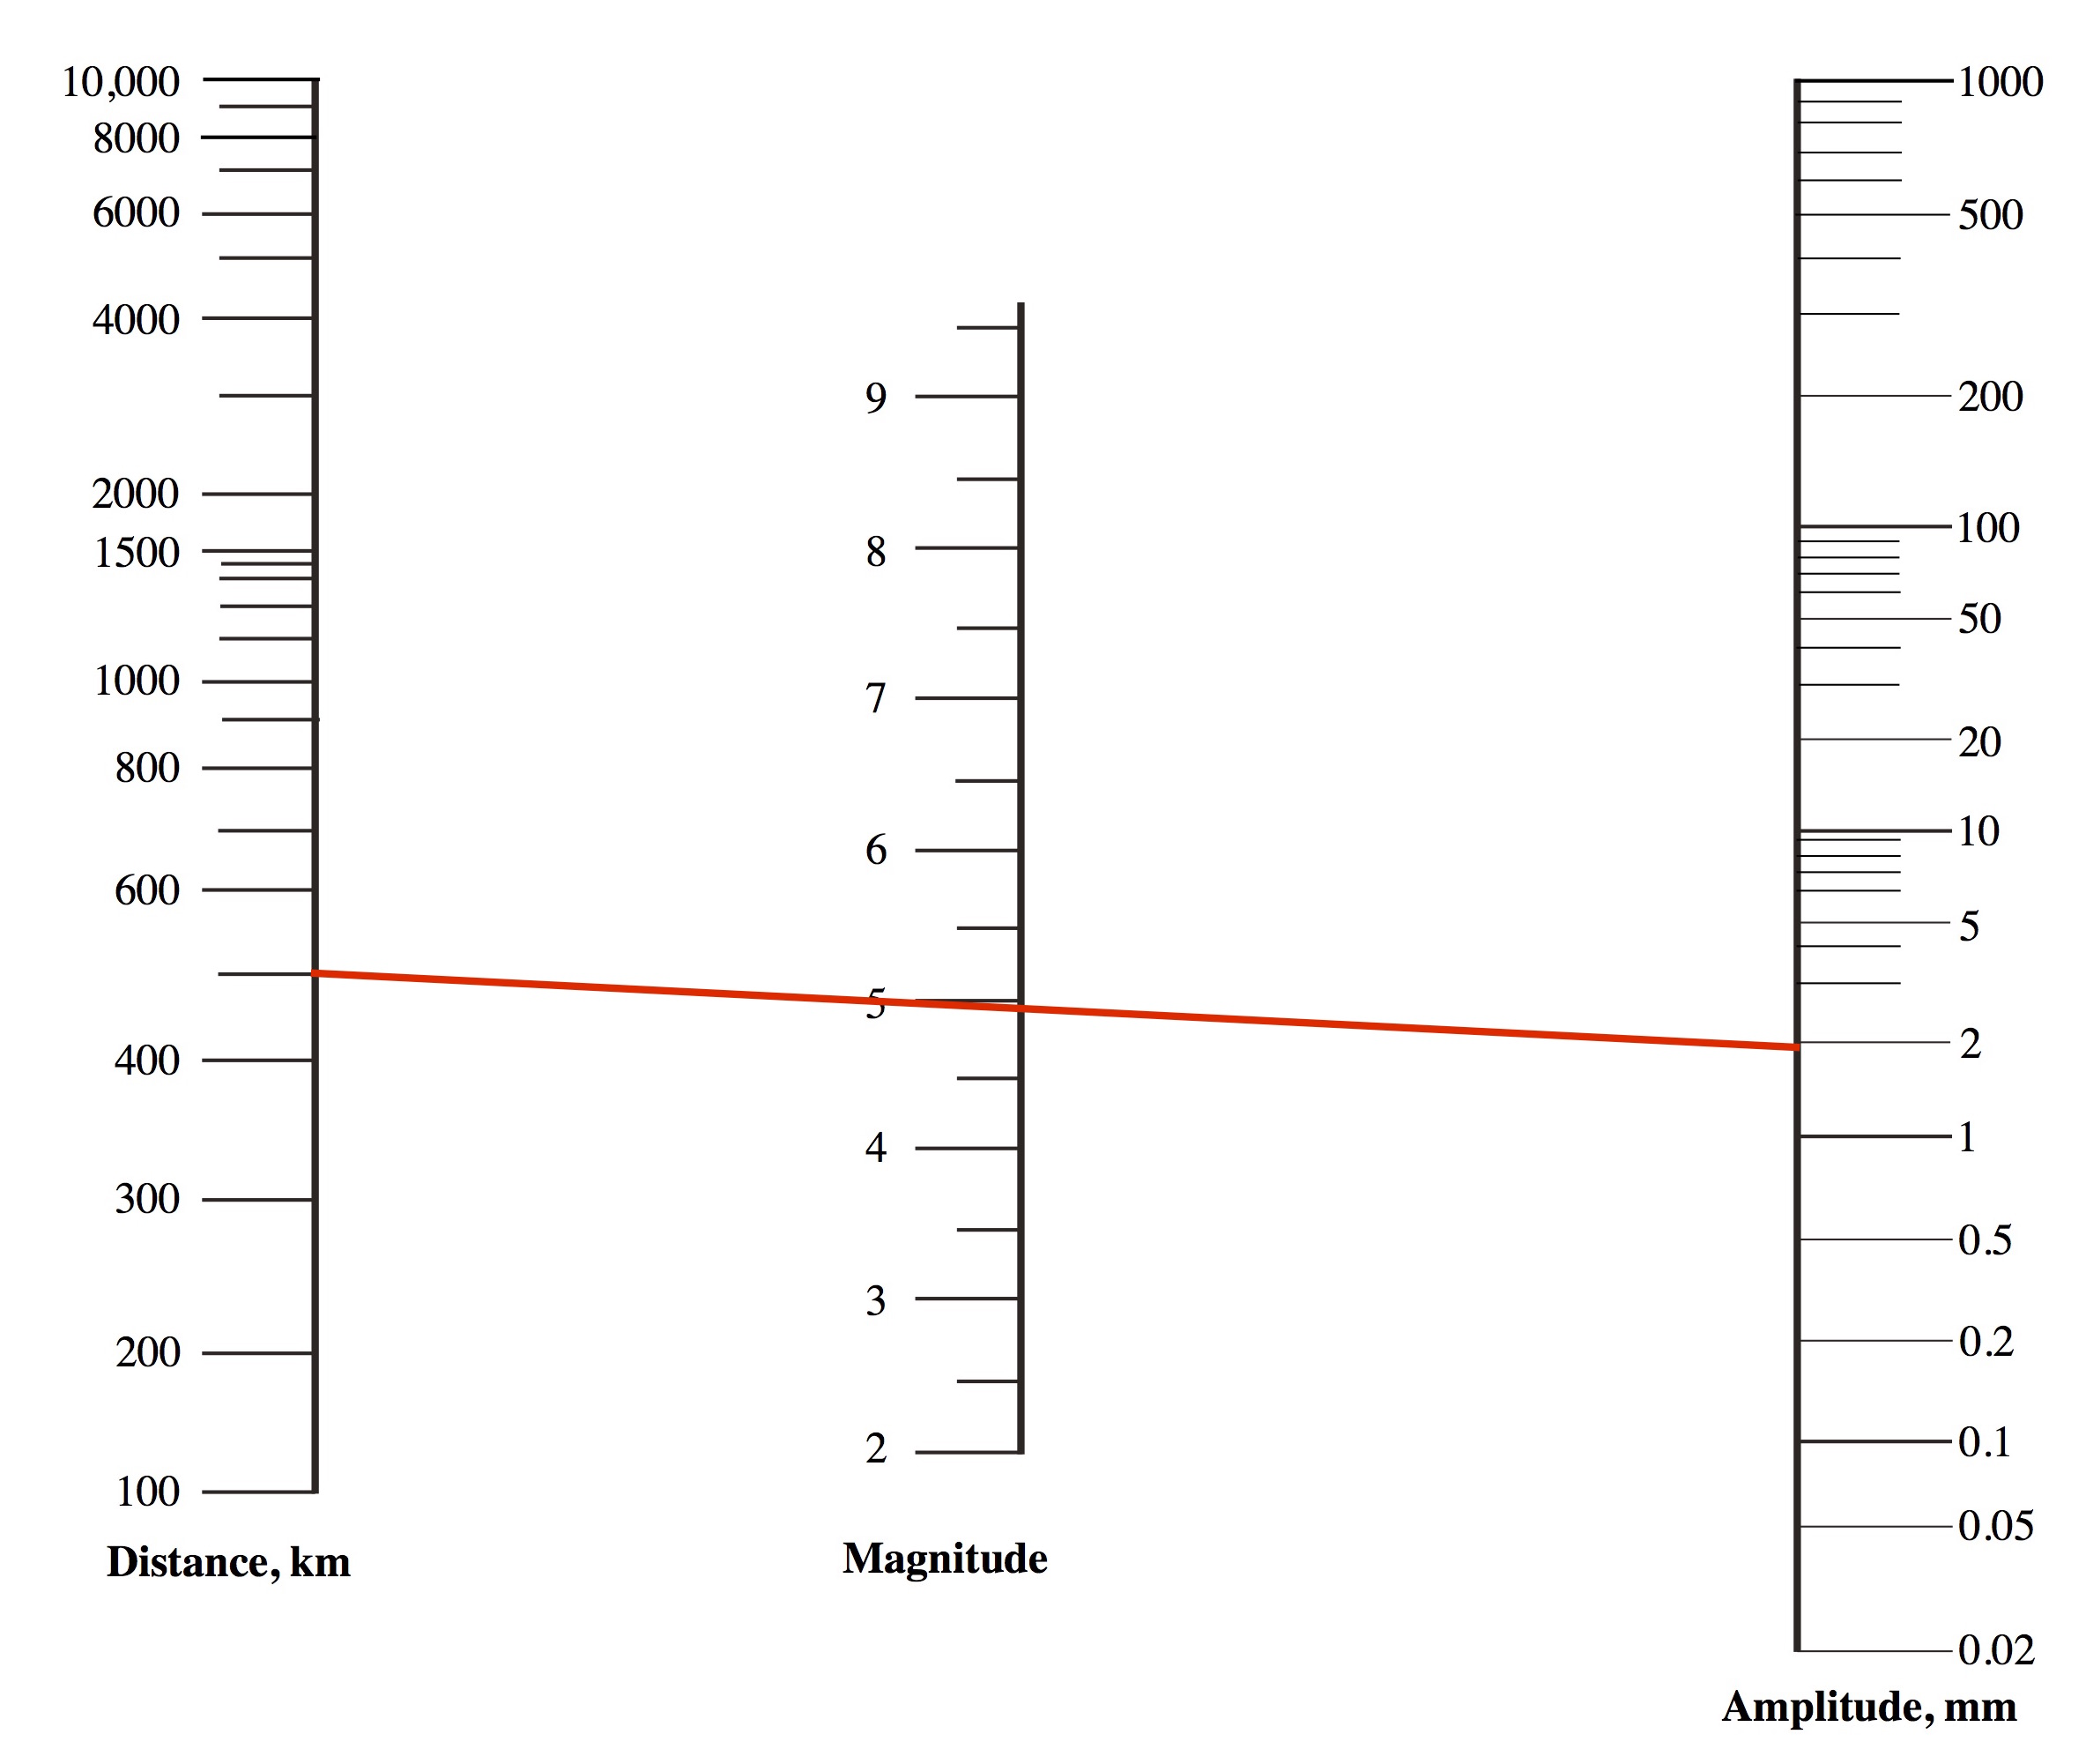

Figure 2.4. How to use a nomogram to determine earthquake magnitude.

8. What is the maximum amplitude for the Buenos Aires seismogram using the nomogram in the PDF? What is the corresponding magnitude of the earthquake?

9. What is the maximum amplitude for the La Paz seismogram? What is the corresponding magnitude of the earthquake?

10. What is the maximum amplitude for the Lima seismogram? What is the corresponding magnitude of the earthquake?

Earthquake Seismograms and Spreadsheets
Part III: Introduction to Spreadsheets

Overview

In Part III, you begin to use spreadsheets to organize data and to do calculations. This part of the exercise provides basic information about using spreadsheets in Microsoft Excel™.

Learning Objectives

- Enter data and a formula in a spreadsheet
- Compute the average magnitude of the earthquake
- Translate algebraic expressions to spreadsheet format

What is a Spreadsheet?

After the invention of modern seismometers, geologists began to accumulate reams of data that were originally kept on paper in tables like the one below or on note cards. These data were increasingly hard to manage until computers became widely available. Now, earthquake catalogs are accessible online in computer format, from the latest quakes to historical events that occurred thousands of years ago. The farther back in time, the less complete the data are; nevertheless, computer spreadsheets provide a convenient way to record and summarize data, make calculations, and plot relationships.

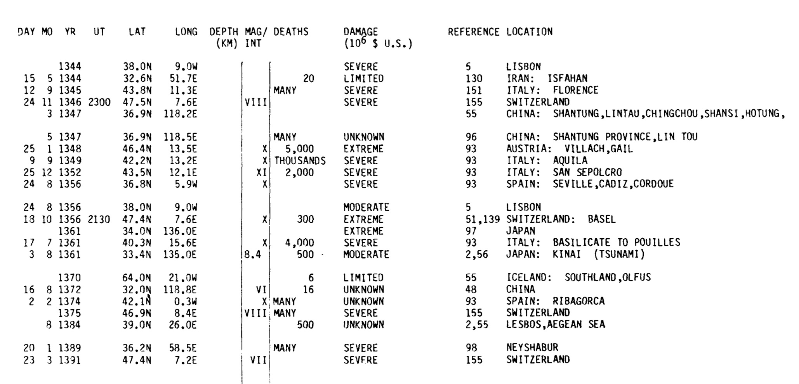

Figure 3.1 Page from a 1981 catalog of earthquakes from 2000 BCE to 1979.
ftp://ftp.ngdc.noaa.gov/hazards/publications/Wdcse-27.pdf

Cell Names in a Spreadsheet

A computer spreadsheet is a file called a workbook, which is made up of one or more worksheets. The main window of a worksheet contains columns (identified by letters) and rows (identified by numbers). The intersection of a column and a row is known as a cell. Each cell has a name consisting of its column letter and row number. For example, the first cell in the upper left corner of the spreadsheet file is named “A1.”

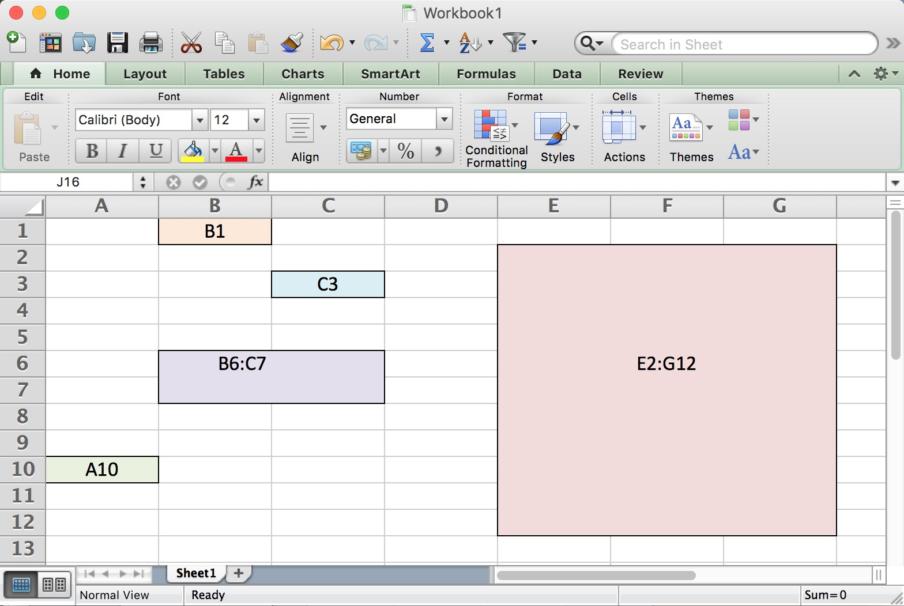

Figure 3.2 Screen shot from Excel showing the names of three cells and two blocks of cells.

Open the spreadsheet that accompanies this exercise, and click on the “Cells” tab at the bottom. “Cells” is the name of one worksheet of the workbook. The other worksheet in this file is named “Quake.”
In the “Cells” worksheet, the title “Cell Names” is entered in cell A1. Cell B3 is outlined in black. The name of the the orange cell is “C10.” If you place the cursor in any cell by clicking the cell, a thick blue line surrounds this cell, and its name appears above the upper left corner of the worksheet.
The block of cells outlined in black can be named as “C6:D8,” meaning all cells within a rectangle having C6 as the upper left corner and D8 as the lower right corner. Scroll right and down to answer the following questions about other specific cells and blocks of cells.

1. What is the name of the green cell?

2. What is the name of the red block of cells?

3. What is the name of the purple block of cells?

Entering Data in a Spreadsheet

To practice using a spreadsheet, you will work further with the Chilean earthquake from Parts I and II. Click on the “Quake” tab at the bottom of the spreadsheet. Enter your distance data from questions #8, 10, and 12 in Part I in cells B4:B6. To enter data, place the cursor in a cell, type the value, and hit “Enter”. Next, enter your amplitude and magnitude data from questions #8-10 in Part II in cells C4:D6.

4. In order to calculate the average of all three magnitudes in D4:D6, enter the following formula in cell D7: =(D4+D5+D6)/3. Be sure to include the equals sign (=) exactly as illustrated. What is the average magnitude of this earthquake?

Programming Algebraic Expressions for Computer Calculations

In order to use a spreadsheet to perform computations, you must translate equations from a familiar algebraic form to a form that is recognizable by the computer, i.e., to a string of characters. The table on the next page shows the translations of some algebraic operations. In the table, “a,” “b”, “x” and “y” represent numbers, and rows 1-4 illustrate how to translate the arithmetic operations (addition, subtraction, multiplication, and division) into computer form.
Rows 5 and 6 show how to raise a number to a power such as 2 (squared) or another power. Row 5 illustrates the exponential function, which equals the irrational number e (2.71828…) raised to a power. Note that unlike the previous operations, the exponential function takes an argument (the “y” inside the parentheses). The natural logarithm in row 6 also takes an argument, and so do trigonometric functions, which use the standard abbreviations (rows 7-8, for example).
Rows 9 and 10 show how to raise a number to a power such as 2 (squared) or another power. The power function takes two arguments: the first argument is the base number, and the second argument is the power itself.
Row 11 illustrates the odd case for the irrational number π (3.14159…), which is a constant. However, its computer form looks like that of a function, i.e., it has parentheses, but it does not take an argument. Note that if you enter the formula: =PI() in a cell, it will return the value 3.14159…
Be careful when using parentheses. Computer calculations follow the mathematical hierarchy: 1) powers and exponential operations; 2) multiplications and divisions; 3) additions and subtractions. At each level, the operations are carried out from left to right. Further, operations inside of parentheses are performed before operations outside of parentheses, and the above rules apply within the parentheses, as well as outside. Finally, do not put spaces around mathematical operators (+, *, /, etc.).

Row | Operation | Algebraic Form | Computer Form
1 | addition | a + b | a+b
2 | subtraction | a - b | a-b
3 | multiplication | a × b | a*b
4 | division | a ÷ b | a/b
5 | exponential | e^{y} | EXP(y)
6 | natural logarithm | ln y | LN(y)
7 | sine | sin y | SIN(y)
8 | cosine | cos y | COS(y)
9 | square | x² | POWER(x,2)
10 | power | xª | POWER(x,a)
11 | pi | π | PI()

5. Write the average of a, b, c, and d in computer format.

π r ² h
3
6. Write the expression for the volume of a cone, , in computer format.

y
5
7. Translate the expression 3 ( x – ) into computer format.

8. Translate the expression e^{m} + n into computer format.

π
4
9. Translate the expression for the sine of into computer format.

D
P
10. Translate the expression ln ( 1 + ) into computer format.

