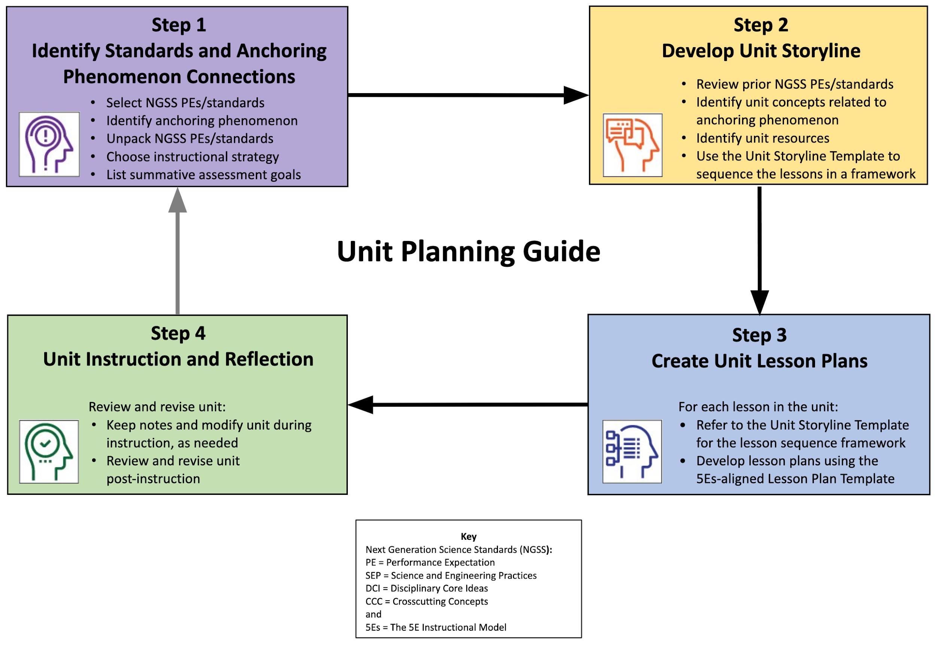

Unit Planning Guide
Develop Units for Instruction
Steps in developing NGSS-/standards-aligned, phenomenon-based units with lessons that are guided by the 5Es instructional model:
- Identify the standards, topics, anchoring phenomenon, instructional strategy, and summative assessment ideas to frame the unit.
- Complete the Unit Storyline Template to create a coherent sequence of lessons to guide unit development.
- Use the Lesson Plan Template to create a detailed lesson plans for the unit.
- Implement unit instruction, review, and revision.

 | Step 1: Identify Standards and Anchoring Phenomenon Connections
Grade and Subject |  |  | Unit Instructional Time
Unit Title (Topic)
1.a Select grade level NGSS Performance Expectations (PEs) or Topics, or district/state standards that build towards unit-based student learning goals.
For NGSS, PE color coding reflects 3-dimensional learning components. Search the Evidence Statements for details on what students should know and do.
1.b Identify an anchoring phenomenon and related phenomena, problem, or project that corresponds to the selected PEs/standards, and is engaging and relevant to students. See more about phenomena and using phenomena with NGSS.
1.c Describe an overview of how investigating the anchoring and related phenomenon, problem, or project through student-driven learning opportunities builds towards understanding of the PEs/standards. Revise, as needed, during unit development.
1.d Unpack the 3-D learning components of the Performance Expectations/standards in the table below.
For NGSS guidance, see the NGSS Topic Arrangements and NGSS DCI Arrangements. Use tools to unpack each PE separately.
1.d.1. Science and Engineering Practices (SEP)  (skills) |  | 1.d.2. Disciplinary Core Ideas (DCI)  (content) |  | 1.d.3. Crosscutting Concepts (CCC)  (connections)

1.e Determine students’ prior knowledge about the lesson concepts. (e.g., pre-test, class discussion, exit ticket, 1-minute report, KWL chart, survey, etc.)
1.f Choose an instructional strategy that best suits teaching and learning about the anchoring phenomena, problem, or project.
For ideas, see the Instructional Strategies matrix.
1.g Generate goals for a summative assessment to measure student learning toward the identified PEs and supporting SEPs, DCIs, and CCCs or standards and supporting skills, content, and connections. Revise, as needed, during unit development.

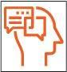 | Step 2: Develop Unit Storyline
Create Coherent Learning Progression
Develop a unit storyline of a sequence of lessons that supports 3-dimensional learning and coherence for students to figure out the anchoring phenomenon.
- Review previous grade level Performance Expectations (PEs)/standards.
- List topics and concepts; then, select potential activities for the unit.
- Copy and paste the Unit Storyline Template, one for each lesson in the unit, to create the lesson sequence framework.
Note: The Unit Storyline Templates will be used to guide detailed lesson plan development (Step 3).

2.a List previous Performance Expectations/standards that support grade level expectations in figuring out the anchoring phenomenon.
2.b Identify Unit Topics and Learning Goals: List main unit concepts related to grade level PEs/standards that support student learning goals in figuring out the anchoring phenomenon; revise as needed.
2.c Select Unit Resources: Identify unit resources to develop lessons that address the PEs/standards and investigate the anchoring phenomenon through a variety of sequenced activities; revise as needed (include title and URL).

Unit Storyline Template (2.d - 2.i)
The Storyline provides an overarching narrative and coherency between the series of lessons that comprise a unit. Copy and paste the Unit Storyline Template for each lesson in the unit. A lesson may consist of one or more activities and take one or more days of instructional time.
2.d Unit Lesson Title (Topic)
Lesson # of #
2.e Anchoring Phenomenon
(lesson aspect of 1.b.)
Where we’ve been…  (previous unit lesson) | If applicable, fill in with the “what we’re doing now” section from the previous unit lesson. If first lesson in the unit, describe past learning.
What we’re doing now…  (current unit lesson) | Teacher text about what happens in this lesson of the unit.
2.f Driving Question…  What we’re investigating about the anchoring phenomenon | 2. g Lesson Activities Sequence  (select from 2.c) | 2. h Skills for Investigating the  Driving Question (SEP)  (select from 1.d.1.) | 2.i What We Figure Out About the Driving Question (DCI/CCC)  (select from 1.d.2 and 1.d.3.) | New Questions &  Next Steps  (build activity/lesson coherency)
Student-driven lesson question:

(Lesson #: min.)

Building toward

NGSS PEs
or Standards
(select from 1.a):

Where we’re going...  (next unit lesson) | Teacher text about what happens in the next lesson of the unit based on this lesson’s outcomes.

Unit Storyline Template adapted from nextgenstorylines.org under a Creative Commons Attribution 4.0 License

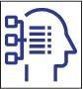 | Step 3: Create Unit Lesson Plans
Develop Lesson Plans for Instruction
Develop NGSS-/standards-aligned lessons that are guided by the 5Es instructional model to instruct the unit.
- Refer to the Unit Storyline Template for each corresponding lesson to guide the lesson plan development.
- Use the Lesson Plan Template to create detailed lesson plans that guide unit instruction.

Lesson Plan Template
Unit Lesson # of # (copy from 2.d)
Grade and Subject |  |  |  |  | Instructional Time  (min.)
Lesson Title (Topic)
(copy from 2.d)
Anchoring Phenomenon
(copy from 2.e)
Driving Question
(copy from 2.f)
Lesson Overview
Lesson Summary  (description) |  |  | Lesson Topics and Student Learning Goals  (copy from 2.b)
Lesson Resources Aligned with Standards
Lesson Resource  (copy from 2.g, sequenced with titles and links) |  |  | Resource Standards Alignment  (copy from 2.h and 2.i, standards notated, link optional)
Teacher Preparation
Student Misconceptions  (potential student ideas that are problematic when engaging in the lesson) |  |  | Scientific Terminology  (vocabulary named once students “figure out” concepts of lesson)
Materials Preparation
Student Needs  (activity sheets, data packet, etc.) |  | Group Needs  (lab equipment, group data packets, etc.) |  | Safety & Technology Needs  (dangerous materials, websites cued, etc.)
Supporting Information
References  (links to cite sources of data, images, websites, etc.) |  |  | Background Reading  (for teachers and/or students)

Complete the 5E Instructional Model section(s) that are relevant to the lesson:

Engage: Interest in a concept is generated and students’ current understanding is assessed.
ACTIVATE interest: Introduce anchoring phenomenon and driving question.
- Engages students in the concepts through a short activity or relevant discussion
- Connects students’ past and present experiences
- Creates interest and generates curiosity
- Uncovers students’ current knowledge and misconceptions
- Initiates students’ investigation into the anchoring phenomenon based on an observation, problem, or question
Phenomenon-based Driving Questions (questions students are likely to ask about the lesson topic)
Lesson Activities (experiment, demonstration, video, visualization, reading, etc., coherently sequenced to help build understanding of PE/standard)
For each activity, provide details of the procedure including timing, teacher guidance, student prompts, strategies for discussions and differentiation, etc.
Formative Assessment (activity sheet, Venn diagram, summary, exit ticket, think-pair-share, etc. to check for understanding of lesson concepts)
Consensus Discussion (claims, evidence, and reasoning on what students figured out in this lesson)
New Questions and Next Steps (student-driven questions, ideas on what to investigate in the next lesson and how to investigate it, etc.)

AND/OR

Explore: Students participate in activities to explore questions related to a concept.
BUILD Knowledge: Learn the science behind concepts.
- Students explore the concepts with others to develop a common set of experiences
- Provides students with one or more actual experiences
- Offers opportunities for creative thinking and skills development
- Students make and record observations and ideas, make connections, and ask questions
- Students usually work in groups
- Teacher acts as coach or facilitator in student-led investigations
Phenomenon-based Driving Questions (questions students are likely to ask about the lesson topic)
Lesson Activities (experiment, demonstration, video, visualization, reading, etc., coherently sequenced to help build understanding of PE/standard)
For each activity, provide details of the procedure including timing, teacher guidance, student prompts, strategies for discussions and differentiation, etc.
Formative Assessment (activity sheet, Venn diagram, summary, exit ticket, think-pair-share, etc. to check for understanding of lesson concepts)
Consensus Discussion (claims, evidence, and reasoning on what students figured out in this lesson)
New Questions and Next Steps (student-driven questions, ideas on what to investigate in the next lesson and how to investigate it, etc.)

AND/OR

Explain: Students construct their understanding of a concept and develop evidence-based explanations.
DEVELOP Concepts: Research information using real-world data.
- Develops students’ explanation for the concepts they have been exploring with teacher providing supporting guidance
- Students describe their observations and come up with explanations
- Students listen critically to each other’s explanations
- Students learn to apply and interpret evidence
- Develops students’ academic vocabulary by applying scientific terms once students have figured out the lesson concepts
- Teacher guides students’ reasoning, asks appropriate questions, and directs students to additional supporting resources
Phenomenon-based Driving Questions (questions students are likely to ask about the lesson topic)
Lesson Activities (experiment, demonstration, video, visualization, reading, etc., coherently sequenced to help build understanding of PE/standard)
For each activity, provide details of the procedure including timing, teacher guidance, student prompts, strategies for discussions and differentiation, etc.
Formative Assessment (activity sheet, Venn diagram, summary, exit ticket, think-pair-share, etc. to check for understanding of lesson concepts)
Consensus Discussion (claims, evidence, and reasoning on what students figured out in this lesson)
New Questions and Next Steps (student-driven questions, ideas on what to investigate in the next lesson and how to investigate it, etc.)

AND/OR

Elaborate: Students deepen and expand their understanding by applying their understanding in new contexts.
APPLY Learning: Utilize information in new ways.
- Extends students’ understanding or applies what they have learned in a new setting
- Students use the information they have gained to propose solutions and extend their learning to new situations
- Teacher supports students in broadening their understanding and extend ideas to other situations so they can draw broader conclusions beyond their experiment or investigation
Phenomenon-based Driving Questions Extended/Applied in a New Context (questions students are likely to ask about the lesson topic)
Lesson Activities (experiment, demonstration, video, visualization, reading, etc., coherently sequenced to help build understanding of PE/standard)
For each activity, provide details of the procedure including timing, teacher guidance, student prompts, strategies for discussions and differentiation, etc.
Formative Assessment (activity sheet, Venn diagram, summary, exit ticket, think-pair-share, etc. to check for understanding of lesson concepts)
Consensus Discussion (claims, evidence, and reasoning on what students figured out in this lesson)
New Questions and Next Steps (student-driven questions, ideas on what to investigate in the next lesson and how to investigate it, etc.)

AND/OR

Evaluate: Students and teachers have opportunities to assess students’ understanding of a concept.
DEMONSTRATE Ability: Write, illustrate, create, etc. artifacts that accurately describe knowledge gained.
- Students have the opportunity to demonstrate understanding of skills and concepts, and evaluate their own progress
- Teacher evaluates students’ understanding and progress, as well as their own instructional practice, and may implement alternative assessment strategies
- Enables adjustment of misconceptions, reinforces students’ understanding of the PE concepts in greater depth
Phenomenon-based Driving Questions (questions about the lesson topic)
Skills Learning Performance (SEPs) Goals (assess student skills related to the lesson)
Formative Assessment (quiz, test, report, presentation, poster, video, model, etc. to demonstrate students’ understanding about the PEs/standards)
Content Learning Performance (DCIs, CCCs) Goals (assess student mastery of lesson content)
Summative Assessment (quiz, test, report, presentation, poster, video, model, etc. to demonstrate students’ understanding about the PEs/standards)

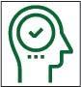 | Step 4: Unit Instruction and Reflection
Lesson Notes During Instruction
- What modifications (instruction, timing, etc.) were made or are needed for specific unit lessons, activities, or resources?
- Which specific unit lessons, activities, or resources were or need to be changed?
- How effective (or ineffective) were specific unit lessons, activities, or resources for student learning?

Review and Revise Post-Instruction
- Which parts of the unit and specific lessons were a success?
- What were some challenges about the unit or lessons?
- How could the unit or certain lessons be changed or improved?

