How do we really know what’s inside the Earth?:

Imaging Earth’s interior with seismic waves

Student worksheet

v3.1, last updated - June 2017

Part I – Background knowledge

1. What is inside Earth? In the space below, sketch what you believe the interior structure of Earth to be like.

Accept all responses. Most students will draw some variation of a series of circles within a circle. While some may include accurate labels for the layers, it is very common for students to have a poor sense of the scale of Earth’s layered interior even if they are aware that Earth has one.

2. Describe any direct evidence, based on data, you have personally observed which indicates the information you sketched above?

Some students may have some sense of how seismic data is used to determine Earth structure, but most will have little data they can cite. The key here is to get the students to focus on evidence and how this differs from information provided in textbooks.

Part II – Comparing model observations and data
You probably didn’t have much evidence about Earth’s interior beyond what textbooks, TV, or a previous instructor described. So how do we really know what is inside Earth? Let’s investigate!

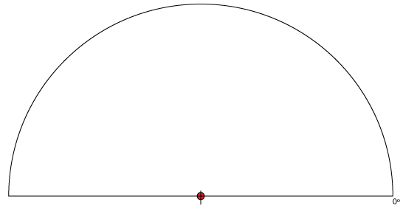
Based on your own direct experience (e.g. digging a hole, visiting a cave or quarry, driving past a road cut) you are probably aware that below the soil is a layer of rock. Let’s begin our investigation into Earth’s interior by assuming that the simplest solution is correct. Thus, we will start from a hypothesis that Earth is made up entirely of this same rock material. This would mean an Earth where rock extends all the way to the center of Earth. This homogeneous Earth model is illustrated in Figure 1. Since the model is comprised of the same material throughout, we can assume that seismic waves will travel at a constant velocity (in this case, we will assume the P-waves travel at a velocity of 11km/s in our model), and in straight lines. We can use this model and these assumptions to make some predictions and calculations that test the accuracy of our hypothesis.
Earth’s surface
Center of Earth
Earthquake location
Seismic wave paths
Figure 1. A scale model of a cross section of Earth comprised entirely of rock. Triangles represent seismic stations at the surface and the red lines indicate example paths that seismic energy travels from the earthquake to each station.

For example, we can use the model to predict how long it should take seismic waves to travel from an earthquake, through Earth, to various points on Earth’s surface. This is indicated in Figure 1 as “seismic wave paths”. This can be accomplished using the basic equation T = D/S where the time (T) it takes for a seismic wave to travel a certain distance, (S) is the speed the waves travel and (D) is the distance between the earthquake and the seismic station. As previously mentioned we are assuming that the speed (S) of P-waves is 11km/s. Since our model is a physical scale model, we can measure the length of the seismic wave paths from the earthquake’s location to various points on the model’s surface. Model measurements can be scaled up to real Earth distances. This has been done for you and the predicted arrival times for our homogeneous Earth model are illustrated in Figure 2 below.
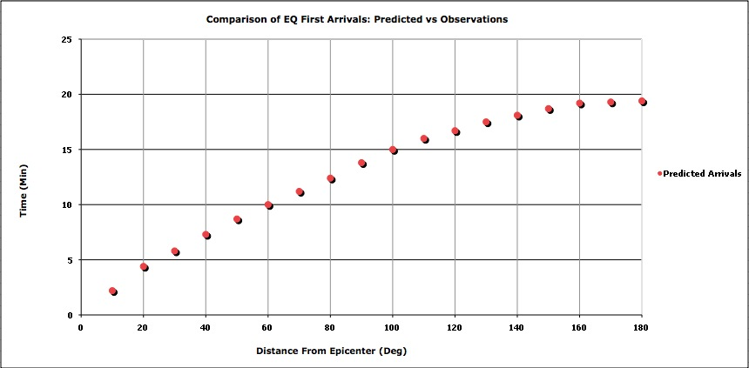

Figure 2: Predicted arrival times for P-waves traveling 11km/s in a homogeneous Earth model.

NOTE: The distances displayed on the X-axis in Figure 2 above and on the seismic record section provided with this lab use angular degrees with Earth’s center as the reference point. This is known as the “geocentric angle.” Each angular degree = ~111km on Earth’s surface. The angular distance between a earthquake and a seismic station is referred to as the “epicentral distance.”
140°
Epicenter
Figure 3: Measuring distances using geocentric angle.

Next we need to compare the predictions derived from the model to observations we make from the real Earth. Modern seismographic networks record how the ground moves in response to earthquakes at points all over the world. These recordings of ground motion, called seismograms, are freely available via the Internet. Your task is to use a collection of seismograms recorded at different distances from a single earthquake, presented together in a format known as a record section, to determine how long it actually takes for P-waves to travel through Earth. Your findings form the observed Earth data that will be compared to the observed data in Figure 2. If your findings match and follow similar trends as the arrivals predicted by our model, then our hypothesis that the Earth is homogeneous rock throughout should be correct. However, if your observations do not match the predicted arrival times, than we can reasonably assume the Earth is not homogenous and does have some structure to it.

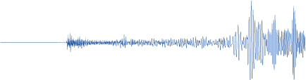
1. Carefully analyze the collection of seismograms (called a record section) provided. Identify the first arrival of seismic energy at the station and determine how long it took the seismic energy to travel (see Figure 4 for example). Record this information in the data table below.
Figure 4. The arrival of seismic energy is indicated on the seismogram by a change from the background or previous signal. In this example, the red arrow denotes the arrival of the P-wave.

Station Distance (degrees) | Travel time (min)

2. Describe any difficulties you and your team had generating your data. Be sure to include any sources of error for your data set.

3. Plot your observed P-wave arrival times on Figure 2 above using triangles to indicate observed data.

See plot in the instructor ppt

5. Examine these two data sets (predicted vs. observed travel times). What conclusions can you draw from them? How do the data sets compare at short and long distances? Are there particular distance ranges where the travel times are different in the two data sets?
The observed travel times are later than the model at short distances, become slightly earlier around 100 degrees, then suddenly become much later beyond 110 degrees.

6. What do the results of comparing the observed arrivals to the predicted arrivals imply about our hypothesis that Earth’s interior is composed of homogenous rock?
- ▶▶▶▶The comparison implies Earth’s interior is not homogeneous rock throughout.
- The comparison implies Earth’s interior is homogeneous rock throughout.
- The comparison is unable to inform us about our hypothesis.

7. Briefly explain why you selected that response.

I selected this response because the observed values did not match the model/predicted data. Since they don’t match, Option B can’t be correct. Option C can’t be correct because we can compare the two sets of data and draw conclusions from it.

8. Which of the following statement is the best hypothesis for explaining the observed values in the plot?
- Earth’s interior changes abruptly at several different depths.
- Earth’s interior is homogeneous throughout.
- Earth’s interior is heterogeneous but changes gradually with depth.
- ▶▶▶▶Earth’s interior is composed of homogeneous material through some portions, but also changes abruptly at a particular depth.

Part III – Examining the implications
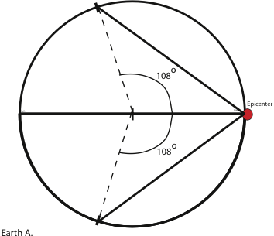
shadow zone
- As shown in Figure 5, on the full-circle Earth scale model provided by your instructor, indicate the epicenter of the earthquake with a small circle at 0 degrees on Earth A (the right edge).

- Examine your graph of the observed arrivals on Figure 2 (above) to determine where there is an offset in the observed seismic waves arrivals compared to the modeled arrivals.

- Measure a geocentric angle equal to the distance you noted in #2 above to the northern hemisphere and make a mark on Earth’s surface (e.g. 108 degrees as shown in Figure 5... though your data will vary). Use your ruler to connect the epicenter to the mark you just drew on Earth’s surface.
Figure 5. Based on the observed seismic data you the P-wave shadow zone can be modeled. The example shown here uses 108 degrees, but your data may differ.

- Repeat this procedure but mark the southern hemisphere’s surface.

- Label the area inside the angles drawn as the shadow zone.

- Answer the following questions.
- What conclusions can you draw about Earth’s interior so far?
We have determined a region where the waves arrive late. A variety of shapes/structures could fit in the space and cause the delayed arrivals.
- How has the seismic data helped us determine Earth’s interior structure?
We can see anomalies in the wave arrivals (e.g. slower than expected in this case).
- Examine the record section again for this area and evaluate how this “shadow zone” might be like a person’s shadow on the ground.
Shadow regions do not receive any direct light. However the shadow zone does receive light that refracts around the “blocking” object and reflects off other objects. Similarly seismic shadow zones do not receive any direct arrivals. Rather the seismic energy that arrives there has refracted around objects or reflected off “surfaces” thus changing their travel paths; this is a process that affects their arrival time. NOTE: The full area we are calling a shadow zone here is not a true shadow zone as defined by seismology, as direct P-arrivals are received by stations beyond 140 degrees. These are rays that have gone through the core. The true P-wave shadow zone (no direct arriving P-waves), goes from 104-140 degrees. The first arriving P-wave between 104 and 140 degrees is either a diffracted P-wave from the outer core boundary, or a P-wave that has bounced once off the Earth’s surface.
- Predict how more earthquakes might help us further “resolve” Earth’s structure?
Additional quakes distributed around Earth could help us further define the structure’s shape by providing more details for their travel paths. For example, if all quakes have a similar delayed arrival starting around 110 degrees away from the earthquake, then the structure is likely to be spherical.
- Use scissors to cut out the wedge-shaped P-wave shadow zone. This represents the area that does not receive “direct” P-waves from an earthquake.

- Seismograms from earthquakes at other locations have been shown to have the same pattern of arrivals as the earthquake you analyzed. How could you use this information along with your cut out wedge to determine the shape of the object that causes the “shadow” inferred by your data? Test your idea by using your wedge to define the shadow region for multiple earthquakes on your 2nd scale model.

Students can be led to model the occurrence of additional earthquakes by placing the point of the wedge-shaped cut-out on the surface of Earth B while aligning the curved arc of the wedge with the opposite side of Earth B (the point on the cone indicates the location of another earthquake epicenter).
They then trace the straight edges of the wedge to indicate the area where direct P-waves from the earthquake do not arrive, and repeat this procedure for a number of earthquakes, each at a different location. Be sure to trace out the P wave shadow zone each time.

- Answer the following questions.
- As additional earthquake data is added, what shape is being defined in the interior of Earth Model B?

Additional data is helping to define a circular object.

- Describe what you think this new inner circle represents?

This inner circle represents Earth’s core.

- Describe what has allowed our model for Earth’s interior to improve since 6d above.

Additional data from more earthquakes has allowed us to improve our image of Earth’s interior.

- Calculate the radius of the structure that was revealed by the seismic data. The scale of Earth model B is 1:127,420,000.
Answers will vary somewhat depending on the data students use and the construction of their scale model. The example data we used (see figure 5 above) generated a core with a radius of ~2.75cm on the model or (2.57cm x 127,420,000cm) / 100,000cm ≈ 3500km for Earth
Part IV – Determining states of matter
As you have observed, seismologists can explore Earth's interior by analyzing seismic wave arrivals resulting from large earthquakes. Figure 6 shows the basic structure of Earth's interior, while the connected Figure 7 shows a more detailed record section than you analyzed in Part II. This example is from the 1994 Northridge earthquake.

- Use the Internet to help you label the layers of Earth’s interior A, B, and C as shown on Figure 6

- How well does the radius you calculated in Part III compare to the accepted values you found? Why might these differ? What is the error in your result, expressed as a percentage?

An accepted radius of Earth’s core is 3486km (http://nssdc.gsfc.nasa.gov/planetary/factsheet/earthfact.html). Students’ calculated radius will vary slightly depending on the data used and students’ construction of their scale model. However, it is possible to get very close to the accepted value. For example, we previously determined that our example data indicated a core with a radius of 3504km.
Absolute Error = | accepted – calculated|
or
|3486km - 3504km| = 18km
% Error = Absolute Error/accepted x 100%
or
18km/ 3486km = .005 x 100% = 0.5% Error
Thus, our value with within 0.5% of the accepted value.

- Highlight the P-wave arrivals on the seismograms on Figure 7. Comparing these to Figure 2 above, select one of the following
  - The arrival times in Figure 7 follow the same overall pattern as the hypothetical values
  - ▶▶▶▶The arrival times in Figure 7 follow the same overall pattern as the observed values

- In Figure 7, over what distances do the P-waves arrive “later” than the shape of the rest of the curve would predict?
  - 10-40 degrees
  - 80-100 degrees
  - 110-140 degrees
  - ▶▶▶▶140-160 degrees

- Examine Figure 7 again. Which of the following best describes what happens to the S-wave arrivals over the same distances you identified in #4 above?
  - ▶▶▶▶No S-waves arrive at those distances
  - The S-waves also arrive later than the rest of the curve would predict
  - The S-waves arrive when the rest of the curve would predict

- Using what you learned about P- and S- wave propagation at the beginning of class and the evidence shown in Figure 6 and 7 to construct an argument (Claim, Evidence, Reason) for the question “What state of matter is Earth’s mantle and Earth’s core?”

Claim: Based on the seismic wave observations, I conclude that the mantle is solid and the core is liquid.

Evidence: S-waves and P-waves propagate through solids. Using this, we can infer that the mantle is solid because both S- and P-waves are recorded at distances where the travel path of the energy is only within the mantle. At distances such as 140 and 160 degrees, where seismic energy travels through the mantle then into the outer core and back out into the mantle, only P waves (no S-waves) are recorded. Since we know that S-waves can’t travel through liquids, but that P-waves can travel through liquid, we can conclude that these waves encounter a core made of liquid.

Note: While not explicitly included here, the core is actually comprised of two layers; a liquid outer core that students identified above, and a solid inner core. The presence of this solid interior was initially detected (in 1936 by Danish seismologist Inge Lehmann) from observations of seismic waves reflecting off the boundary between the liquid exterior and the solid interior.

Note that the record section in Figure 7 shows small arrivals that have been diffracted from the core-mantle boundary, which is why there are early arrivals beyond 110 degrees.
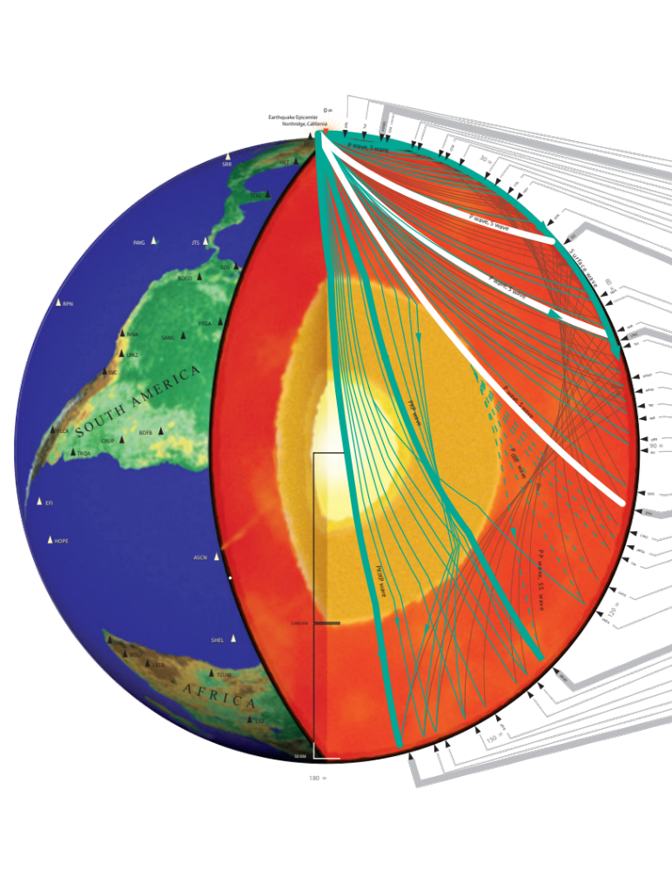
A _________________________________________________

B. _________________________________________________

C. _________________________________________________

A..
B..
C..
Core (or Inner and Outer Core)
Mantle
Crust
Figure 6. The basic structure of Earth's interior as inferred from studies of the energy released by earthquakes, which travel through Earth as seismic waves. This energy is reflected and refracted at boundaries that separate regions of different materials. Shown here are the paths for seismic waves including from the 1994 Northridge earthquake that were recorded at seismic stations around the world. Seismic station locations are marked as triangles and some are labeled with their station codes. Seismograms for these seismic stations are shown on the right half of this figure.

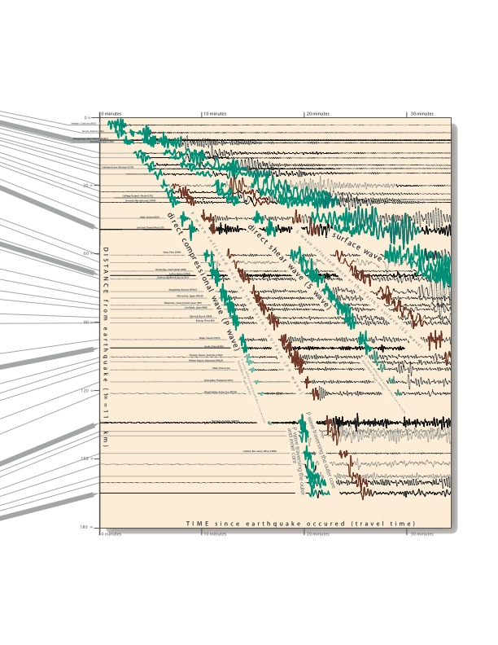
Figure 7. Seismograms, running from left to right in time, show the arrival of seismic waves from the 1994 Northridge earthquake. The traces are the actual ground motions recorded at the seismic stations. Some traces are labeled with the location of the seismic station at which they were recorded. The direct ray paths for P-, S- and surface waves are shown in green. Seismologists compare the arrival times and amplitudes of seismic waves from many stations to determine seismic velocities and hence the structure and composition of Earth’s deep interior.

Part V – Viscosity and resistance to flow
In Part 3, you used the seismic waves from the 1994 Northridge earthquake to establish that Earth is essentially solid from the top of Earth’s crust to the base of the mantle, about 2900km below the surface. In this next section we will examine this outermost layer in more detail. While this region is solid, all solid materials are not all alike. That is, some solids are harder or softer than others, and some deform more easily than others. Take, for example, modeling clay and glass. Both materials are solids, but it is much easier to deform the clay than glass. If, however, you carefully applied a force to the glass over a very long period of time, it would eventually deform without breaking. One of the ways that geoscientists measure how easily a substance can deform or flow is by determining its viscosity. Viscosity is formally defined as the resistance of a material to flow. Figure 8 illustrates the viscosity of a range of solid and liquid materials.

Current Plate Tectonics theory suggests that the outer shell of Earth consists of a high viscosity layer of rock called the lithosphere. This lithosphere is separated into several major and numerous minor tectonic plates that are in slow, but continuous motion. Beneath the lithosphere is a layer of rock with a lower viscosity called the asthenosphere.

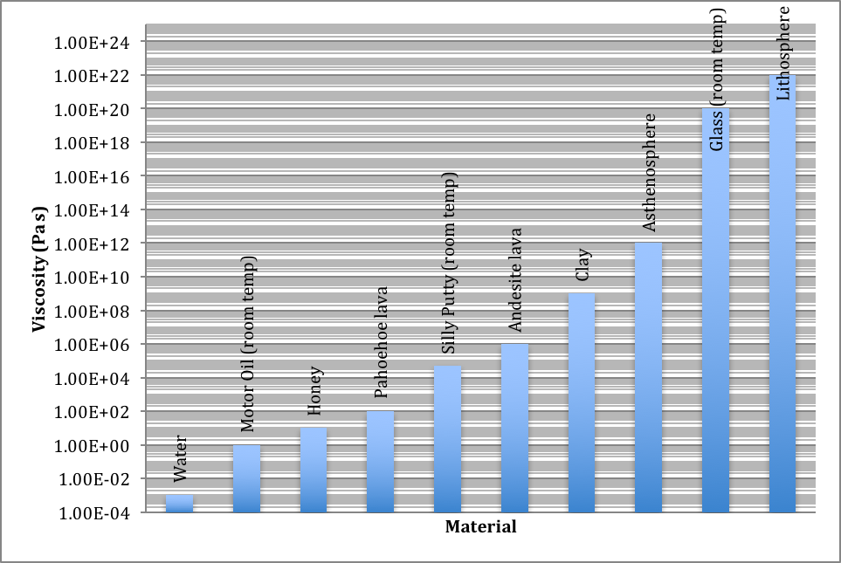)
Figure 8: The viscosity of both common and less-uncommon materials. The unit for viscosity is Pascal-seconds (Pa-s), which is a measure of the material’s resistance to flow. In this figure, viscosity units are written in scientific notation where 1.00E+2 is equal to 100, 1.00E-3 is equal to .001, and so on.

1. Which of the following statements best describes how the asthenosphere relates to lava and glass in its resistance to flow?
▶▶▶▶a. The asthenosphere is more similar to lava than glass in its resistance to flow.
b. The asthenosphere is equally similar to both lava and glass in its resistance to flow.
c. The asethenosphere is more similar to glass than lava in its resistance to flow.

2. Which of the following correctly compares the viscosity between the lithosphere and the asthenosphere?
a. The asthenosphere is more viscous, and therefore more fluid-like than the lithosphere.
b. The lithosphere is more viscous, and therefore more fluid-like than the asthenosphere.
c. The asthenosphere is more viscous, and therefore less fluid-like than the lithosphere.
▶▶▶▶d. The lithosphere is more viscous, and therefore less fluid-like than the asthenosphere.

4. Draw and describe how you might use a glass block, Silly Putty, and an inclined plane to model plate tectonics to another student.

The more viscous glass plate can be stacked on top of the less viscous silly putty. The Silly Putty will flow and the glass plate will move along in the direction of flow.

Glass Block

Silly Putty

5. For a reality check, is the difference in viscosity of glass vs silly putty greater than or less than the difference in viscosity of the lithosphere vs the asthenosphere? By how much?

The ratio of glass/silly putty viscosity is more than 10¹⁵ while the llthosphere/asthenosphere viscosity ratio is 10¹⁰ thus there is a much greater difference (10⁵) in viscosity between glass and silly putty than between the lithosphere and the asthenosphere.

Part VI – Examining the lithosphere/asthenosphere boundary
In addition to using seismic waves to find where the core-mantle boundary occurs inside Earth, geophysicists can also use seismic waves to identify other boundaries within the solid Earth.
To do so, geophysicists produce tomographic images of Earth’s interior through a process that is similar to a CT scan that you might get at a hospital for your body. CT scan machines shoot X-rays through a patient’s body in all directions. Instead of making just one two-dimensional (2D) image, CT scans enable three-dimensional (3D) imaging which show the patient’s internal structures from different directions. Analogous to X-rays, geophysicists record P- and S–waves from earthquakes to remotely probe Earth’s interior. S-waves are a particularly excellent tool for finding changes in viscosity because they are more sensitive to changes in the physical state of Earth’s interior, as we learned in Part V.
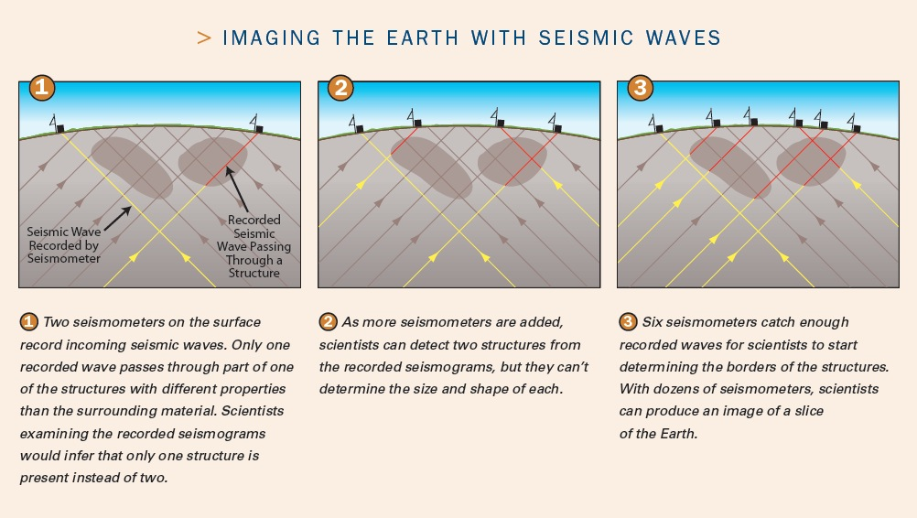

Figure 9. Constructing tomographic images of Earth’s interior.

As illustrated in Figure 9, geophysicists use the distance the S-wave traveled to a seismometer and the time it took to get there, to calculate the average speed of the S-waves. They then map out large regions where the seismic waves traveled slower or faster than average. The speed of the waves depends on the type of material through which they travel. In general, S-waves travel more slowly in lower viscosity materials and faster in higher viscosity materials. Looking at the changes in S-wave velocities, geophysicists can identify the lithosphere-asthenosphere boundary and measure the depth to it.

Geophysicists often use cool colors (blue and green) to show areas inside Earth where seismic waves travel more quickly, and warm colors (red and orange) to show areas inside Earth where seismic waves travel more slowly. Figure 10 shows a vertical slice of the Earth beneath North America where a dense network of seismic stations was used to image Earth’s interior. The blue colors illustrate areas inside Earth where S-waves travel faster than average while red colors illustrate areas where S-waves travel slower.

1. Which of the following materials would you expect an S-waves to propagate faster in?
a. Silly putty
b. Asthenosphere
c. Motor oil
▶▶▶▶d. Lithosphere

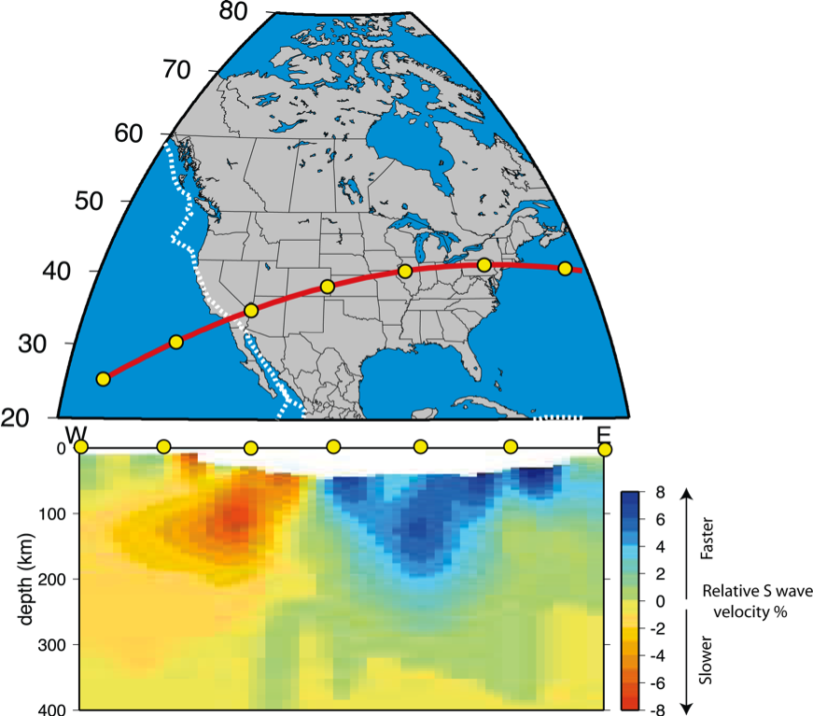
/

Figure 10. A slice through an S-wave tomographic model of Earth beneath the United States. Modified from Nettles and Dziewonski, 2008.

The dashed white line at 100km of depth is a hypothetical boundary between the lithosphere and asthenosphere. If this line truly separated these two layers, we would see only green and blue colors above the line and yellow and red colors below the line.

2. Since the white dashed line does not appear to do a good job accurately separating the lithosphere from the asthenosphere, which of the following statements best describes the lithosphere-asthenosphere boundary in this slice through North America?
a. The lithosphere-asthenosphere boundary is about 150km deep in nearly all places.
b. The lithosphere-asthenosphere boundary is about 50km deep in some places and shallower than 10km in other places.
▶▶▶▶c. The lithosphere-asthenosphere boundary is less than 100km deep beneath the ocean, some plate boundaries, and the western US, and deeper than 100km beneath the older parts of the North American continent.
d. The lithosphere-asthenosphere boundary is about 50km deep in nearly all places.

3. How easy is it to decide where the lithosphere-asthenosphere boundary is?
a. It is easy because you can use a single value to follow across the bottom of the lithosphere
b. It is difficult because the speeds change abruptly from fast to slow.
▶▶▶▶c. It is difficult because the speeds change from fast to slow gradually over a wide range of depths.

4. Refer back to the glass block and silly putty model you described previously. How might this simple model be different from the observed data displayed in Figure 10 above?

In the glass block and silly putty model, the boundary was well defined which is unlike the tomographic model where the transition is much more gradual.

Next, examine the following images showing S-wave velocities at various depth slices beneath North America.

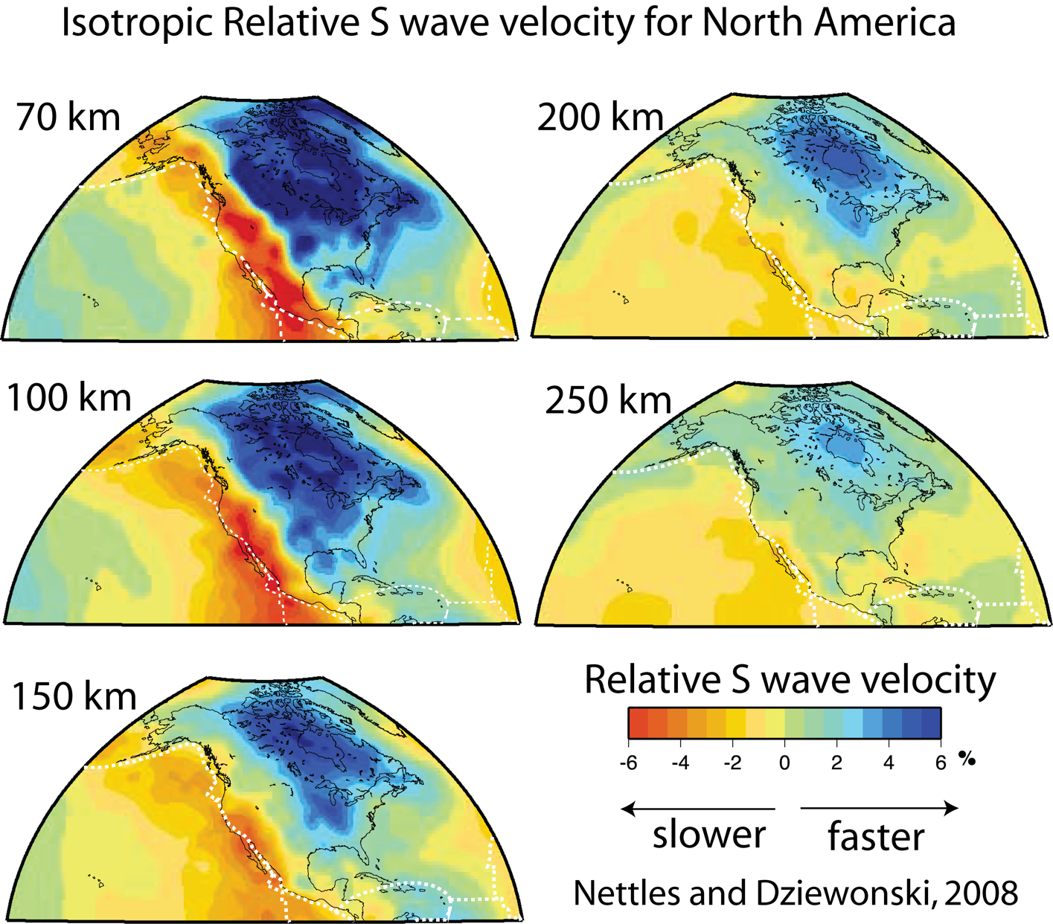

Figure 11. S-wave velocity structure beneath North America sliced through the Earth at 70 km, 100 km, 150 km, 200 km, and 250 km depth through the Earth. Plate boundaries around North America are plotted as white dashed lines on the tomographic slices.
5. If S waves travel faster through high viscosity material, and slowly through lower viscosity material, where in North America do you find the thickest lithosphere?
▶▶▶▶a. Northeastern North America
b. Southeastern North America
c. Southwestern North America
d. Northwestern North America

6. Where in North America is the thinnest lithosphere?
a. Northeastern North America
b. Southeastern North America
▶▶▶▶c. Southwestern North America
d. Northwestern North America

7. Plate boundaries are shown as white dashed lines on Figure 11. How does lithospheric thickness correlate with the location of the active plate boundaries? Why do you think this might be the case?

The lithosphere in this cross section is thinnest near the plate boundary, especially in Southern CA and the Baja Peninsula. This is because this boundary includes a number of spreading centers where new lithosphere is being formed. The deepest lithosphere is found far from the plate boundaries where the lithosphere is the oldest and coldest.

8. Describe Earth’s internal structure (layers of different material properties and composition) and summarize how this is inferred through the analysis of seismic data. How is this the same or different from your answers to questions 1 and 2 of Part I at the beginning of the lab?

Patterns in seismic wave velocities can tell us a lot about Earth’s interior structure. From P-wave arrivals we can detect and measure Earth’s core. From global S-wave arrivals, or more specifically, the lack of S wave arrivals beyond 104 degrees away from an epicenter we can infer that the outer portion of the core is a liquid. Finally we can also image the boundary between the lithosphere and asthenosphere. This can be mapped by studying the velocity of S-waves traveling through the region. Such studies reveal a boundary that has significantly more topography and lateral variation than commonly shown in textbooks.

Students should be able to reflect on what they have learned about Earth structure and its determination using seismic data.

9. In this lab, we have analyzed Earth structure in terms of crust/mantle/core and also lithosphere/asthenosphere. Based on the activities in the lab, and any other knowledge you have of Earth structure, what is the difference in these 2 ways of describing Earth structure? Why are both descriptions useful?

One highlights chemical differences (crust/mantle) and different states of matter (mantle/outer core) and the other is a change in material properties from solid to more viscous behavior. Both are useful depending on what features of the Earth system are being examined. When describing plate motions or the mechanical strength of the plates, it can be more useful to consider the lithosphere/asthenosphere, whereas crust and mantle are better descriptors when considering compositional differences, such as places where a piece of ancient crust/mantle boundary has been brought to the surface.

