Static GPS/GNSS Survey Methods Manual
Ian Lauer (Idaho State University)
This document is a practical guide to field methods for static positioning systems. It does not cover positioning computation or theory, but is focused on field-based application of survey systems. This guide is intended for both instructors and students in its current form and may include asides of technical material targeted toward advanced users.
Table of Contents
Note on GNSS and GPS Terminology 1
1. Introduction to Static GPS/GNSS 2
1.1 Rapid Static Survey 2
1.2 Static Surveys 4
1.3 Continuous Surveys (Semi-permanent to Permanent Stations) 4
2. Equipment 4
2.1 Antennas 4
2.2 Receivers 5
2.3 Power and Batteries 5
2.4 Data Management, Storage, and Initial Settings 6
2.5 Tripods, Monuments, and Distance Measurement 7
3. Field Workflow: General 7
3.1 Site Analysis 7
3.2 Preparation and Logistics 8
4. Static Field Setup 8
5. Data Processing 11
5.1 Data downloading and backup 11
5.2 Data formats 11
5.3 Data processing 12
5.4 Data archiving and data access 14

Note on GNSS and GPS Terminology
GPS or GPS/GNSS will be simplified to GNSS herein. GPS, Global Positioning System, is the most commonly used system in the United States but is being complemented by a growing number of systems from international organizations. GNSS, Global Navigation Satellite Systems, refers to the various active satellite constellations including GPS (USA), GLONASS (Russia), Galileo (EU), BeiDou (China), and others.

1. Introduction to Static GPS/GNSS
Static GNSS surveys deliver the highest-accuracy positions available in a system, which occupies a point for longer periods of time than kinematic systems. Static systems include a range of survey styles from rapid static surveys to continuously operating stations, such as CORS and NOTA sites. The equipment setup varies significantly, depending on how long the site will be operational, which could vary from 15 minutes to several years. For the practicality of this field module, instructional material will focus on surveys ranging from rapid static to semi-permanent installations. Continuously operating permanent stations require many of the same techniques as other static systems, but require a level of precision and detail in their installation and processing that is beyond the level of this course.
Static surveys rely on long occupation times to produce high-accuracy positions, and the details of their setup will vary to reflect the quality of measurements required. A static survey typically consists of a single receiver and antenna combination, which individually records satellite observations that are post-processed using a variety of techniques to receive a position. The precision of the position is a function of the length of survey and also the precision of the mounting and monument system used. Static surveys require much more stable and precise mounts than kinematic surveys. A typical mounting system ranges from a range pole and bipod for rapid static occupations to anchored rods with direct antenna mounts for permanent surveys.

1.1 Rapid Static Survey
Rapid static surveys use shorter occupation times to collect a moderate number of points. They do this by occupying a given point for a longer period of time than most kinematic surveys but much less than regular static surveys (Section 1.2 below); typically, rapid static surveys are 15 minutes to 2 hours. A static survey is advantageous due to the simplicity of its setup, using a single antenna and receiver combination that has half as many components as a kinematic setup. This configuration is also necessary when radio communications or baseline distances for a survey exceed the capability of a kinematic design. However, static surveys typically have reduced accuracy compared to a kinematic survey of the same occupation time. Rapid static surveys also rely on proximity and availability of CORS or IGS stations for positional corrections. A map of the US with coded potential quality of CORS corrections can be found on the OPUS page https://www.ngs.noaa.gov/OPUSI/Plots/Gmap/OPUSRS_sigmap.shtml.
Rapid static surveys are typically conducted by surveying monument locations and then post-processing positions in the lab. First, monuments are established for any point, which will be reoccupied, such as measuring change or movement. Then the antenna is placed over the monument using a stable mount. The antenna records for the necessary occupation time and is then removed and taken to the next point of the survey. When the survey is complete, data is downloaded from the receivers, transformed into a RINEX file, and processed using proprietary software or a service such as OPUS (Online Positioning User Service). Processing through OPUS follows a similar style to PPK (post-processed kinematic) surveys such as in High-Precision Positioning with Static and Kinematic GPS/GNSS, Unit 2: Kinematic GPS/GNSS Methods (https://serc.carleton.edu/getsi/teaching_materials/high-precision/index.html).

Table 1. Advantages and disadvantages of different types of GNSS surveys
Survey Type | Advantages | Disadvantages
Real-time kinematic (RTK) | Real-time corrected positions in a known coordinate plane. Able to navigate to and compute geometries of data points in the field | Significantly increased equipment cost and logistics. Must have radio connection between base and rover. Must set up base on a known position to use advantages
Post-processing kinematic (PPK) | Reduced logistics, cost, and complications. Sufficient for most nonengineering-type surveys | Corrected data is typically not available until processed. Necessary to set up base at benchmark or fix its location later
Rapid Static | Reduced equipment expense and complication compared to PPK. Local base stations not necessary | Requires longer occupation times up to 2 hours, with fewer potential measurements. Lower accuracy than RTK or PPK
Static | Higher precision than rapid static, less equipment than RTK or PPK | Requires long occupation times to reach similar accuracy to RTK or PPK. Requires more precise mounting and metadata collection than RTK, PPK, and rapid static
Continuous | Highest possible precision and accuracy (mm) | Requires complex infrastructure, precision mounting, and very long occupation times.

Figure 1. An example of a rapid static survey. The antenna is mounted on a bipod centered over a monument pin in the ground. This allows the antenna to remain stable over the occupation time (15 min in this case). Antenna mounts depend on the stability of the survey needed, with tripod, tribrach, and fixed mounts in ascending levels of stability. (Photo: Ian Lauer)

1.2 Static Surveys
Static surveys offer the second highest precision of static surveys by occupying a single location for occupation times ranging from 2 to 48 hours. When processed through OPUS, static surveys have a maximum accuracy of ~1–2 cm, depending on the quality and length of data collection. This is most comparable to accuracies achievable by PPK systems with long baselines, but in general PPK surveys are recommended if a local base station with short baseline is possible.
Static surveys are conducted and processed in the same way as a rapid static survey, but typically use higher-precision mounts and more equipment, such as large batteries, solar panels, and equipment enclosures to support the GNSS receivers during the length of the survey. The amount of equipment needed increases with increased occupation times. See Section 2.3 for advice on batteries and length of surveys with some known hardware configurations.

1.3 Continuous Surveys (Semi-permanent to Permanent Stations)
Semi-permanent to permanent surveys involve extended deployment of a station beyond 48 hours and potentially for many years. The advantage of a permanent survey is continuous data collection, which enables high-precision (mm-scale) positioning and the potential for monitoring an area beyond what is practical for a single field deployment. These installations require significant knowledge in geodesy and processing techniques, which are not included in this guide. However, field techniques for site selection, logistics, installation, and execution are similar and can be applied for the whole range of applications. In general, the additional hardware requirements of permanent installations include precision mounting devices, extended battery banks, and solar panels or other auxiliary power charging units.

2. Equipment
Various types and combinations of antennas, receivers, and controllers are available in the modern market and are constantly evolving. Generally, it is easiest to work with antennas and receivers from the same manufacturer, unless other compatibility is specifically mentioned, although the data is completely interchangeable once retrieved and processed. EarthScope-supported projects receive Topcon, Trimble, or Septentrio branded units. Because processing software and workflow is manufacturer dependent, instructions provided here are manufacturer independent. The general workflow should apply to most manufactures, but see manufacturer literature or the GAGE Knowledge Base for specific instructions.

2.1 Antennas
Antennas are the physical equipment that receive the carrier frequency and positioning code from the satellites and transmits it to the receiver for processing (Figure 2). Antennas may consist of just an antenna or include one or more signal-modifying or blocking apparatus, which are aimed at reducing or enhancing multi-path signals and atmospheric distortion. Some modern antennas, such as the Septentrio APS-3 (Figure 2, left), have a combined antenna and receiver unit in one package, sometimes referred to as a smart antenna.
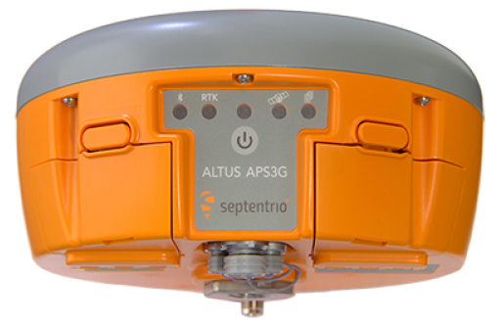
Figure 2. (Left) Septentrio smart Antenna/receiver combination. It is designed to be a self-contained unit for static, PPK, and RTK surveys. (Right) Trimble Zephyr geodetic antenna mounted on a tribrach and connected to an external receiver via a port on the bottom the antenna. (EarthScope)

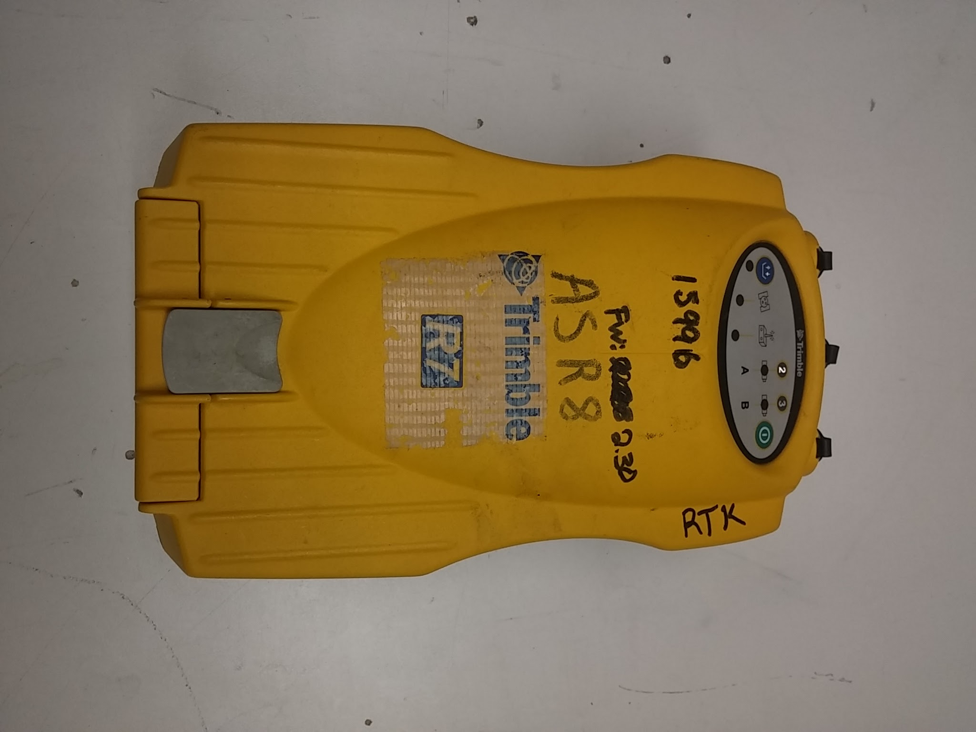
2.2 Receivers
Receivers are the central processing units of the GNSS system (Figure 3). They connect the various other hardware including antennas, radios, and power. They receive signals from the antenna and compare the satellite and receiver time codes to calculate distance between them. This time differential is fed into a complex code for determining position based on at least 4 satellite signals. Positional data may be stored in various formats, most of which are proprietary for each manufacturer. The receiver is responsible for sending the position data to the controller computer for user viewing and for taking user input and executing the commands.

2.3 Power and Batteries
Receivers, antennas, and controllers use both internal and external batteries for power. Average running time for batteries depends on manufacturer design but typically last 4–10 hours for internal setups, with external setups limited only by ability to transport larger batteries to the site (Table 1). Battery technology will depend on environmental conditions. Gel cell and LiPo batteries have the advantage of being environmentally stable and spillproof. Battery estimates need to be made based on power draw of the equipment. A simple formula for estimating battery consumption is
Figure 3. A Trimble R7 receiver commonly used at EarthScope. Receiver designs vary with manufacturer. (EarthScope)
Total Amperage (Volt*Watts) * Total Operational Time (hours) = Battery Capacity (Amp/Hrs)
Capacity should be overestimated to account for logistical oversight or complications, keeping in mind battery capacity is reduced over time with use. Power can also be supplemented by many means including solar, wind, or other power sources as demanded by the site. For more information on alternative power, see the EarthScope Resources: Power page on the Knowledge Base. http://kb.unavco.org/article/unavco-resources-power-524.html

Table 2. EarthScope Campaign GPS GNSS Handbook, Receiver Power Consumption
Receiver | Power draw (approximate)* | Lifetime w/ a 12 V, 18 Ah battery*
Trimble NetRS | 3.5 W | 2.25 days
Trimble 5700 or R7 | 3–4 W | 2–2.5 days
Topcon GB1000 | 4 W | 1.9 days
Septentrio APS3G | 4 W | ~1.5–2 days
*For information on power options available from and testing performed by EarthScope, see http://kb.unavco.org/category/gnss-and-related-equipment/power/93/.

2.4 Data Management, Storage, and Initial Settings
Data management is a small but critical step in the survey design. It is ineffective to have a well-designed survey only to find out you have run out of storage space, lost the data, or collected improper occupation lengths for the precision needed. Each unit has a unique set of capabilities and limitations (Table 2). Consider the following:
- File length – do you want the receiver to bin the data into files of a fixed time window?
- Sample rate – how often do you want the receiver to collect data? The base station (fast static and kinematic surveys) must collect data at least as often as the rover(s). A kinematic rover will typically collect 1 sample/second for a total occupation at each site of 5–15 seconds.
- Elevation cutoff angle – data coming from low-elevation satellites is often noisy because of the atmosphere; below what elevation do you want the receiver to discard, rather than store, the data? Note that this data can also be discarded during processing. A typical value is 5–10°
- Storage Capacity – There must be enough free memory in the receiver for the desired survey. Whereas memory is an issue with older receivers, the later generation receivers have large amounts of data storage. File size is dependent on manufacturer file formatting. Note the Topcon collects half as much data at a 30-second sample rate (versus 15-second on Trimble), but produces a larger file. Upgraded storage space is relatively cheap and easy to acquire.
Table 3. Typical parameters for different survey styles (file lengths, sample rates, and elevation cutoffs)
Survey style | File length | Sample rate | Occupation time | Elevation cutoff angle
Continuous | 24 hr | 30 seconds | Continuous | 0-10 degrees
Static | 2+ hr | 30 seconds | 2+ hours | 0-10 degrees
Rapid Static | none | 15 seconds | 5+ minutes | 0-10 degrees
Kinematic | none | 1–15 seconds | 5+ seconds | 0-10 degrees

Table 4. Potential maximum survey length for specific equipment and parameters (available memory, sample rate, elevation cutoff).
Receiver * | Memory (Typical) | Sample rate | Elevation cutoff angle | Potential Survey length
Trimble 5700 or R7 | 128 Mb | 15 seconds | 5 degrees | ~90 Days
Trimble NetRS | 1 Gb | 15 seconds | 5 degrees | ~2 Years
Topcon GB-1000 | 1 Gb | 30 seconds | 5 degrees | ~140 Days
Septentrio APS-3G | 2 Gb | 15 seconds | 10 degrees | ~100 Days
*For information (specifications, how-tos, dealer information) on receivers available from EarthScope, see http://kb.unavco.org/article/unavco-resources-campaign-and-kinematic-gps-gnss-390.html.

2.5 Tripods, Monuments, and Distance Measurement
Details on this equipment can be found in the GETSI GPS/GNSS Antenna Mounts Guide. Basic equipment could include a bipod, tripod, or spike mount for static or rapid-static surveys. For repeatable surveys, some kind of permanent benchmark or monument will need to be located or established such as a NGS survey marker, pin, or threaded rod mounted in an appropriately stable surface. A collapsing measuring stick, engineer’s tape, or other measuring device appropriate for your setup is necessary for metadata collection, especially for establishing antenna height. See the GETSI GPS/GNSS Antenna Mounts Guide for more information.

3. Field Workflow: General

3.1 Site Analysis
Initial site analysis is integral to good survey design and subsequent successful data collection. Anticipating and compensating for good sky coverage, line of sight, and multi-path issues will significantly increase your success (Figure 4). The largest inhibitors to good surveys are overhead or high-standing structures such as trees, buildings, canyon walls, and other objects that can limit sky view, obstruct signals, and create multi-path signal error. Strategies for overcoming these obstructions include placing stations away from the study area in a position that best limits obstructions to the sky.
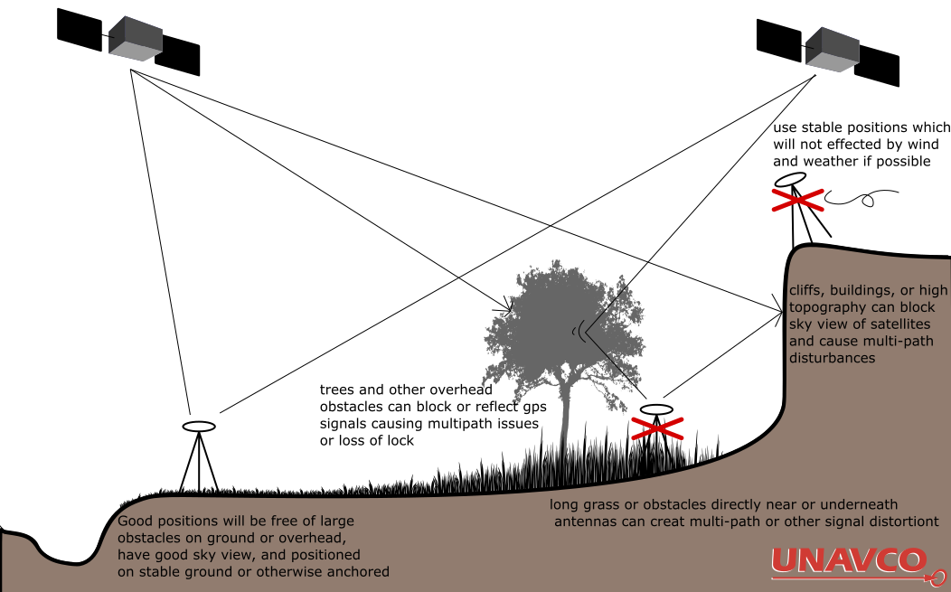
Figure 4. Schematic diagram of GPS station location considerations. (EarthScope)

3.2 Preparation and Logistics
- Calculate power needs for equipment. Charge and test batteries.
- Locate memory devices (typically SD cards) and verify sufficient storage is available.
- If unfamiliar with equipment, do a complete test setup and verify connectivity between equipment before leaving for the field or be prepared to troubleshoot later.
- Do reconnaissance of the field area. Topographic maps, Google Earth Imagery, or a pre-trip to the area can significantly improve success on your field day.
- With reconnaissance knowledge, plan the base sites, data points, and paths to navigate the field site. A good plan will reduce time spent in the field later. Anticipate the number of points to be collected and time associated with the plan.
- Pack all equipment using a checklist.

4. Static Field Setup
This section outlines the general steps in a static survey (Figure 5). This outline was developed based on Trimble hardware, but should translate to other manufacturers. See manufacturer manuals for alternative instructions and additional information in the EarthScope Knowledge Base (http://kb.unavco.org/), specifically EarthScope Resources: Campaign and Kinematic GPS/GNSS (http://kb.unavco.org/article/unavco-resources-campaign-and-kinematic-gps-gnss-390.html).
- Locate the benchmark, monument, or landmark to be measured. Alternatively, establish a new monument, using best practices in EarthScope Resources: GNSS Station Monumentation (http://kb.unavco.org/article/unavco-resources-gnss-station-monumentation-104.html).
- Whenever you establish or reoccupy a campaign monument is absolutely essential to thoroughly record a monument log (http://kb.unavco.org/article/campaign-monument-log-sheet-62.html).
- Set up the tripod, spike mount, or another mount on top of the benchmark. See the GETSI GPS/GNSS Antenna Mounts Guide or for the “EarthScope” method of leveling tripods and spike mounts, see the EarthScope GNSS Antenna Mounts (http://kb.unavco.org/category/gnss-and-related-equipment/gnss-antenna-mounts/23/).
- Center tripod or spike mount over the benchmark and level the antenna mount
- Anchor legs so they will not move throughout the survey.
- Attach antenna to the top of the mounting system.
- Connect all appropriate cables. The antenna will connect to the receiver with the battery being connected last. Connect the battery last to avoid unrecognized equipment.
- Measure and record slant height or antenna height to phase center as appropriate.
- To measure slant height, place measuring stick or tape on center of benchmark and measure to the outer edge of the antenna where phase center is located (as found in manuals). Measure in at least three locations around antenna. Measurements should be equal if the tripod is level, +/- 0.5cm. If not, re-level system before recording data. Do not move the tripod after leveling is completed or while data is being collected. Doing so will affect the precision of positioning.
- Record general site observations, location, times, and configurations in a field book (ex. http://kb.unavco.org/article/logsheets-and-field-notes-72.html).
- Power on the receiver and set the occupation time, sampling rate, antenna height, and elevation mask.
- Some receivers automatically begin logging data when powered on, others require a prompt. If necessary, start data collection.

When you have completed surveys of all points continue below.
- Stop data collection on the receiver or controller.
- Verify there is a saved file with the correct date, time, and duration of your survey.
- Before moving anything on the base station, check the slant height of the antenna and record it in your field book. It should not have moved.
- Verify that the tripod is still level and centered over the benchmark or landmark. If not record this with any observations or measurements as to how it moved.
- If a field laptop is available, remove the memory card from both rover and base station receivers and back up data files to an external device for redundancy.
- Pack all equipment using the checklist.
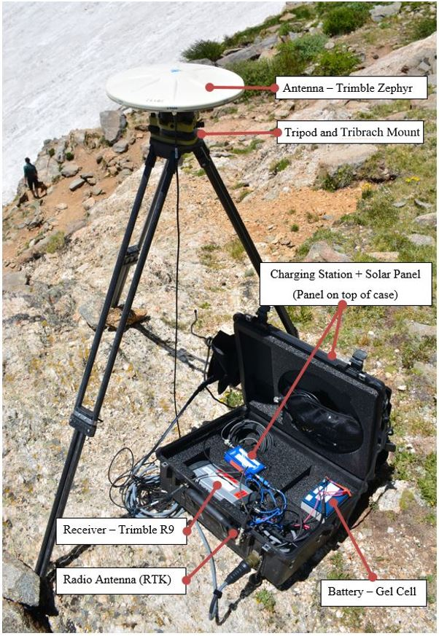
Figure 5. A typical EarthScope GNSS base station. Trimble R7 receiver, radio, and battery stored in waterproof case with flexible solar charging kit on top. The case is closed during normal operation for weatherproofing and security. The case was modified by adding cable pass-throughs to all equipment. (Ian Lauer)

5. Data Processing

5.1 Data downloading and backup
(Adapted from the EarthScope GPS/GNSS Survey Guide)
Data collected with geodetic GNSS receivers must be downloaded as soon after data collection as possible to free up receiver memory (if needed) and to back up the data. As a field precaution, a duplicate copy of the data should be made as soon as it is downloaded from the receiver. Data are typically downloaded to a laptop computer; to download a receiver, manufacturer-specific download software and procedures are usually required.
Downloading instructions depend on the equipment (receiver and/or survey controller) being used; see http://kb.unavco.org/category/gnss-and-related-equipment/2/.
Considerable expense goes into collecting geodetic quality GNSS data, and the data should always be backed up as soon as possible to safeguard against loss, destruction, or corrupted media. While the data backup strategy may vary, there should always be at least two independent copies of all GNSS data until it is confirmed that the data have been safeguarded in a data archive such as EarthScope’s. Options for data storage prior to final archiving include DVDs, PC memory cards, USB drives, computer hard drives, and the GNSS receiver memory. Before deleting any files from a GNSS receiver, make sure they are adequately backed up elsewhere! A good practice is to keep copies of the data in separate locations and with different people.

5.2 Data formats
GNSS receivers generally collect and store the raw GNSS data in a proprietary format, which may need to be translated into a different format for data processing or data sharing. Later generation Trimble GNSS receivers (5700, R7, NetRS) collect data in .T01 files, a format that must be translated to be read into Trimble’s processing software, Trimble Geomatics Office (TGO). These data are automatically translated to .DAT files, a Trimble format that can be read by TGO, when downloaded via the Trimble Data Transfer Utility. The Topcon GB-1000 collects data in a .tps file.
RINEX (Receiver Independent Exchange Format) is the ubiquitously accepted data format for raw GNSS data. Reference site data is generally provided in RINEX. RINEX is read by most processing software, including Trimble Geomatics Office and Topcon Tools, and also more sophisticated processing software like Bernese, GAMIT, and GIPSY. Almost any raw high-precision GNSS data can be converted to RINEX using TEQC. TEQC (pronounced “tek”) is a simple yet powerful and unified approach to solving many pre-processing problems with GNSS, GLONASS, and SBAS data. The three main functions from which TECQ gets its name—translation, editing, and quality check—may be performed altogether, in pairs, or separately. You can download TECQ for free at: https://www.unavco.org/software/data-processing/teqc/teqc.html.
While most raw data are stored as binary files, RINEX is in an ascii format and can therefore be viewed in a text editor. An example of a RINEX file is given below (Figure 6), and illustrates the information contained in raw GNSS data files.

5.3 Data processing

2.10 OBSERVATION DATA G (GPS) RINEX VERSION / TYPE
teqc 2004Oct27 UNAVCO Archive Ops 20041028 19:19:00UTCPGM / RUN BY / DATE
Solaris 2.7|Ultra 2|cc SC5.0|=+|*Sparc COMMENT
BIT 2 OF LLI FLAGS DATA COLLECTED UNDER A/S CONDITION COMMENT
P020 MARKER NAME
MARKER NUMBER
Mike Jackson UNAVCO OBSERVER / AGENCY
4413233095 TRIMBLE NETRS 0.7-0 REC # / TYPE / VERS
0220330167 TRM29659.00 SCIT ANT # / TYPE
-2083774.1380 -3827351.0369 4642283.4316 APPROX POSITION XYZ
0.0083 0.0000 0.0000 ANTENNA: DELTA H/E/N
1 1 WAVELENGTH FACT L1/2
6 L1 L2 C1 P2 S1 S2 # / TYPES OF OBSERV
15.0000 INTERVAL
RINEX file created by UNAVCO GPS Archive. COMMENT
For more information contact archive@unavco.org COMMENT
Monument ID: 00000000-18321-2004a COMMENT
UNAVCO 4-char name: P020 COMMENT
4-char name from Log or data file: P020 COMMENT
Monument location: 47.002209 -118.565769 480.1383 COMMENT
Visit ID: 76927 COMMENT
COMMENT
WSU_Dryland_Research_Station_Lind_WA_2004_CGPS COMMENT
COMMENT
End of DB comments COMMENT
SNR is mapped to RINEX snr flag value [0-9] COMMENT
L1 & L2: 2-19 dBHz = 1, 20-27 dBHz = 2, 28-31 dBHz = 3 COMMENT
32-35 dBHz = 4, 36-38 dBHz = 5, 39-41 dBHz = 6 COMMENT
42-44 dBHz = 7, 45-48 dBHz = 8, >= 49 dBHz = 9 COMMENT
2004 6 17 0 0 15.0000000 GPS TIME OF FIRST OBS
END OF HEADER
04 6 17 0 0 15.0000000 0 8G 1G 4G25G11G13G16G30G20
-3009032.38359 -2334639.62958 20726832.8364 20726820.9734
53.7504 46.0004
-3692368.30957 -2871796.35252 23958733.3914 23958722.8164
43.0004 22.2504
8468383.67659 6575277.72356 22094150.9694 22094139.1054
51.0004 40.0004
11821613.29356 9184820.42652 24814845.6094 24814834.4494
39.7504 21.2504
-6586713.07057 -5464689.84452 23734383.6954 23734372.0084
43.5004 25.2504
-7043354.68058 -5468882.80555 22454713.5394 22454701.2664
48.5004 36.7504
9647017.67655 7491528.96151 25227887.4304 25227876.7384
37.0004 14.7504
265471.93859 207372.30558 20246338.1564 20246325.4734
52.7504 48.0004
04 6 17 0 0 30.0000000 0 8G 1G 4G25G11G13G16G30G20
-3017172.37149 -2340982.47348 20725283.8594 20725271.8794
53.7504 46.0004
-3697743.72746 -2875984.98442 23957710.2814 23957700.3524
41.0004 23.5004
8517694.52749 6613701.75046 22103534.3524 22103522.6054
51.0004 39.7504
11881161.02046 9231221.22742 24826176.9454 24826165.9614
39.5004 21.2504
-6619885.39547 -5490538.40242 23728071.8204 23728059.6054
43.5004 27.2504
-7070702.28149 -5490192.60545 22449509.7424 22449497.2344
49.2504 37.2504
9704628.90245 7536420.81341 25238849.7894 25238839.7424
38.0004 17.7504
280861.96149 219364.52348 20249266.8444 20249253.9264

Figure 6. A sample RINEX file. (EarthScope)
GNSS data collected for high-precision applications must be post-processed to provide millimeter- to meter-level precision. Typically, the post-processing involves differential processing relative to a fixed base location. For static surveys this is usually a CORS or IGS site in close proximity to the study area. OPUS provides availability maps in the US for CORS corrections.
Post-processing the data accomplishes several things. First, there are numerous error sources in GNSS positioning, the most significant of which are:
- Receiver and satellite clock errors,
- Delay of the GNSS signal through the Earth’s atmosphere (most significantly, the ionosphere and the troposphere),
- Use of imprecise satellite orbits, and
- Multi-path (multiple signal arrivals resulting from the signal bouncing off nearby objects or the ground).
Many of these errors can be greatly minimized or eliminated in post-processing by using data from at least two receivers with at least four satellites in common.

Data Processing Workflow:
- Import data from receivers and open base station and rover positions into your hardware-specific processing program (ex. Trimble Business Center for Trimble receivers). Set the antenna heights, equipment models, etc. during importing if this was not done in the field. Double-check these values.
- Export the data for your base station as a RINEX file. This can be done in TEQC (https://www.unavco.org/software/data-processing/teqc/teqc.html) or a proprietary software.
- Upload the RINEX file for your base stations through an appropriate precision processing program (such as OPUS for surveys in the US) You will receive a file with the corrected base position from OPUS.
- Correct your base and rover positions in your hardware-specific processing software (i.e. Trimble Business Center).
- Enter the corrected base station coordinates. Skip this step if you are processing in the field for a quality-assurance check (Not as precise, but ok for QA).
- Create baselines from base station to rover positions. Visually inspect reasonable distances and spatial relationships from rover to base station.
- Process baselines to correct for sources of error and receive new positions.
- Transform and Project data if necessary
- Export your data in the appropriate format for further analysis and processing

Different processing programs can serve different surveying needs. The following summarizes some of the options.
To obtain a position to within several cm of a static point where a very accurate position is not needed, several online services are available:
- OPUS - http://www.ngs.noaa.gov/OPUS/
- A data file of at least two hours is recommended. Data files may be uploaded directly to site. It sometimes improves processing if you wait 1–2 days before processing.
- CSRS-PPP - http://www.geod.nrcan.gc.ca/products-produits/ppp_e.php
- Canadian Spatial Reference System – Precise Point Positioning (CSRS-PPP) is a flexible service that offers both static and kinematic data processing. Access to the database is free but requires a username and password. Data files may be uploaded directly to the site.
- AusPos - http://www.ga.gov.au/geodesy/sgc/wwwgps/
- Australia. Data files may be uploaded directly to the site.
- APPS - http://apps.gdgps.net/
- A JPL service that replaces AutoGIPSY. Data files may be uploaded directly to the site.
For cm-level static or kinematic surveys with short (ideally < 10 km) baselines, commercially available software (e.g. Trimble Geomatics Office [TGO], Topcon Tools) is often adequate. See http://kb.unavco.org/article/trimble-geomatics-office-how-to-process-fast-static-and-post-processing-kinematic-surveys-using-tgo-613.html for a how-to on TGO.

Additional helpful processing resources include the following:
Several organizations provide precise satellite orbital information, which is calculated daily and available with a two-week delay. The application of this information (rather than the orbital information broadcast by the satellites) can improve precision of ground coordinate solutions. Examples of places to find precise orbital information, generally available in files appended .SP3, are:
- SOPAC - http://sopac.ucsd.edu/
- IGS - http://www.igs.org/
- NIMA EGM96 Geoid Calculator, to calculate the geoid-ellipsoid separation at any given point: http://earth-info.nga.mil/GandG/wgs84/gravitymod/egm96/intpt.html
- NGS Reference Frame Transformation, to translate coordinates from one reference frame to another: https://www.ngs.noaa.gov/NCAT/
Also, see the section on Reference Stations for links to data from continuous GNSS sites.

5.4 Data archiving and data access
As a service to the geodetic community, the EarthScope Archive manages, stores, and provides access to high-precision GNSS geodetic data. The archive will also accept non-geodetic GNSS data projects (e.g. mapping). The data stored are primarily collected on research projects sponsored by the National Science Foundation (NSF) and National Aeronautics and Space Administration (NASA). Please contribute to the Boulder Facility Archive immediately after campaign completion to best preserve time-sensitive information. Most data must be archived within six months of data collection. See the EarthScope GPS/GNSS Data Policy for more information: http://www.unavco.org/community/policies_forms/DataPolicy.html.
To archive project data, fill out a project support request form if you have not already done so for your project: http://achaia.unavco.org/public/newproject/supportform.aspx.
Prepare legible copies of site descriptions and log sheets (e.g. Monument Record forms [http://kb.unavco.org/assets/63/monument.pdf] and Site Visit Log sheets [http://kb.unavco.org/article/campaign-monument-log-sheet-62.html]) and any other pertinent material (photos etc.) to accompany data. At the very least, the archive needs the site name, antenna height, antenna height measurement method (e.g., slant), antenna mount type, and antenna and receiver models and serial numbers; this is the minimum information needed to meaningfully process the GNSS data.
Data should be submitted in raw format if possible. Data may additionally be submitted in a translated format.
Coordinate submissions with the EarthScope Data Management and Archiving Group: archive@earthscope.org. Submissions can be mailed/shipped or dropped off via ftp (preferred) for the archive. For more details, look up Submissions on the EarthScope GSP/GNSS Data Archive page: http://www.unavco.org/data/data-help/submission/submission.html.

If submitting data and metadata (accompanying information) via ftp, a directory will be assigned to you.
To access both campaign and permanent station data, check out our interactive Data Archive Interface, the DAI2 (Figure 7): http://www.unavco.org/community/policies_forms/DataPolicy.html.
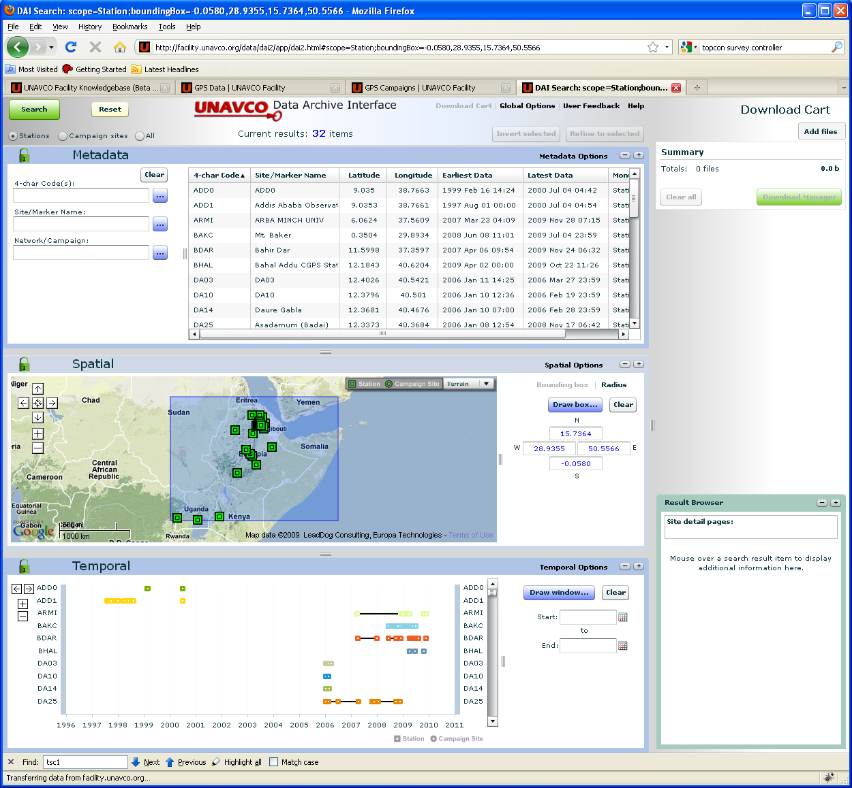
Search for data by station name, marker name, campaign name, or geographical region. For a brief tutorial, see the Help feature at the top of the page (you may have to widen your browser window to see the Help option).
Figure 7. Screenshot of the DAI2, EarthScope’s Data Archive Interface.

