Table 2
Homework questions for which documented problem solving was required and the Final Exam question used for comparison, by chapter

Chapter 3 - Supply and Demand: Theory

Homework: Use the information below to answer the following question.

Price per Barrel Quantity Demanded Quantity Supplied
$30 120 million 350 million
26 240 320
22 260 260
18 290 190
14 310 130
10 320 100
6 325 80

An increase in price from $18 to $22 will cause:
- An increase in supply by 70 million barrels.
- A decrease in quantity supplied by 70 million barrels.
- An increase in demand by 30 million barrels.
- A decrease in quantity demanded by 30 million barrels.

Final Exam: According to the law of supply, an increase in the price of coffee results in:
- An increase in the supply of coffee.
- A decrease in the quantity demanded of coffee.
- An increase in the quantity supplied of coffee.
- A decrease in the quantity supplied of coffee.

Chapter 4: Macroeconomic Measurements

Homework: In an economy with 100 million people, 64 million hold jobs and 4.7 million are not working but are looking for jobs. The unemployment rate is ______.
- 6.8 percent.
- 13.1 percent.
- 7.3 percent.
- 4.7 percent.

Final Exam: If the number of people classified as unemployed is 12,000 and the number of people classified as employed is 88,000, what is the unemployment rate?
- 13.6%.
- 10%.
- 11%.
- 12%.

Chapter 5: Aggregate Demand and Aggregate Supply

Homework: The economy is in long-run equilibrium whenever AD and SRAS:
- Intersect to the right of Natural Real GDP.
- Intersect to the left of Natural Real GDP.
- Intersect at Natural Real GDP.
- Fail to intersect.

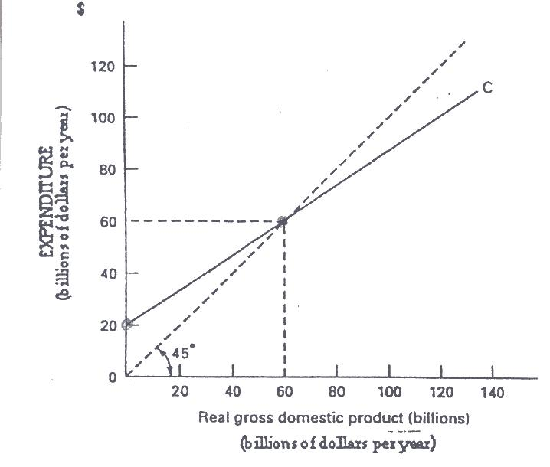
C + I + G + NX

Final Exam: If the natural unemployment rate were $80 billion per year in the figure above, then:
a) There would be an inflationary gap.
b) There would be a recessionary gap.
c) Full-employment income would equal equilibrium income.
d) Saving would equal investment.

Chapter 6: The Self-Regulating Economy

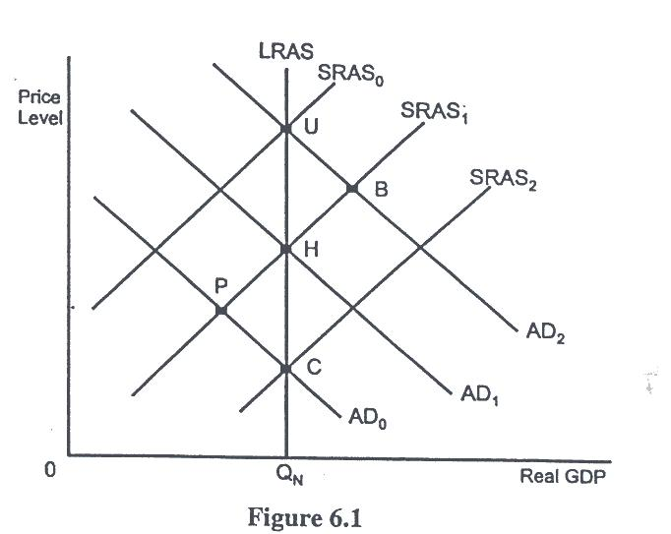

Homework: In the figure above, at what point or points does the unemployment rate exceed the sum of the frictional and structural unemployment rates?
- B.
- B, U, H and C.
- P and C.
- P.

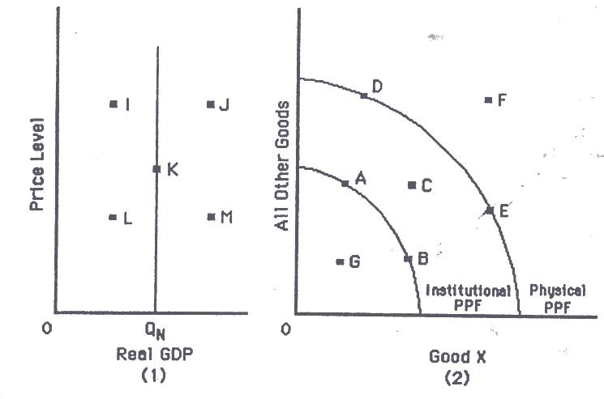

Final Exam: Refer to the figure above. Point B on graph (2) corresponds to which points on graph (1)?
- I or J
- K
- L or M
- I or L
- J or M

Chapter 7: Economic Instability: A Critique of the Self-Regulating Economy

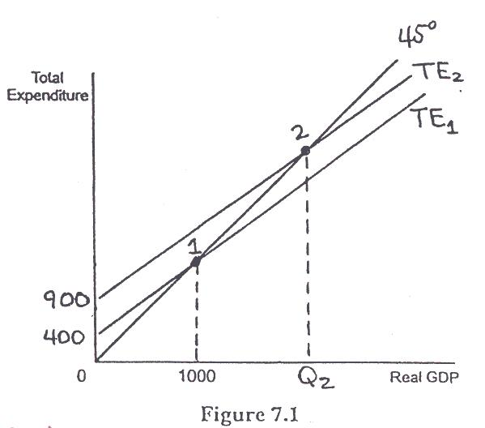

Homework: In the figure above, what is the marginal propensity to consume?
- 400
- 0.4
- 0.6
- 2.5

Final Exam: Which of the following represents the consumption function consistent with the graph in the figure above?
- $20 billion + 0.75Yd.
- $20 billion + 0.67Yd.
- $60 billion + 0.67Yd.
- $60 billion + 0.75Yd.

Chapter 9: Money, the Price Level, and Interest Rates

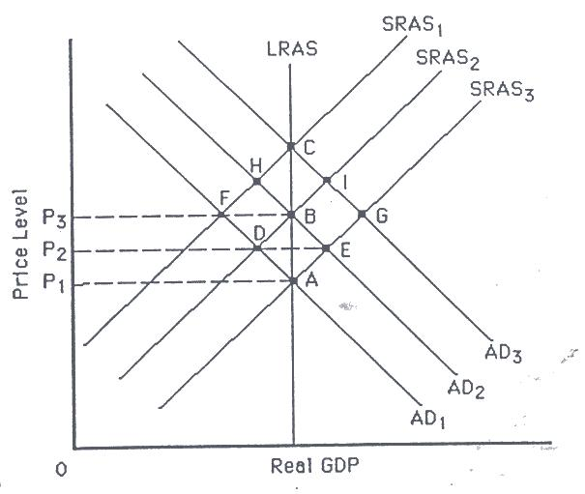

Homework: Refer to the figure above. Starting from point A, a one-shot, demand-side induced inflation raises the price level in the economy to P2. Assuming no other changes, the economy is likely to settle at point:
- A.
- B.
- C.
- D.
- E.

Final Exam: Inflation is:
- A decrease in the overall level of economic activity.
- A decrease in the overall price level.
- An increase in the overall level of economic activity.
- An increase in the overall price level.

