Biology 123 – Living Systems: Global Concepts, Local Connections

Syllabus - Fall 2010


Course Description: Students construct comprehensive understandings of the living world, interconnecting foundational principles about genes, cells, physiology, ecology, and evolution to each other and to contemporary scientific, societal, ethical, and religious issues. Biology is taught in the course as it is practiced, as a process of creative and critical inquiry. Contemporary problems set the context for laboratory activities, studies and discussions that facilitate investigating, thinking, and applying. Three two-hour sessions weekly.

Key Learning Goals:
- Learn how to maximize one’s effectiveness as a learner and take responsibility for doing so.
- Hone creative, critical, practical and computational thinking skills that are essential in biology.
- Learn how to apply biology skills and concepts to help resolve complex, real-world problems.
- Integrate scientific perspectives to inform one’s personal worldview.
- Recognize biology as a communal process of analyzing and interpreting the living world; exercise virtues (diligence, honesty, humility, patience, etc.) necessary to sustain communal learning.

Required Books:
- Meadows, Donella. Thinking in Systems. White River Junction, VT: Chelsea Green Publishing, 2008 (ISBN 9781603580557). This book is the primary text for unit #1.
- Barnosky, Anthony D. Heatstroke: Nature in an Age of Global Warming. Washington, DC: Island Press, 2009 (ISBN 9781597261975). This book is the primary text for unit #2.
- Pollan, Michael. In Defense of Food: An Eater’s Manifesto. New York: Penguin Press, 2008 (ISBN 9780143114963). This book is the primary text for unit #3.
- Snyder Sachs, Jessica. Good Germs, Bad Germs: Health and Survival in a Bacterial World. New York: Hill and Wang/Macmillan, 2008 (ISBN 9780809016426). This book is the primary text for unit #4.

Learning Environment:
In previous science courses you probably focused on learning terms, facts, and concepts so that you could solve a few example problems and answer test questions. Your teachers probably did most of the work of finding meaning in the material and explaining it to you. The advantage of this approach is that you could “cover” a lot of content. But recent research into how people learn has revealed significant problems with this approach: it tends to promote surface learning (see chart at right) and fails to convey the process and excitement of using science to address complex, real-world problems.
Surface Learning | Deep Learning
Memorizing facts | Looking for meaning
Receiving information passively | Interacting actively in the learning process
Focus on outward signs and formulae needed to solve a problem | Focus on central argument and concepts needed to solve problem
Treating concepts as disconnected ideas | Making connections between concepts
Not recognizing new knowledge as building on previous work | Relating new and previous knowledge
Learning for the test  (short term) | Linking course content to real life (long term)

Lately, a reform movement has begun to alter the way science is taught at the undergraduate level, mirroring the best learning-by-doing practices of top graduate and medical schools. This course reflects one of these best practices: using complex, real-world problems as the context in which to learn scientific concepts, their interconnections, and their applications. This approach involves asking and refining questions, finding and weighing evidence, evaluating likely interpretations, and building consensus conclusions. It is a dynamic interactive process that conveys some of what makes “doing science” so exciting and so important in today’s world. We hope it will also inspire a deeper sense of calling.

Class Policies:
This type of learning entails a different set of responsibilities. It is collaborative, requiring the same kind of teamwork you will find in your professional career. For you to succeed, it is crucial that you:
- Be fully prepared to actively participate. Attend all classes and team meetings on time. Promptly notify all affected parties whenever you cannot attend for whatever reason.
- Exercise good time management. Keep up with all out-of-class learning activities. Unless you have my prior consent, late work will typically be deducted 20% per day.
- Actively contribute questions, insights, and perspectives. Make the most of each learning opportunity by contributing to class discussions, investigations, and team deliberations.
- Communicate learning concerns to your instructor in a timely way. ASAP bring to the attention of your instructor all communication concerns, allegations of prejudice, behavioral problems, and other matters that may undermine your ability to effectively learn in this course.
Attendance: Attendance in class is expected. A significant portion of the time spent in class will require active participation on your part, whether as a part of an interactive lecture or group discussion/problem-solving activity. In-class assignments cannot be made up.
Academic Accommodations: Reasonable accommodations will be made for individuals with documented disabilities. Students should notify the Coordinator of Services for Students with Disabilities located in Student Academic Services, HH 455 and notify the instructor within the first two weeks of class.

Grading:
Biology Department Grading Scale
A | 95-100% | C | 73-76%
A- | 90-94% | C- | 70-72%
B+ | 87-89% | D+ | 67-69%
B | 83-86% | D | 63-66%
B- | 80-82% | D- | 60-62%
C+ | 77-79% | F | 0-59%
Formative assessments 5%
In-class assignments 15%
Problem-based learning (PBL) assignments 20%
SALG surveys and teamwork assessments 5%
Reading blog 10%
Tests 30%
Final exam 15%
TOTAL 100%

Tests and Formative Assessments:
Formative assessments will contain short answer questions. Tests and the final exam will contain a blend of multiple choice and short answer/essay questions, focusing on biological concepts and problem-solving. A few of these will involve working in teams. The final exam is cumulative.
Tests and formative assessments must be taken at the scheduled time, except in cases of illness or emergency. In the event of illness, please contact your instructor before class time.

SALG Surveys and Teamwork Assessments:
These on-line surveys are conducted near the beginning, middle, and end of the course. They are meant to gauge students’ assessments of their learning gains with respect to the course goals. Your instructors will not be able to track your answers to you, but they will know whether or not you have completed each SALG. Full credit is given to all who complete each SALG in the allotted time.
Team members and instructors will assess teamwork near the middle and end of the course.

Reading Blog:
Reading is crucial to succeed in Biology 123. Each assigned reading must also be accompanied by a reading blog where you answer questions relating to the reading and your reflections on it. Since the reading blog will be 10% of your grade, you will be held accountable for submitting your blogs. Grading will be as follows:
- On time: full credit
- 1-24 hours late: 50% off
- >24 hours late: no credit

Schedule of Topics, Assigned Readings, and Learning Activities
Biology 123 – Fall 2010

Unit 1 – Learning to Affect Change towards Sustainable Systems
 | Day | Topic | Assigned Reading* | Learning Activities
Learning to become an  Effective Change Agent | 9/8 | Challenges and opportunities to affect change in biology | - “Change agent abilities required to help create a sustainable future” | - Course intro  - Biology at the Five Minute University  - The New Biologists
Learning to become an  Effective Change Agent | 9/10 | Affecting change via collaborative problem-solving | - “Effective interpersonal / intrateam communication”  - “Understanding conflict and conflict management”  - “Effective decision making in teams” | - Formation of teams and team contracts  - Practice PBL: The Geritol solution
Introduction to Systems Theory | 9/13 | Systems and their functions | - Meadows intro & ch 1 | - ICA: Using Cmap Tools and Vensim to model a food web
Introduction to Systems Theory | 9/15 | Systems and us | - Meadows chs 2 & 7 | - PBL: Modeling system relations affecting New Biology challenges
Introduction to Systems Theory | 9/17 | Affecting change within systems | - “Food, livestock production, energy, climate change, and health”
 | 9/20 | Unit summary |  | - PBL presentations and reflections
* Titles in quotes refer to articles posted on KnightVision.
Unit 2 – Biodiversity and Global Climate Change

 | Day | Topic | Assigned Reading | Learning Activities
Biodiversity Conservation and Evolution | 9/22 | Biodiversity | - Wikipedia: biodiversity | - Pre-unit quiz  - Planet Earth excerpts  - Lecture: biodiversity  - ICA: NCEP Interactive
Biodiversity Conservation and Evolution | 9/24 | Evolution | - Wikipedia: evolution  - “Speaking of evolution…” | - Darwin’s Dangerous Idea  - ICA: EvoDots  - ICA: Making sense of the evolution controversy
Biodiversity Conservation and Evolution | 9/27 | Conservation biology | - Wikipedia: conservation biology | - ICA: Conservation and restoration on Calvin’s campus
Biodiversity Conservation and Evolution | 9/29 | GLISTEN Project #1 - Lamberton Lake Fen | - “The good of a flourishing creation” | - Service learning project at Lamberton Lake Fen
Global Climate Change | 10/1 | The Global Climate Change Controversy | - Barnosky Chs 1-2 | - PBL: Analysis of the GCC Controversy
Global Climate Change | 10/4 | GCC Trends and Future Scenarios | - Barnosky Chs 3-4 | - Thin Green Line  - ICA: Trouble in Rocky Mountain National Park
Global Climate Change | 10/6 | GLISTEN Project #2 – Saul Lake Bog | - Barnosky Ch 6 | - Service learning project at Saul Lake Bog
Global Climate Change | 10/8 | Responding to GCC, Part 1 | - Barnosky Chs 10-11  - “Climate care” | - PBL: Climate change and your community – adapt or mitigate? (concept map and systems model)
Global Climate Change | 10/11 | Responding to GCC, Part 2 | - Barnosky Chs 13-14
Summation | 10/13 | Unit summary and review |  | - PBL presentations
Summation | 10/15 | Unit assessment |  | - Unit test  - Mid-term SALG

Unit 3 – Food, Fuel, Health, and Sustainability
 | Day | Topic | Assigned Reading | Learning Activities
Food, Nutrition, and Health | 10/18 | Proteins | - Wikipedia: nutrition  - Pollan Intro | - Pre-unit quiz  - Lecture: proteins  - Guns, Germs, and Steel
Food, Nutrition, and Health | 10/20 | Carbohydrates and fats | - Wikipedia: trans-fat  - Pollan, Part I: Chs 1-2 | - ICA: Food labels  - Lecture: carbs and fats  - King Corn, part 1
Food, Nutrition, and Health | 10/22 | The obesity epidemic | - Wikipedia: metabolism  - Pollan, Part I: Chs 3-5 | - King Corn, part 2  - Lecture: metabolism  - PBL: Should we tax junk foods and drinks?
Food/Fuel Systems and Sustainability | 10/25 | Food-fuel interconnections | - Pollan, Part I: Chs 6-10  - “The greenhouse hamburger” | - ICA: Food miles  - Eating in Place
Food/Fuel Systems and Sustainability | 10/29 | Biofuels | - “Green dreams” | - ICA: Is “food vs fuel” a myth?
Food/Fuel Systems and Sustainability | 11/1 | Agriculture and food sciences | - Pollan, Part II  - US food system factsheet  - “…Also many animals” | - Food Inc.  - ICA: Go green or stay conventional?
Food/Fuel Systems and Sustainability | 11/3 | Real food | - Pollan, Part III: Chs 1-2 | - PBL: Diet for a hot, fat, and crowded world
Food/Fuel Systems and Sustainability | 11/5 | Slow food | - Pollan, Part III: Chs 3-4 | - PBL: Diet for a hot, fat, and crowded world
Summation | 11/8 | Unit summary and review |  | - PBL presentations
Summation | 11/10 | Unit assessment |  | - Unit test

Unit 4 – Public Health and Personalized Medicine
 | Day | Topic | Assigned Reading | Learning Activites
Microbes & Humans | 11/12 | Infectious and inflammatory diseases | - Wikipedia: immune system  - Sachs Prologue, Part 1 | - Pre-unit quiz  - ICA: Infectious disease simulation & case study
Microbes & Humans | 11/15 | Life on/in planet human | - Wikipedia: virus  - Sachs Part 2 | - Outbreak in Asia  - ICA: SIR modeling of infectious disease  - Lecture: What is a virus?
Microbes & Humans | 11/17 | Too clean? | - Wikipedia: bacteria  - Sachs Part 3 | - ICA: Bacteria on antibiotics, part 1  - Lecture: Bacteria and human hosts
Public Health | 11/19 | Bugs on drugs | - Sachs Part 4 | - Lecture: Inflammatory diseases  - ICA: Bacteria on antibiotics, part 2
Public Health | 11/22 | Beyond lethal force | - Sachs Part 6 | - ICA: Bacteria on antibiotics, part 3  - PBL: Controlling hospital outbreaks
Personalized Predictive & Regenerative Medicine | 11/24 | Principles of genetics | - Wikipedia: introduction to genetics  - Wikipedia: meiosis | - ICA: Bacteria on antibiotics, part 4  - Lecture: genetics and meiosis
Personalized Predictive & Regenerative Medicine | 11/29 | Personal genomics and predictive medicine | - Wikipedia: predictive medicine  - Wikipedia: personal genomics | - ICA: Bacteria on antibiotics, part 5  - Faces of America, #4: “Know thyself”
Personalized Predictive & Regenerative Medicine | 12/1 | Stem cells and regenerative medicine | - Wikipedia: mitosis  - “Proposal 2008-02: Human embryonic stem cell research”  - “Stem cells: fast and furious” | - ICA: Proposal 2  - Lecture: mitosis, stem cells, and regenerative medicine
Personalized Predictive & Regenerative Medicine | 12/3 | Genomic medicine | - “Genomic medicine – an updated primer”  - Eugenics Archive | - PBL: Gut Reaction
Personalized Predictive & Regenerative Medicine | 12/6 | Faith and human genome | - “Faith and the human genome” | - PBL: Gut Reaction
Summation | 12/8 | Unit review |  | - PBL presentations
Summation | 12/10 | Unit assessment |  | - Unit test
Summation | TBA | Final assessments |  | - Final exam  - End-of-course SALG

Welcome to Biology 123!

This isn’t your “same old” biology course. Quickly scanning through the syllabus on the ensuing pages, you'll find that the whole course is comprised of four unusual topics:
- learning to affect change towards sustainable systems
- biodiversity and climate change
- food, fuel, health, and sustainability
- public health and personalized medicine

We've chosen these topics deliberately. They are some of our society’s greatest challenges, involving contentious issues that spark heated debates. Their inherent complexity necessitates multi-dimensional problem-solving; simple solutions won't work. This is the real world – the place where you hope to earn a living in a few years from now. And this course is your opportunity to examine and understand it so that you can more deliberately prepare yourself academically to make a difference when you get there.

No doubt you've already noticed the unusual books we've selected for this course. These “trade books” will give you a whole new perspective of biology in ways no textbook ever could. Some may frighten you. Others may inspire you. All of them will model for you essential professional skills: how biologists' questions lead them to investigate; how they make sense of sometimes-conflicting findings; and how they weave their data into convincing arguments. This course will provide opportunities for you to develop these same skills – skills that will serve you well in your coursework... and beyond.

The strategies (or pedagogies) we employ to promote learning in this course are probably also a bit different than you've experienced in previous biology courses. At the beginning of a typical class period, we will introduce some aspect of a complex, real-world problem. Much of the remaining class time will be spent working in teams to investigate and develop reasonable solutions (just like research in the real world). This process will require some instructor guidance, especially at first. But soon each team will get comfortable with the process and become quite adept at problem-solving. Along the way you will encounter important biological concepts and their interconnections, insights that are essential for solving the problem. Finally, after you've had multiple opportunities to practice these skills with your team, we will test your individual mastery of conceptual comprehension, critical thinking, and problem-solving.

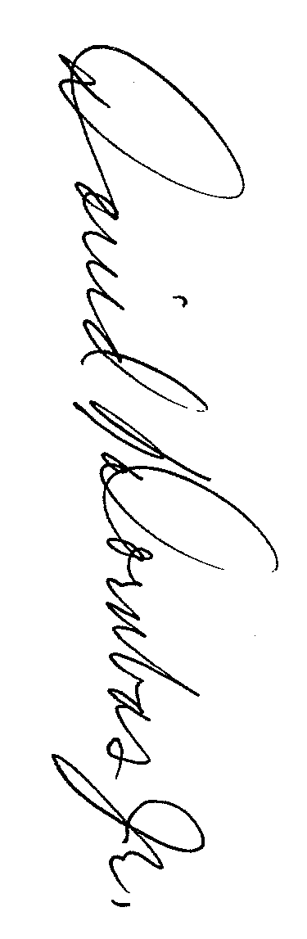

Perhaps at this stage you have some mixed feelings: excitement, concern, maybe even apprehension. This is normal. Rest assured that we will do our best to help you make the adjustments. Learning how learn, ask good research questions, find information and evaluate it, work effectively together, manage your time, and develop creative solutions – all these take time. To succeed it is crucial that you actively and consistently participate: ask and discuss questions in class, consult with your peers and instructor outside of class, and be diligent in completing assignments! For our part of the bargain, we will regularly solicit your input on surveys and do our best to provide timely feedback on your work. These will help us with ongoing efforts to make Biology 123 the best possible learning environment for you and future students.

Your Biology 123 Teaching Team,



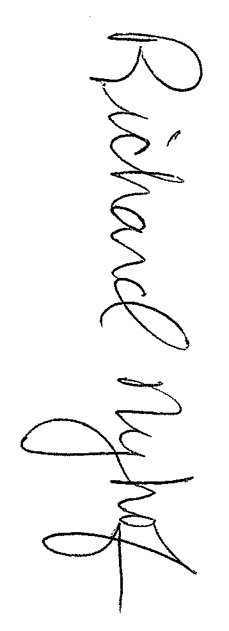
Curt Blankespoor David Dornbos David Koetje

Rich Nyhof Amy Wilstermann

