Lab 1: Gathering field data using a GPS and ArcGIS 9.3

(collecting point data)

The following is a step-by-step guide on how to use GPS receivers with the Tablet computers and ArcGIS software. Keep this lab handy whenever you go into the field because it will be a useful reference.

PLEASE NOTE: You will be turning in answers to the questions as a SEPARATE document. All questions are italicized and scattered throughout this laboratory assignment. Upload to moodle as Lab_1_yourlastname.doc.

Part 1: Setting up the GPS to work with ArcGIS

1. Turn on the GPS receiver (US GlobalSat BT-368i) by holding the button until the green and blue lights come on. Then, connect the GPS receiver to a USB port on the Tablet PC.

If outside, hold the GPS receiver until the green light starts blinking (may take a couple of minutes). When this occurs, the GPS unit is telling us that it is seeing the overhead satellites and is now receiving data. If inside just go to step 2.

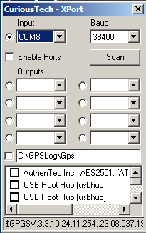
2. From the start menu, run the XPort program. Ignore the warning (click OK) and then set the baud rate to 38400. From the Input drop down, select a Com (Port 4, 5 or 6). You should see some alpha numeric code scrolling along the bottom. This is the raw GPS data in NMEA (National Marine Electronics Association) format - the code means nothing to you or me, but it does indicate that the receiver and the computer are communicating. If you don't see the code, then try selecting another Com port (make a note of which one works). After you get it working, close XPort.

3. From the Start menu select the ArcGIS folder and then launch ArcMap. When the program asks for what to start with select A new empty map and click OK. Then click on the add data button (a yellow plus sign) and browse to C:\GIS\ENST150\Your_lab_section\Campus.gdb
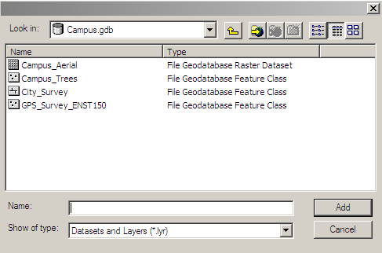
The .gdb extension denotes a geodatabase. The geodatabase is made up of a number of component files. Select Campus_Aerial and Campus_Trees and click Add. Right click on the Campus_Aerial feature in the table of contents (along the left of the screen) and select “zoom to layer”. You should now see a map of campus.

4. In ArcMap, go to View > Toolbars and select the GPS toolbar (as shown below).
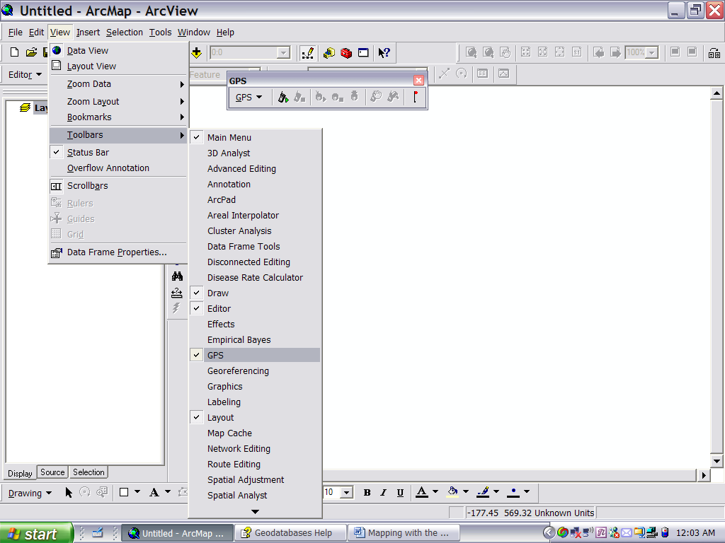

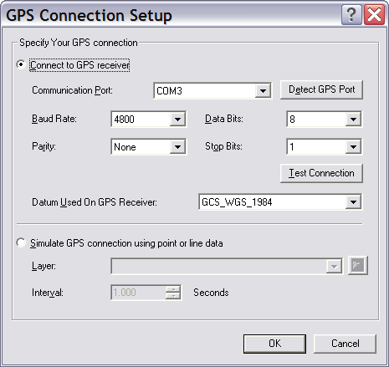
Once open, pull down the GPS menu to GPS Connection Setup (see screenshot below). Make sure that the Baud rate is set to 38400, that Parity is set to none, that Data bits are 8 and Stop bits are 1. Select Com Port 4, 5, or 6, (which ever one you selected in XPort) and click the Detect GPS port button. You may get an error message that says the port can't be detected. If this happens, try clicking the Detect button a couple more times. If it still doesn't work, change the Communication Port and try again. Click on the Test Connection button to verify that you have a connection and click OK.
Click here first.
Click here second.

5. Once you are sure that the computer communicating with the GPS receiver, go to the GPS menu again and drop down to Display Options (see next screen shot). Note: at this time you probably are not receiving any good data unless you are outside. But that is OK for now.

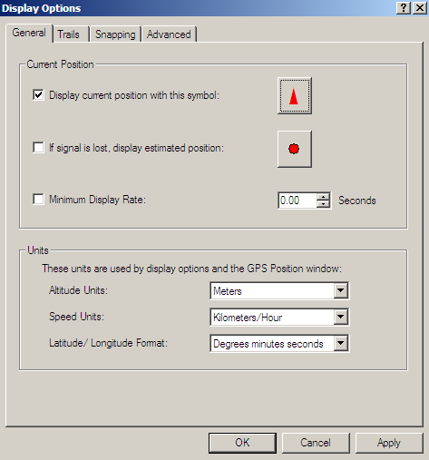

The default position indicator is a black solid triangle, which is kind of hard to see outdoors, so we'll change it. Click on the actual symbol which brings up another menu. Click options and then choose a color of your choice. (May I suggest a bright green?)

Now click on the Trails tab at the top, (see screen shot below). I suggest changing the symbol to a + sign and using the yellow to blue color ramp (but you can do as you please). Select 20 trailing points and a distance of 5 feet between points (it should look like the graphic below). This will show your path for the last 100 feet (20 points X 5 ft). Click Apply and then OK. 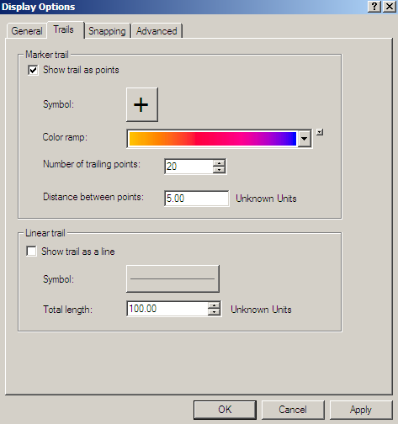

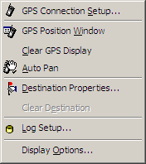
6. Now you are ready to see your position in real time on the base maps. Head outside to the clock tower and click on the Open GPS connection button . Ignore the warning about the coordinate system and projection. It will take a few minutes to get a GPS fix - be patient.

7. Under the GPS menu you can display the coordinates of your position by selecting GPS Position Window (see right). This display is similar to hand-held GPS units you might have used.

8. Look at the GPS plotted position on the base map vs. where you know you are. Note: While you are walking and streaming GPS data, make sure the receiver can "see" the sky.

(Question 1) Is the display an accurate depiction of your location/path? Compare and contrast the two.

Consider adding a question about error analysis

9. Go to the Clock outside of Youngchild Hall. Zoom in to your position. Note that even as you stand still your plotted position moves around a bit.

(Question 2) Explain why. You might revisit the following website to help you answer this question. www.trimble.com/gps/index.shtml. What other things might affect accuracy of your GPS position? Again see the trimble site.

10. You can get an estimate of how accurate your position is by looking at the GPS display window and seeing what the PDOP and the SNR values are (click the advanced button). PDOP stands for Percent Dilution of Position and it is a measure of the geometrical strength of the GPS satellite configuration. PDOP less than 4 gives the best accuracy. Between 4 and 6 gives acceptable accuracy. Greater than 6 yields poor accuracy. SNR stands for the signal to noise ratio. Larger values are better.

(Question 3) Develop a hypothesis for how the SNR and accuracy might change with your proximity to buildings. State your hypothesis. Test your hypothesis and report your results.

(Question 4). Is there a positive or negative correlation between the SNR and the number of satellites?

Part 2: Taking Point Data
Until this point we’ve just been displaying your position on the base maps, now we will start to collect data that we might analyze later.

1. Go to the GPS menu again and turn off trails from the display menu so they don't clutter the display. Close the GPS Position Window. Then from the GPS menu, drop down to Clear GPS Display.

2. In the table of contents along the left side of the screen you will see a data file called "Campus_Trees" in addition to the aerial photography you've been using as a base map. We will use the Campus_Trees file to map the location of several trees on campus. First you need to add the Editor toolbar to your workspace. In ArcMap, go to View > Toolbars and select "Editor".

3. From the Editor tool bar dropdown menu, select start editing. Verify that the task is create new feature and that the target is Campus_Trees (see above). Click on the Attributes icon (second to last from the right) - this brings up a box that we will use to describe the attributes (characteristics) of the trees. Lastly, click on the little pencil icon and note that the cursor changes to a set of cross hairs. Now wherever you click with the cross hairs on the map a new point will be created.

4. Let’s try it by adding a point right on where the GPS says we are. Just put the cross hairs over the GPS position triangle and click. Bingo! Now use the measure tool to determine the distance between your plotted point and the actual clock on the aerial photograph. Make sure the snap to feature tool (the green filled circle on the Measure toolbar) is selected. Simply click to the beginning of the measurement and double click to finish it. You might want to zoom in so you can see things. Keep in mind that your vertical position accuracy is roughly twice worse than your map (X, Y) position.
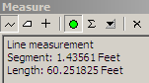
(Question 5) What is the distance between the known and plotted point?
(Question 6) Estimate the vertical accuracy.

***See instructor before you move on.

Part 3: Adding Attributes to data in the Field
To give you some practice with live data collection and attribute addition we'll do a simple exercise. You will create a map that has the location of a portion of the trees on main hall green and that classifies them as deciduous or coniferous and as large (cannot reach arms around it), small (hands can fit around it) or medium (neither large nor small).
1. Select Stop Editing from the Editor drop down. Do not save the edits.
2. Start editing again (basically we just cleared the clock tower as a data point because it isn't a tree).
3. Head over to a tree in the section you are assigned. Use the GPS position to find your approximate position on the map. Zoom in and use the map itself to more accurately locate the tree of interest. Try to locate the base of the tree and beware of the shadows.
(Question 7) Why not just use the GPS to locate the tree? Why even bother with the GPS if we have an aerial photograph already?
4. Ok, now that you've marked the point, lets describe some basic characteristics of the tree. We will do this using the Attributes box. On the right hand column of the box are the Property and Value headings. Under Property there are three fields OBJECTID, Type, and Size. OBJECTID is assigned by the computer, so we don't mess with it. We can however click on the <Null> box in the value field of Type and see that we can select either Deciduous or Coniferous. Likewise in the Size value box you can select Small, Medium, or Large.

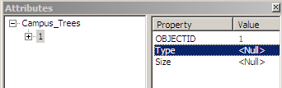

5. For each tree in your assigned area map its location and its characteristics. Save your edits often in case the computer crashes!
6. When you are done, save edits, turn editing off, and close the GPS connection.
7. Head back to the lab where we will make a map of the distribution of types of trees and their size.

Part 4: Symbology and Formatting
You might be wondering why we bothered creating a data layer of trees when the aerial photograph already shows the tree location. Well, we can manipulate the point data more easily that the photograph and we can subject the point data to analyses that we cannot perform on the photograph. For example we could quickly tabulate how many trees are conifers. We could make a map that shows all of the conifers and we could determine if on average conifers are bigger or smaller than deciduous trees. In short there are many questions that we can answer quickly with the point data. In this portion of the lab you will create a map of the trees classified by tree type and by size. These kinds of classified maps are called "thematic maps" in the parlance of GIS.

Symbology:

- Double click on Campus_Trees and select the symbology tab (see below). In the left pane (called "Show") click on the bold "Categories" and make sure unique values is highlighted. In the Value Field select Type (or Size) - this is the attribute by which we are going to classify the data.
- Chose a color scheme of your liking in the color ramp and towards the bottom click on Add All Values and then click on the color ramp again (sometimes it doesn't take the first time). Before you click OK, see the screen shot on the next page.
- What you have basically done is told the computer to assign a color according to Tree type (or size).
- You could get fancy and actually change the symbol as well. Just double click on the colored circle (the default symbol) and it will bring up a large menu of symbols to choose from. If you select “more symbols” from the bottom left you can upload hundreds of specialized symbols for nearly every imaginable application. You might like to check out “3-D trees”.
- Now perform an additional classification using the size of the tree.
- You can classify by both tree type and size by selecting the Multiple Attributes from the left pane of the symbology tab (see #1 above).

(Question 8): Make a map that shows the location of the trees and some classification by size and type. Include this in your write up. To export the map, first click File and then Export Map. From the Export Map menu give chose a file name, and a location to save it to (probably your share space). Make sure you save it as a JPEG, and use a resolution of at least 150 dpi. You can then easily cut and paste this file into MS Word or any program that accepts JPEGs.

