Tracing sediment provenance from source to sink: Isotope records in the Bay of Bengal and Indonesia

INTRODUCTION

One of the world’s largest deltas is formed where the Ganges and Brahmaputra Rivers coalesce in the Bay of Bengal. Sediments carried by the Ganges-Brahmaputra river system and deposited in the Bengal delta have their main sources in rock outcrops of the Himalayas and Tibetan Plateau which are the result of the collision of the Indian land mass with the Eurasian plate. The major rock units of this region each have characteristic Sr and Nd isotopic signatures, which can be used to determine the dominant source areas for sediments deposited in the delta.
Tip:Check out http://en.wikipedia.org/wiki/Geology_of_the_Himalaya for a short summary on Himalayan Geology.

In contrast the area around Indonesia is dominated by volcanic activity in the Sunda arc, a 3000 km long line of volcanoes extending from northern Sumatra to the Banda Sea. Most of these volcanoes are the result of subduction of the Australian Plate beneath the Eurasian Plate.…

INSTRUCTIONS:

We will be extracting data from global collections and visualizing the distribution of two radiogenic isotopes in the Indian Ocean to make hypotheses on the processes of weathering, erosion, transport and deposition….. For the first part of the class, you will retrieve and plot data to make your own hypotheses regarding …... In the second part of the class, you will retreat to small groups to discuss your results and generate a report explaining your observations and conclusions.

- Download GeoMapApp from http://www.geomapapp.org
- Log on to SedDB (http://www.seddb.org) and click on “search the SedDB database.

On the Start Search page select the little map icon to activate the map search function. Click on the plus sign twice to zoom in closer and move either by the arrow function or by clicking on the map and dragging to the right until you are in the area of the Indian Ocean.

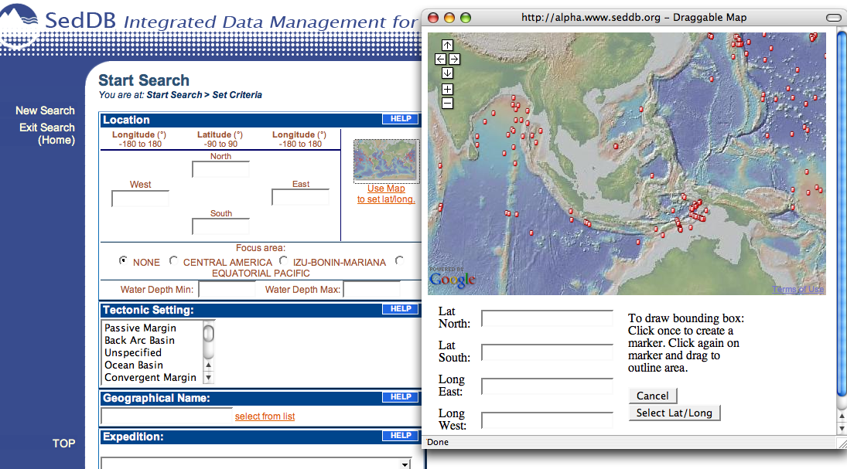

Click and drag the marker to create a bounding box of approximately 25 N, -20S, 135 E, and 75W to capture sites in the Indian Ocean and Indonesia. You are aiming to capture sites in the Indian Ocean and along the Indonesian arc. Click on “Select Lat/Long”, you will see the numbers populate the lat/long boxes, and will be returned to the start page, click “submit”.

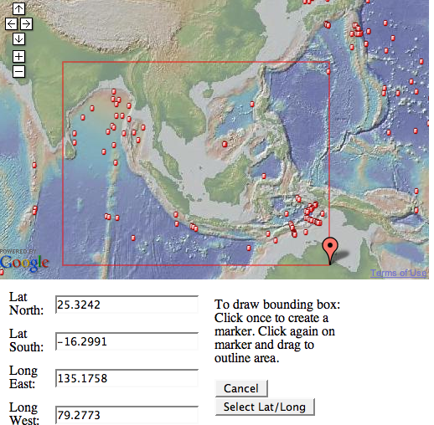

You will have retrieved data from roughly 80 sites.
Under FAST SEARCH, click “Continue with all sites in your current selection”

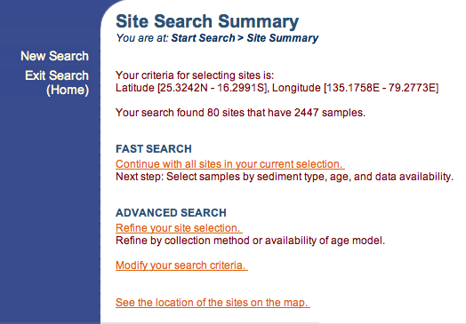

On the Select Samples page, click “Continue with ALL XXXX samples available”

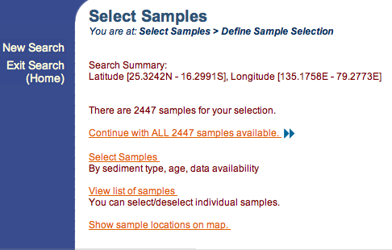

On Sample Summary page, go to ADVANCED SEARCH and click “Refine your sample selection”

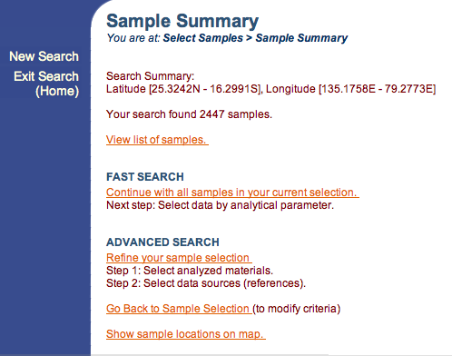

Check off “Bulk Sediment” and submit:

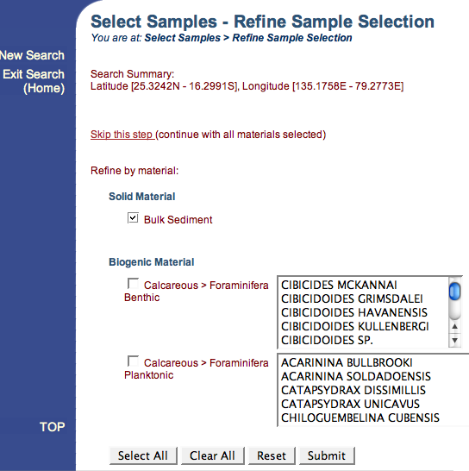

Next, select all references and submit:

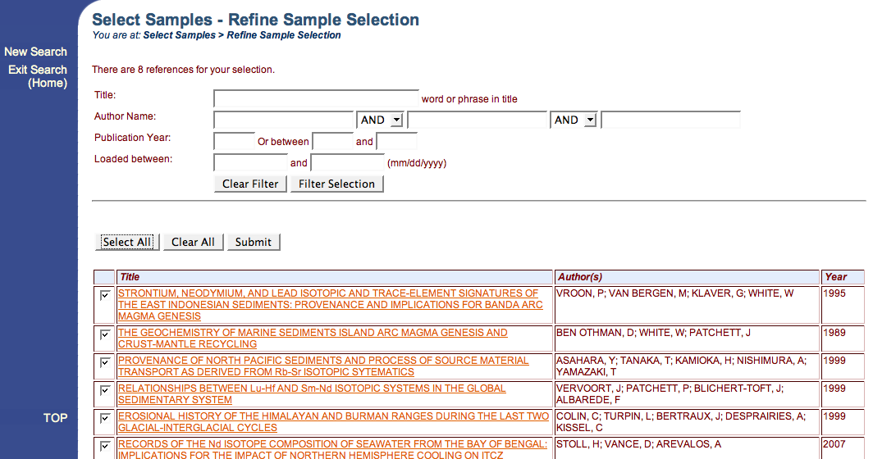

On “Select Data—Set Parameters” check off Nd143_Nd144 and Sr87_Sr86

: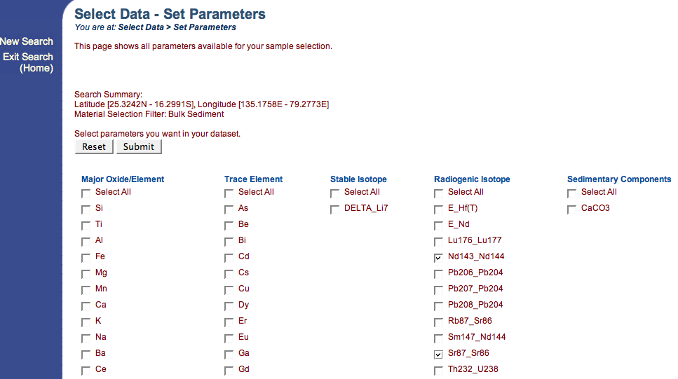

Select all methods, Submit:

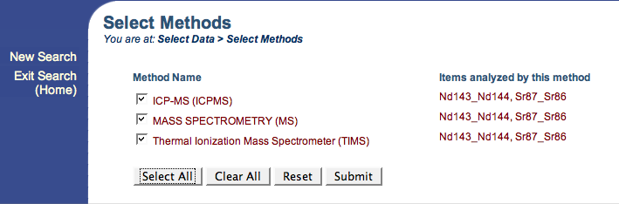

Click Download Results, and find the file “data.xls” on your desktop. Open the Excel file to make sure the document contains data. Once you have confirmed this, save your file as IndOc_Indo_YourName.xls.

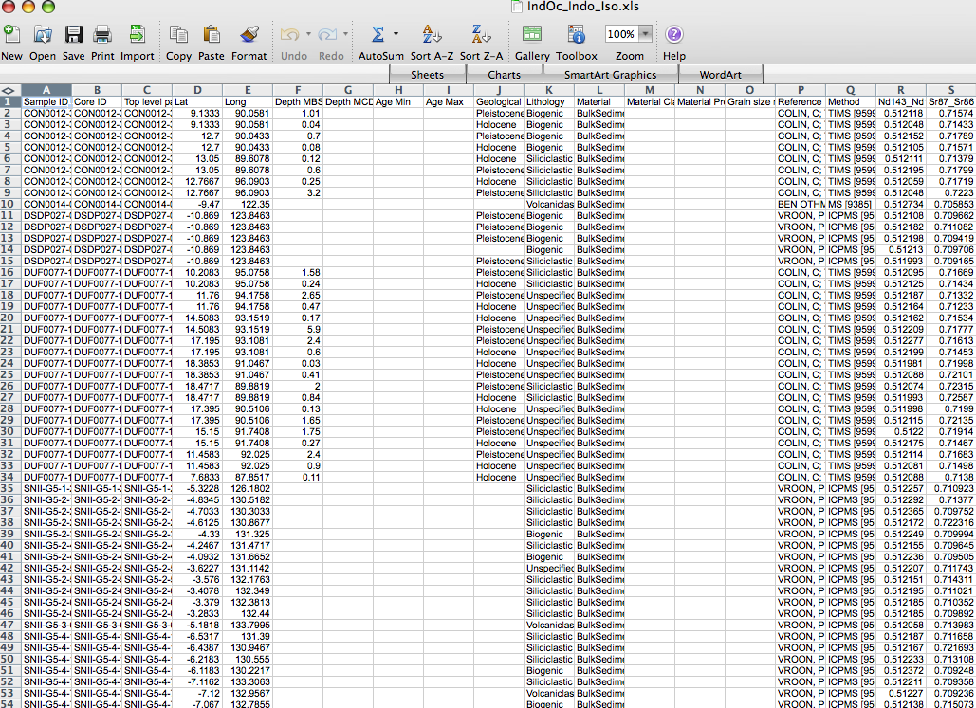

Go to http://www.geomapapp.org/#DOWNLOAD and install GeoMapApp.
Select and copy the entire data.xls file that you just created in SedDB. Tip: click on the little diamond shape in the upper left corner of the spreadsheet to copy it.
Go to File in GeoMapApp>Import Data Tables>Import from Clipboard.

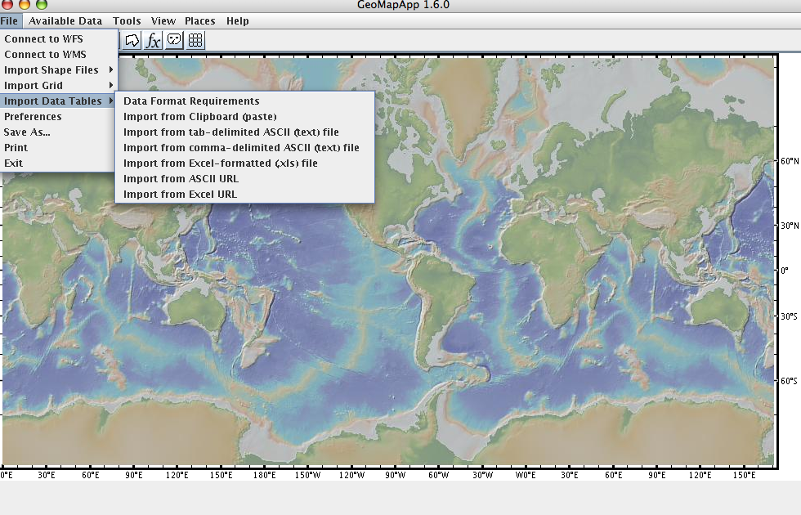
A window called “Imported Data Tables will open, click Ok.
A second window opens (Config untitledX), with Lat/Long chosen to demarcate the symbols, click Ok and the core sites will be plotted on the map.

Select “Graph” on the right side of the menu and select Sr87_Sr86 and Nd143_Nd144 as X and Y values respectively, click Ok, and the program will plot the values as a scatter plot.

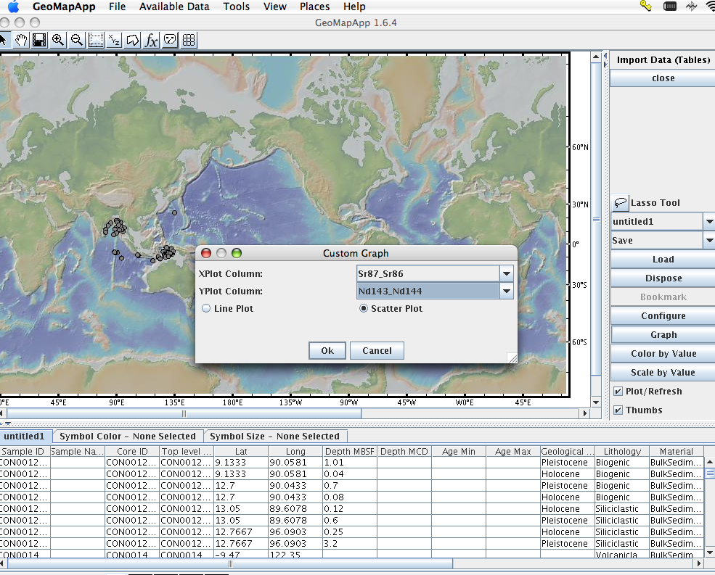

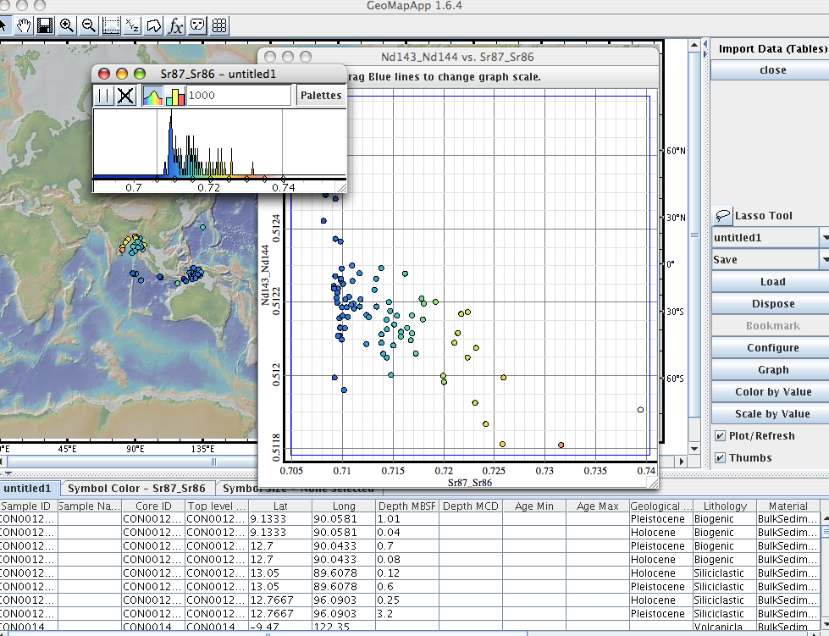

If you click on “Color by Value” you will see the values scaled by color. Move the graph to the side so that you can see the colored data points on the map.

