Transport of Heavy Metals in the Clark Fork River

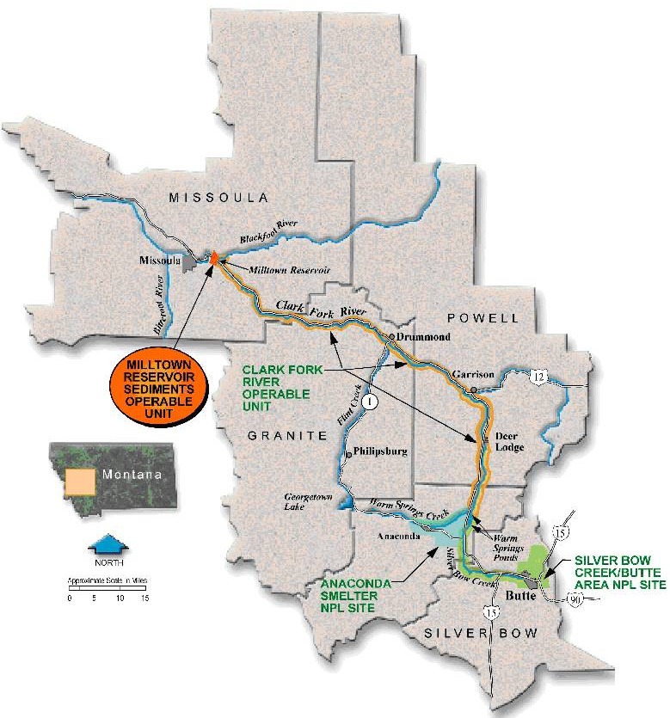
Kathleen Harper, University of Montana Geosciences

Activity A. Meander Migration: A Practical Application

Introduction to the problem
The area around the headwaters of the Clark Fork River has been the site of a long history of intensive mining activity. In the late 1800’s, gold and silver were mined in the Butte area, mostly in placer and small scale underground mining operations. The scale of mining in the Butte area expanded enormously in the early part of the 20th Century, during which time the metals contained in the contact metamorphic zone around the Boulder Batholith beneath and near the city of Butte were extracted. Ores containing abundant copper (critical for copper wires for the expansion of electrical networks in the U.S.), lead, silver, gold, and molybdenum, zinc, and manganese were removed via extensive underground mine systems including over 10,000 miles of tunnels down to the depth of a mile underground!
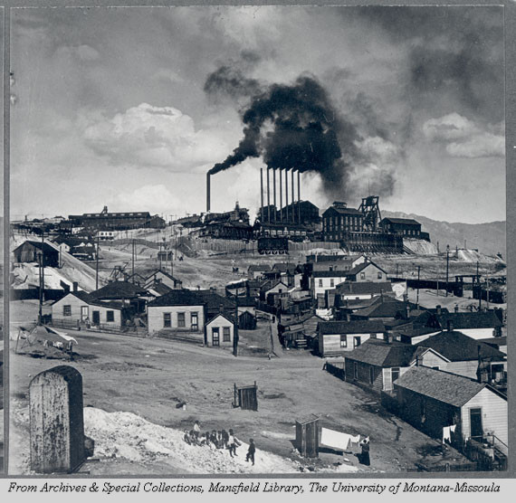
Metals were separated from the ore by smelting, a process that use heat and chemical reactions. Smelting was originally done in Butte, however, the intense pollution produced in this process, including emission of large quantities of arsenic and acidic sulfur fumes, was causing extensive illness and death among residents of the city, particularly during wintertime inversions. Additional smelters were constructed in Anaconda, both to move the toxic output from the smelter away from uptown Butte, where the tycoons of Anaconda Mining Company lived, and because there was more water available in Anaconda for the smelting process. The Anaconda smelter was the last to cease operations -- in the 1970’s. Output of toxic material from the Anaconda smelter caused the death of hundreds of livestock in the Deer Lodge Valley and killed large areas of vegetation. Local ranchers were unable to sell their hay because of the potentially toxic levels of arsenic it contained. Waste material from processing of the ore, called tailings, was discarded in piles both around the mines in Butte and near the smelter sites in Butte and Anaconda.

Photo. Butte, Montana, circa 1909. Note the mine tailings and smelter smokestacks.

In June, 1908, the Clark Fork River experienced the largest flood on record. The flood mobilized large volumes of mine tailings from the upper Clark Fork watershed and carried these down the river. Mine tailings were transported and deposited by the floodwaters on the entire active floodplain of the river between Butte and Anaconda and the first major obstruction to sediment transport downstream, which was the newly constructed dam at the confluence of the Blackfoot and Clark Fork Rivers near Milltown . Areas called “slickens” in the Deer Lodge Valley consist of areas of tailings which are barren of vegetation and are particularly slick when wet. The contaminated sediments contain high concentrations of copper, arsenic, lead, and other heavy metals.
The addition of new contaminated sediment to the Clark Fork River has been stopped by various remediation actions taken by the Environmental Protection Agency (EPA) as part of an immense Superfund cleanup involving a number of contaminated locations within the Clark Fork River watershed including Anaconda, Butte, and Opportunity Ponds near Warm Springs (a complex of settling ponds originally designed to store contaminated sediments produced as a by-product of smelting). However, the thick layer of contaminated sediments deposited by the 1908 flood across the floodplain of the river is constantly being eroded by the natural migration of meanders.

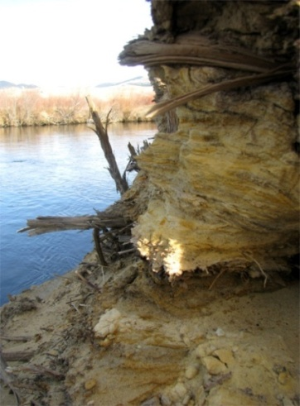
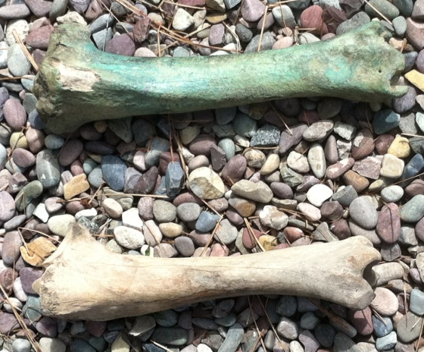

Left: Riverbanks composed of contaminated sediments, derived from mine tailings, deposited along the Clark Fork River in the Deer Lodge Valley by the 1908 flood. Right: Bones within the stream-side sediments have absorbed copper and other heavy metals as can be seen in the photo above. Upper bone is from the Deer Lodge Valley, lower bone is from an uncontaminated area.

Problem
The EPA has already spent millions of dollars cleaning up the widespread contamination resulting from mining in the Butte area, however, cleanup efforts tend to focus on areas where contamination is most easily isolated or removed. Removing a thick layer of material deposited across a river floodplain for 100 miles downstream was not deemed to be a practical solution. So the heavy-metal laden sediment remains, although new contamination is no longer being added. However, the river is continually reworking the sediment layer, by the natural processes of erosion and deposition along its length. Reworking of the contaminated sediments will dilute the high-concentrations of heavy metals as it is carried downstream and becomes mixed with non-contaminated sediment. But – how quickly will this process occur?
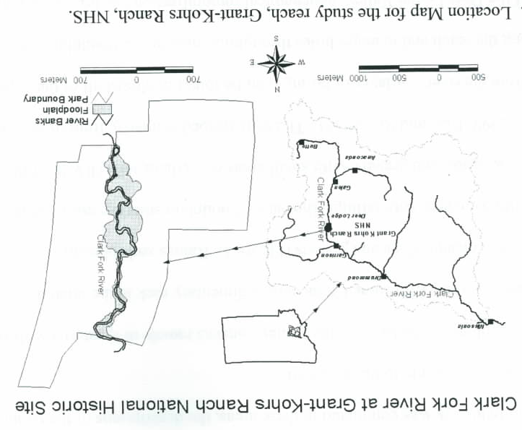
In this activity, you will look at the rate of erosion of the contaminated layer in a portion of the Clark Fork River north of Deer Lodge to estimate how long it will take for the river to rework the sediments deposited by the 1908 flood just one time. This stretch of river has been selected because of the presence of a number of large meanders, whose lateral migration across the floodplain maximize erosion.

As we will be using aerial photographs to obtain an estimate of erosion, you will be measuring area as a proxy for volume of sediment removed. Ground surveys, combined with chemical analysis of sediments for heavy metals, have yielded a thickness for the contaminated 1908 flood deposits of 1.2 meters.

- Examine the following two aerial photos of a meander of the Clark Fork River in the area of the Grant-Kohrs ranch north of Deer Lodge (you will find these on the next page). Draw a careful sketch, in the space below, of the meander (does not have to be the exact same size as the photos) and show the difference in the river channel location between the two years. Use a piece of tracing paper (attach to your finished work).
- Add an arrow to your sketch to show the flow direction of the river.
- Label, with an arrow, the direction the meander as a whole is migrating over time.
- Outline and label the area of erosion over this time interval.
- Label the point bar (where deposition is occurring) on this meander.

1983

10 m
2004

- Use the transparent grids provided in lab to estimate the area of land that has been eroded by the cut bank of the large meander in the photo during the time interval between the photos (1983 to 2004). This is a visual estimate only – no calculations are required to obtain this number.

Estimate of area eroded over whole time interval: __________________

- Now convert this to an annual erosion rate for this single meander:

$$\frac{area eroded over whole time interval }{number of years}=erosion per year$$

$$\frac{}{ }=$$

- This method has been applied to six significant meanders in this meandering section of the Clark Fork River. Erosion from eight meanders over this same time interval (the Grant-Kohrs Ranch study area), combined with erosion from observed widening of the river channel in straighter sections, has yielded an erosion estimate of 740 m²/year.
This amounts to a total of 4,106 kg of arsenic, 31,570 kg of copper, 4,360 kg of lead, and assorted other toxic heavy metals transported during that same time period.
Given that the area of contaminated sediment deposited on the floodplain within this section of river is 700,000 m², how long will it take the river to erode (and redeposit) the contaminated layer in the Grant-Kohrs Ranch area just one time? (show your work)

- What does this tell you about the long-term impact of surface contamination downstream of an area with a long history of heavy-metals mining?

- Although this method provides a good illustration of how long it takes a river to transport and disperse contaminated sediment, what are the some of the limitations of this analysis?

Activity B: Geochemical Signature of Contamination

The EPA Superfund cleanup program came into being after identification of toxic waste dumps in the 1970’s. Since then, cleanup of a variety of types of contaminants and sites produced by mining and other industries has been carried out by the EPA. These efforts attempt to mitigate or prevent the potentially devastating effects of the presence of toxic chemicals in our environment. Previous to that, it was assumed that natural processes could absorb the effects of these human activities and that the areas impacted were limited to piles of tailings or other such visible remnants.

- Examine the chart below showing one heavy metal, arsenic, contained in contaminated river sediments downstream between Butte and Milltown. Keep in mind that the drinking water standard (maximum concentration allowable to be considered “safe” or with no adverse health effects) for arsenic is 0.01 ppm (or 1 part per billion).
- Label – on the chart – which side of the chart is Butte and which side is Milltown.
- Draw a smooth curve through the arsenic concentration data points.
- Describe the pattern of the data in one or two sentences below.

- Plot the following additional data points on the graph above. These are samples of sediment from tributary streams. Their locations, in river kilometers, indicate where the stream joins the Clark Fork River. Obtain a copy of the “Butte, Montana” raised relief map and use it to identify the locations of these tributaries.
Tributary stream/river | River kilometer (km) | Arsenic concentration (ppm)
Silver Bow Creek | 790 | 166
Gold Creek | 701 | 7
Flint Creek | 672 | 241
Rock Creek | 614 | 10
Little Blackfoot | 717 | 31

- Historical mining activity is widespread in western Montana!
- Which of the tributaries show the least evidence (in arsenic concentration) of extensive mining history?

- Which tributary, besides Silver Bow Creek in the Butte area, would you suspect has the most extensive history of mining? Why?

- Why does the joining of this creek with the Clark Fork River not significantly impact the trend of the arsenic concentrations in Clark Fork River sediment?

- Why does the data plot end with Milltown? (Hint: what happened to the Clark Fork River at that location up until March, 2008?)

