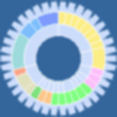
Clusters of Orthologous Groups of proteins
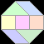
http://www.ncbi.nlm.nih.gov/COG/
A COG represents a group of orthologs (proteins related through vertical evolutionary descent). The COGs site may be used to identify protein families. The database is accompanied by the COGnitor program, which can be used to assign new proteins to pre-existing COGs. A Web page containing structural and functional information is now associated with each COG: systematic classification of the COG members under the different classification systems; indications of which COG members (if any) have been characterized genetically and biochemically; information on the domain architecture of the proteins constituting the COG and the three-dimensional structure of the domains if known or predictable; a succinct summary of the common structural and functional features of the COG members, as well as peculiarities of individual members; and key references. There is a database of COGs (66 prokaryotic genomes) and KOGs (7 eukaryotic genomes). Within the eukaryotic version (KOGs), there are four functions of this database:
- KOGs: Listing of orthologous groups between all possible combinations of 7 genomes (see below)
- TWOGs: listing of all orthologs that are found in only two genomes (See below)
- LSEs: Lineage specific expansions in each of the 7 eukaryotic genomes
- Kognitor: blast your sequence of interest against all KOGs to see whether it falls into any orthologous groups
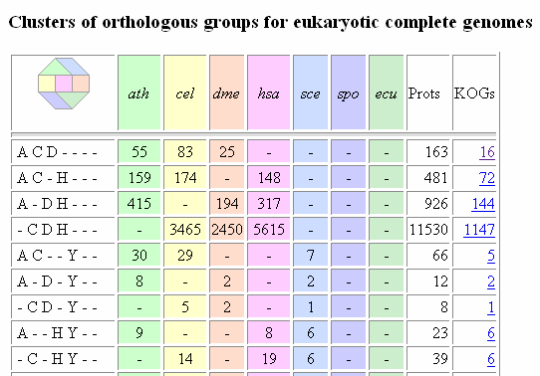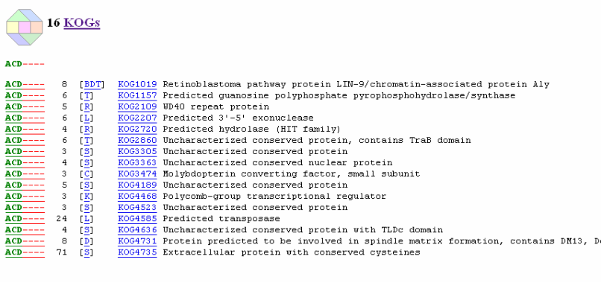

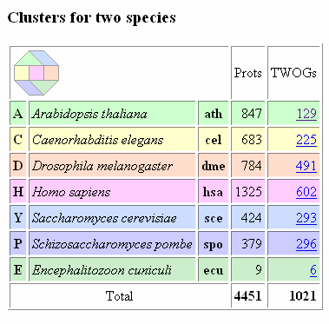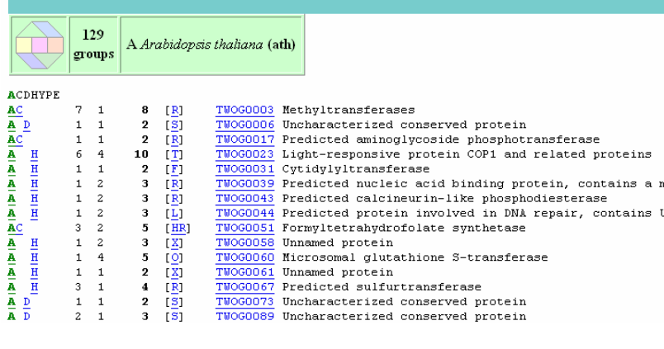
Other ortholog/homolog databases:
- http://www.ncbi.nlm.nih.gov/sites/entrez/query.fcgi?db=homologene
- http://phigs.jgi-psf.org/
- http://www.metazome.net/

