Bioinformatic Analysis: Designing primers and annotation gene of interest

Search for the DNA sequence of the Aiptasia or Symbiodinium gene
- WHERE is the best place to try and find the DNA sequence for the species you want to use (in our case, Aiptasia or Symbiodinium)?
- You already know about AiptasiaBase to find anemone genes, right?
- For Symbiodinium I recommend trying NCBI
  - In NCBI, go to Nucleotide database
  - Search for gene name AND species (rbcL AND Symbiodinium)
  - Go to FASTA page for the sequence
  - Copy the sequence and paste it into your own online journal or into a text file
- Create a text file that contains the full sequence. You will annotate it later.

Design primers
- Navigate to Primer-BLAST page
- Copy the DNA sequence into the Blast window
- Change default settings for PCR product size:
  - PCR product size between 70 nt (min) and 150 nt (max)
- The primer results page will show you five primer sets. The first primer set should work fine.
- Copy the primer sequences into your online journal or your text file.
- Name the primers with the gene name and append F or R
  - Example: the forward primer for the rbcL gene should be named rbcL-F
  - Enter the primer sequences into the Primer Order Form

Annotate the Aiptasia or Symbiodinium gene (blast, alignment, Pfam) to evaluate the potential function of this gene
- The goal is to provide evolutionary and functional information about the Aiptasia/Symbiodinium gene.
- You have already copied the DNA sequence of the sequence into a text file.
- You now need to determine the protein sequence (use ORF Finder)
- You then need to perform a blast search against one or more databases to collect potential homologs for an alignment (for example, Aiptasia, Nematostella, Human)
  - Create a table showing the blast results of the relevant hits (see example table, below)
- Conduct an alignment
- Conduct a Pfam analysis
  - Create a figure showing the alignment and Pfam annotations (see example figure, below)

Example Table showing BLAST results:
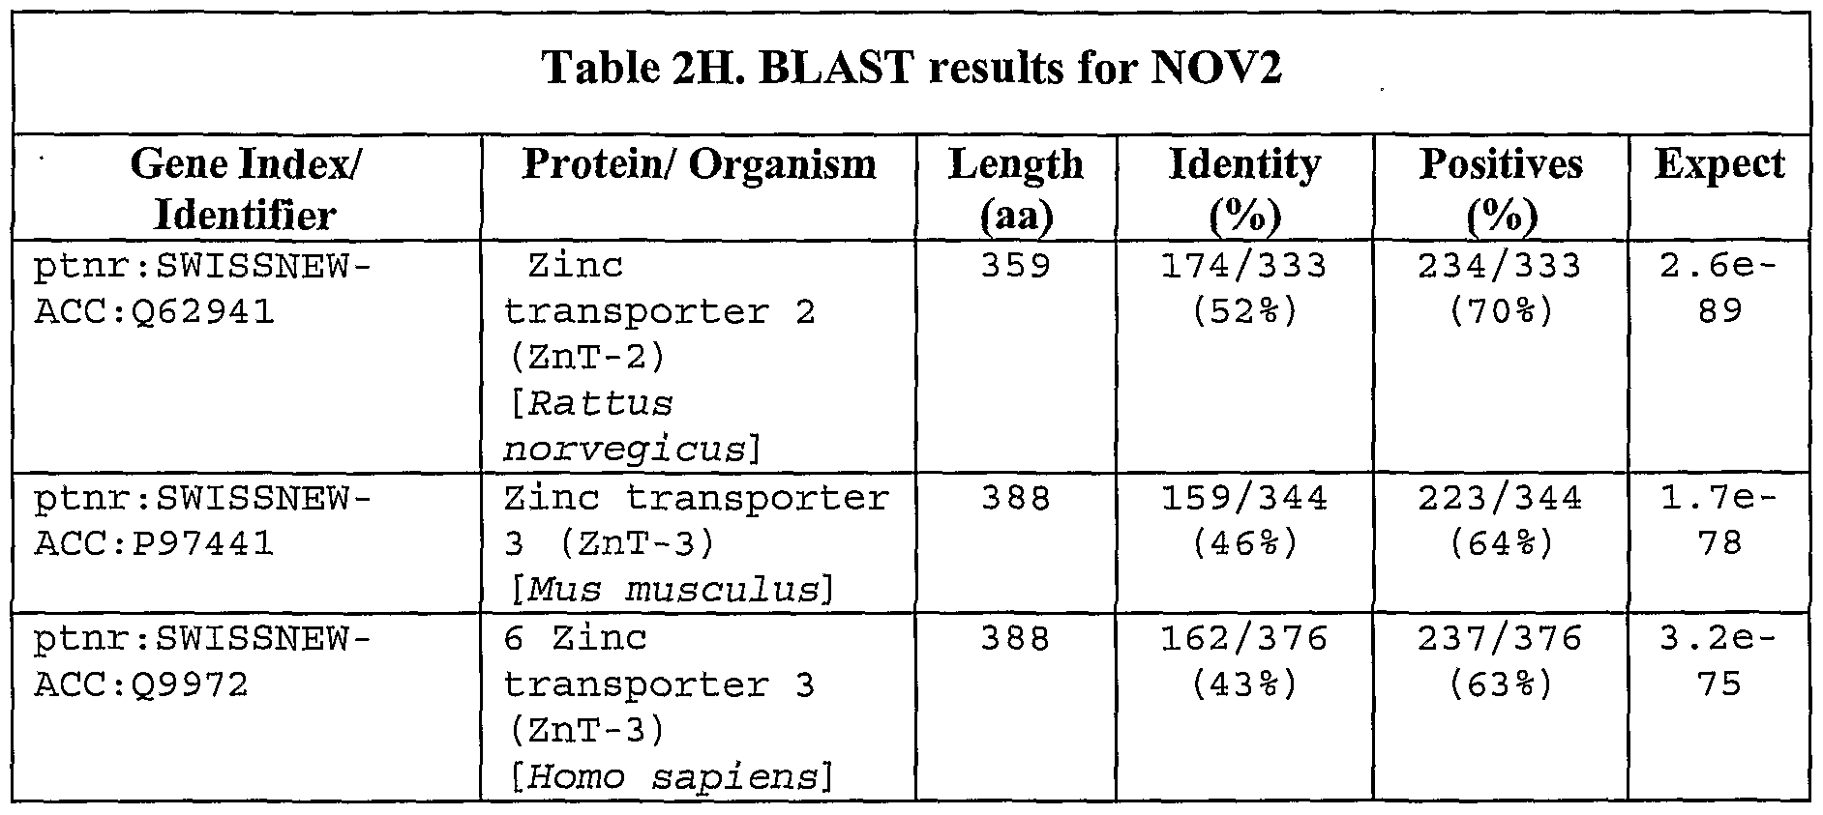

A
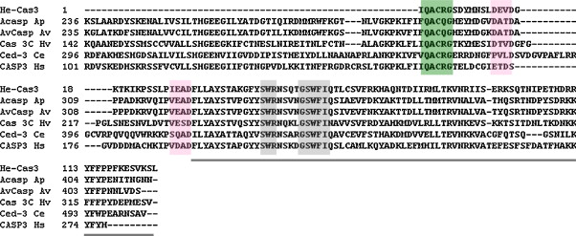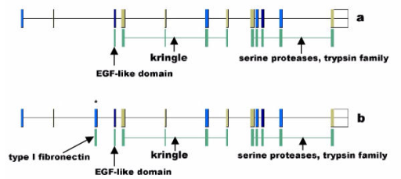
Figure 1. This is a made-up figure showing the bioinformatics annotation of my gene of interest. Panel A shows sequence homology revealed by alignment, and Panel B shows the presence of various functional domains in the Aiptasia protein.
B

