Spectacle Island Data Collection

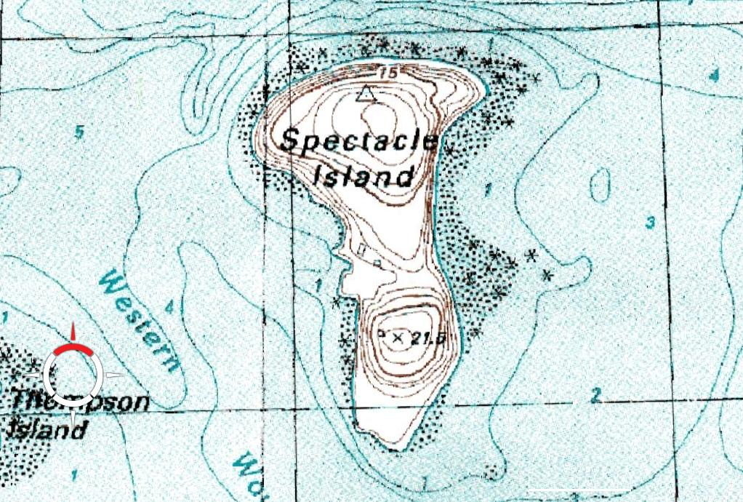

Let’s use some of the ImageJ tools to investigate, collect data and analyze the development of Spectacle Island.
- Open the ImageJ program on your desktop.

- Go to: File>>Open>>Spectacle Island

- Within the Spectacle Island folder open 1938m.jpg

- Let’s get the image ready to analyze……

- Go to Analyze> Set Scale

- Set the following: Pixels: 144
Distance: 225
Aspect: 1 (default)
Units: m
Global: select
Select OK

- Go to: Analyze>Set Measurement
Select: Perimeter, Display Label

- On the 1938 image, find the measurements (one at a time) between points A&B, C&D, E&F, and G&H. Make sure they all get recorded on your results table.

- Repeat this same procedure for: 1955m, 1969m, 1978m, 2000m

- When all the length measurements have been made, your results table should have 20 data points.

- Save your results to your documents folder. Label it Spectacle Island Lengths.

AREA

- Follow the first 6 directions from above.

- Go to: Analyze>Set Measurement
Select: Area, Display Label

3. On the 1938 image, using the Freehand button, carefully trace around the
perimeter of the island image and record it’s measurement.

- Repeat this same procedure for: 1955m, 1969m, 1978m, 2000m

- When all the area measurements have been made, your results table should have 5 data points.

- Save your results to your documents folder. Label it Spectacle Island Areas.

