Name __________________ Per. _____ Date ______________________

Which is the Biggest Piece of the Pi (e)?

Open Excel (Start Menu>Programs>Microsoft Office>Excel)

When Excel opens you will see a screen with Book 1 on it and cell A1 highlighted.
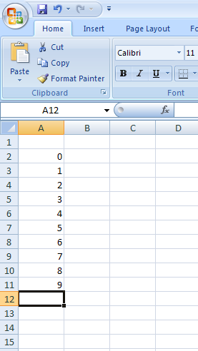
Beginning on cell A2 and continuing down
to cell A11 number the cells 0-9.

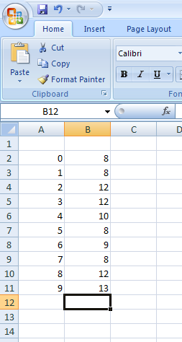
Beginning on cell B2 and continuing down to
cell B11 record your tallies for the first 100 digits of Pi.

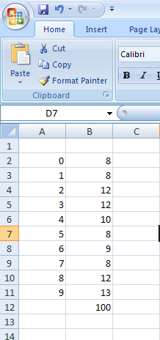
Highlight the cells from B2 to B11 and find the Sum Total.
**If the sum total does not = 100
then please re-tally your digit distribution.

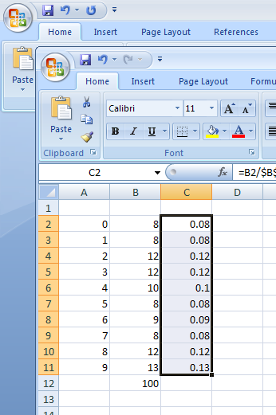
Highlight the C2 cell. In the formula bar please type =B2/$B$12.
The formula will also appear in the C2 cell.
Carefully find the dark box in the lower right hand corner of cell C2
and drag it down to C11. Decimal representation of your data should appear.

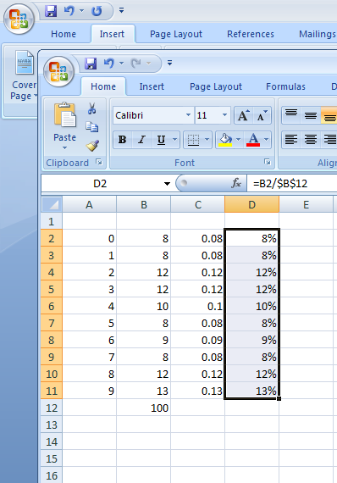
Highlight the D2 cell. In the formula bar please type =B2/$B$12 again.
Also drag the small black box in the lower right hand corner of the D2
cell and drag it down to D11. Another column of the decimal
representations should appear. Highlight cells D2 to D11 and click on
number format. Under number format, click on percentage.
This will change the decimal representation to representation with percent.

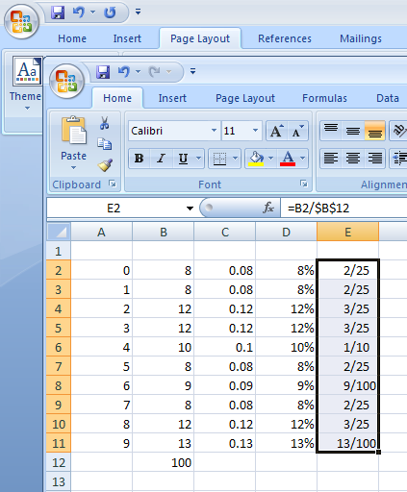
Highlight the E2 cell. In the formula bar please type =B2/$B$12 again.
Also drag the small black box in the lower right hand corner of the E2
cell and drag it down to E11. Another column of the decimal
representations should appear. Highlight cells E2 to E11 and click on
number format. Under number format, click on fraction.
Please make sure that “up to 3 digits” is selected under fraction type.
This will change the decimal representation to representation by fraction.

Making a Pi Chart

You can now use the represent the data you just organized into a Pie Chart.
Select Insert> Pie Chart
Choose the Pie Chart type you prefer.
Be creative and follow these simple guidelines.
Your chart must:
  - Be a pie chart
  - Display a legend
  - Have each piece labeled with the proper percentage
  - Not be covering the spreadsheet
  - Have a title, name, date and period

