Fill down
Click for function (mean, median, range)

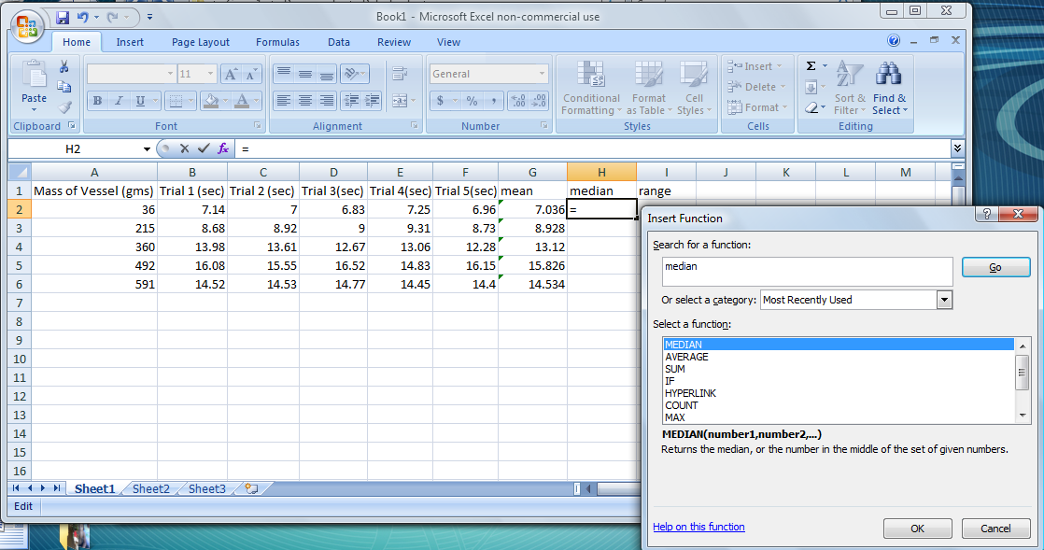

To enter the range use this formula =MAX(B2:F2)-MIN(B2:F2)
