DataTools Investigation Planning and Documentation Template

Please include your initials in the file name of the electronic version of this document.

Part 1

Your Name: Bob Elliott
Date: March 1, 2009
Grade(s) taught: 5-6 woodshop/boat building

Key Parts of an Investigation

- Question(s)
- Goals
- MA state frameworks
- Overview & approximate time
- Dataset(s)
- Analysis tool(s)
- Main steps for analysis techniques
- Background information
- Example product(s)
- Student handouts for data collection & analysis
- Support for student inquiry
- Reflections on Implementing the Investigation (complete after implementing)

Investigation Question(s)
Can you create a ferry that can that can carry a two car load 3 meters so that the cargo arrives dry, the vessel remains upright and the passage time is minimized?

Investigation Goals
- Students will successfully employ all of the steps of the engineering design process to design a boat with the given constraints that will achieve the given objective.

The engineering design process requires creative thinking and consideration of a variety of ideas to solve practical problems. Steps:
            - Goal – Identify the need or problem
            - Ask – Research the need or problem, identify the constraints
            - Imagine – develop possible solutions, brainstorm ideas
            - Plan – select the best possible solution
            - Create – construct and test a prototype
            - Communicate – the solution and tradeoffs
            - Redesign

- Use Excel to create a graph that illustrates the results of different designs

MA State Frameworks
1.1 Given a design task, identify appropriate materials (e.g., wood, paper, plastic, aggregates, ceramics, metals, solvents, adhesives) based on specific properties and characteristics (e.g., strength, hardness, and flexibility).
1.2 Identify and explain appropriate measuring tools, hand tools, and power tools used to hold, lift, carry, fasten, and separate, and explain their safe and proper use.
1.3 Identify and explain the safe and proper use of measuring tools, hand tools, and machines (e.g., band saw, drill press, sander, hammer, screwdriver, pliers, tape measure, screws, nails, and other mechanical fasteners) needed to construct a prototype of an engineering design.
2. Engineering Design
Central Concept: Engineering design is an iterative process that involves modeling and optimizing to develop technfrological solutions to problems within given constraints.

Central Concept: Transportation technologies are systems and devices that move goods and people from one place to another across or through land, air, water, or space.
6.2 Given a transportation problem, explain a possible solution using the universal systems model.  6.3 Identify and describe three subsystems of a transportation vehicle or device, i.e., structural, propulsion, guidance, suspension, control, and support. | 6.4 Identify and explain lift, drag, friction, thrust, and gravity in a vehicle or device, e.g., cars, boats, airplanes, rockets.

Overview & Approximate Time
- 1 period to design and collect data
- 1 period to enter data in excel ,create graphs, and interpret results

Dataset(s)
- Time trials collected

Analysis Tool(s)
- Excel
Steps for Data Analysis
Students will collect data on all of the boats that are created and tested. They will create a graph using excel and write 2 statements based on the graphed results.

Background Information
The engineering design process requires creative thinking and consideration of a variety of ideas to solve practical problems. Steps:
            - Goal – Identify the need or problem
            - Ask – Research the need or problem, identify the constraints
            - Imagine – develop possible solutions, brainstorm ideas
            - Plan – select the best possible solution
            - Create – construct and test a prototype
            - Communicate – the solution and tradeoffs
            - Redesign

Example Data Analysis Product(s) (i.e. graph, map, image, etc.; something you expect students to be able to create during the investigation)
Speed second
sss

Student handouts for data collection & analysis (can attach these separately):

Foil Ferry Design Challenge Name:____________________________________

The engineering design process requires creative thinking and consideration of a variety of ideas to solve practical problems. The steps include:
            - Goal – Identify the need or problem
            - Ask – Research the need or problem, identify the constraints
            - Imagine – develop possible solutions, brainstorm ideas
            - Plan – select the best possible solution
            - Create – construct and test a prototype
            - Communicate – the solution and tradeoffs
            - Redesign
For this project:
Goal : Create a ferry that can that will carry a load of 2 matchbox vehicles 3 meters so that the cargo arrives dry , the vessel remains upright, and the passage time is minimized.
Ask/Constraints :
Dimensions:The maximum beam(width) is 20 cm. The maximum length is 25cm. You must tape or fold in a washer that will attach to the magnet to pull the vessel
Materials: You may use one precut aluminum foil sheet, 12 soda straws, 6 popsicle sticks, 24 inches of masking tape
Time:The prototype needs to be developed in 15 minutes.
Imagine – (5 min) Brainstorm and sketch at least 2 possible solutions

Create – (10 min) Construct the prototype. Give it a name.
Test – Test, time and record 3 trials for your ferry. Record the class data.
Ferry Name | Mass of cargo  (gm) | Trial 1  (seconds) | Trial 2  (seconds) | Trial 3  (seconds) | Average  (seconds) | Comments/Observations
Enter the data into excel and make a meaningful graph of the results.
Improve- Overhaul your design based on the information gathered

Support for student inquiry (List strategies this investigation will use to promote student inquiry)
Students are given two sets of materials. One to help in the imagine phase of the design process and one to use in the challenge. Students are reminded that there are usually many different solutions to design problems. In their observations of the different boats theories will develop about the results that are seen.
_______________________________________________________________________
Part 2
COMPLETE Part 2 AFTER YOU HAVE IMPLEMENTED THE INVESTIGATION

Today’s Date: March 8, 2009

Number of classes that used the investigation: 1 (I plan to repeat this with my boatbuilding class this Spring)

Approximate number of students who completed the investigation: 8

Paste an example of student work (final graph, student analysis, etc.) from the investigation

Vessel | Time in sec. | Mass gm.
S-Allie | 8.2 | 135
Frog | 8.41 | 135
Batman | 6.3 | 135
Krucytanic1 | 6.7 | 135
Krucytanic2 | 7 | 135

Reflections on Implementing the Investigation

- How you feel the investigation went with students? The lesson went very well.
Here are a few photographs:
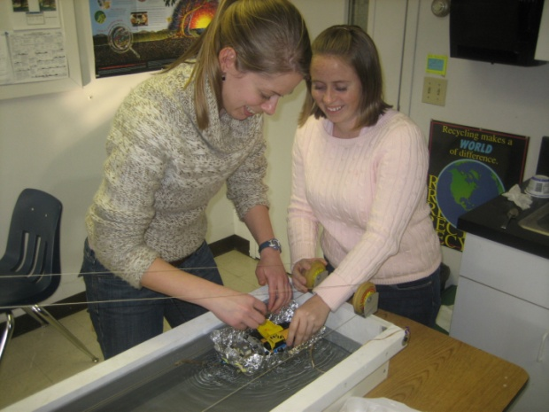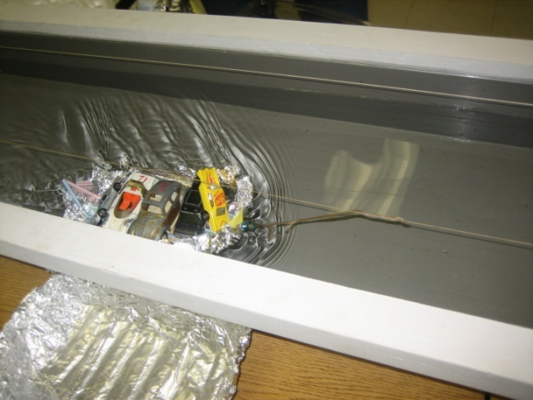

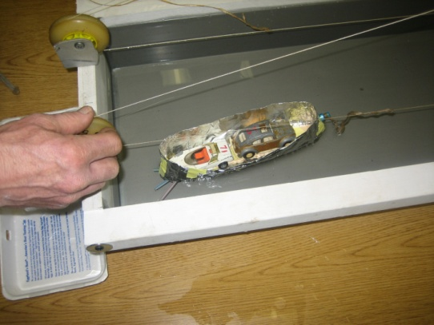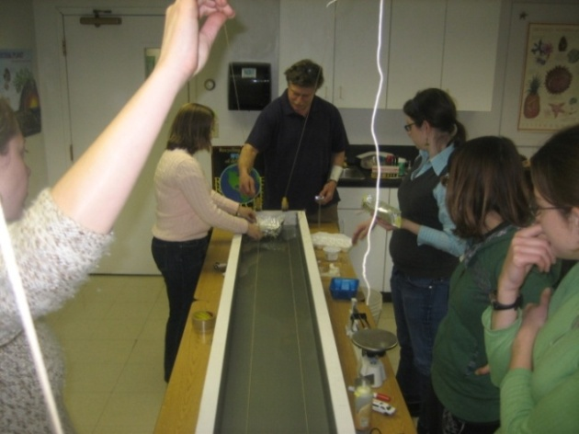

- Were you satisfied with the level of student engagement?
Yes, the class I taught was very enthusiastic and engaged, particularly in the ferry challenge.
What sorts of questions did student ask? What insights did they have?
The discussions were terrific. Topics included:
Trade -offs between freeboard (height of hull above water and beam (width of the boat)
Directional stability, with attempts at making rudders and keels
Center of gravity issues (the importance of keeping the weight low)
Connections to real world shipping including biological implications of purging ballast water (zebra mussels).
Historical connections including the explanation as to why brick houses were the status houses in the American Colonies.
An important was they observed that testing their model was an important feedback loop to implement.
How proficient are they in using the software? Although only half of the students had used Excel before, they were all successful in entering their data into the spreadsheet generating this very simple graph.

- How will you carry out this investigation differently in the future? I plan to use this and several variations with my boatbuilding class focusing on hulls, sails (with a fan as the wind), interaction with waves etc. From these engineering design challenges my hope is that students will select an investigable question that they can then design a fair test to answer.

