The 2013 Allied Social Science Associations annual conference date is fast approaching (January 4-6, 2013) in San Diego California and the preliminary schedule has already been posted: http://www.aeaweb.org/aea/2013conference/program/preliminary.php
For those who are going to the annual meeting for the first time, I have come to offer you some friendly advice. I attended the meeting for the first time in Chicago of this year and I would like to share some tips I’ve learned and news ones that I did not learn, in time, from those whom have gone before. This primer isn’t designed around what specific panels you should and shouldn’t see, but rather a way to make sure your experience is a fun and memorable one.
Remember now that you are not on the job market this should be a pleasant experience.
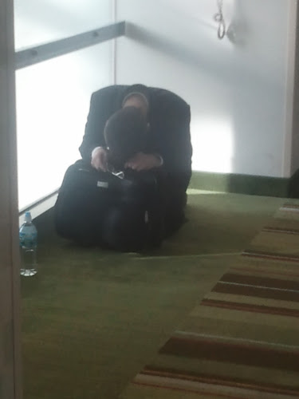
Creating a Battle Plan
First things first: before doing anything else, you should figure out how you're going to be getting to the meeting. While some people are lucky enough to have the annual meeting in their hometowns (most of you are lucky enough to have it in your state this year), getting to a convention will involve a bit of leg work for most people. Depending on the circumstances, train, plane or automobile may be the most convenient means of transportation, so be sure to look into all available options. If you plan on driving, carpooling with friends and fellow colleagues helps to keep costs down, and it never hurts to have a little company on long road trips.
Very soon it will be time to register for the meeting. So, if you are sure that you're going, take the time to act early and pre-register (by December 3rd). You'll save a few bucks ($60 to be exact), but more importantly you'll have to register in order to secure accommodations. There are a number of possibilities when trying to plan where to stay. This year the hotel rooms range in price from $109-$214 per night in price. More important than price are the amenities offered. If you are bringing a friend, spouse, or colleague Embassy Suites is nice since all rooms are suites and a cooked breakfast and evening reception (beer, wine, and some well drinks) are included. If you need internet be certain to check the cost—some hotel offer complimentary access and some want your first born.

Be Economical & Think Efficiently
Now that most of the logistics are out of the way, it's time to start planning for the annual meeting itself. Deciding what to bring along with you can be a difficult process. While it's a good idea to carry the necessities with you, remember that you'll be spending the majority of your time on your feet walking around, so don't bring more than you can comfortably carry for a day. However, there are a few items that are a good idea to have with you on your trip. Make sure to pack business cards, if you have them, as an easy way for people to remain in contact with you. Also, check the weather and bring an umbrella along just in case. Nothing is worse than being stuck out in the rain (should not be a problem in San Diego).
While it may not come to mind, anyone that has been to a convention can tell you that it's a good idea to bring some snack food along with you. Packing a lunch or some snacks will make your day a lot easier and won't cost you an arm and a leg. Of course, there are always outside dining options.
Stay Charged
It should come as no surprise that open electrical outlets are in short supply. You know how long your electric device lasts, and taking that into account, make sure you begin the day with your phone, laptop, etc. fully charged. Additionally, you may want to bring a spare battery. Going back to the whole “new friends advice”, bring a power strip and you’ll be the most popular guy/gal at the meeting.

So Many Things to Do, So Little Time
For first-time attendees, the annual meeting can be a bit overwhelming with so many things to see and do. This is especially true if you do not realize prior to attendance that the meeting is composed of talks, panels, and poster sessions from not only the AEA, but also 55 associations in related disciplines.
From personal experience, here are a couple tips if you're having trouble deciding what events to attend or if you're torn between multiple events scheduled at the same time. As a teaching faculty member attend the Community College Instructor Round Table (time-date-place forth coming) first. Second, attend teaching related presentations (I include the teaching poster sessions in this as well). Jennifer Imazeki (http://economicsforteachers.blogspot.com/) has posted these sessions in an easily digestible form on her web-site in the past. If she does this again we will let you know. If not, I will do it for you. If you have any time left over focus on attending talks related to what you are interested in. Remember there are talks hosted not only by the AEA, but also by the International Association for Feminist Economics, Association for Social Economics, Labor & Employment Relations Association, Union for Radical Political Economics,… (55 more).
After deciding what events to attend, it's helpful to figure out where they are taking place so that there isn't a last-minute scramble to find the room. Be sure to arrive early (especially if you want good seats) you would be surprised how many other economists are interested in the indigenous economies of Intuits.

Rules for the Q&A
Some panels will hold a question-and-answer session near the end of the presentation. This can be the most cringe-worthy part of any presentation because some people don’t think before they speak. This isn’t a criticism. I absolutely understand getting star struck, wanting to take the opportunity to speak with a ‘famous’ economist you admire, and not having a good question to back it up. Here’s a tip: be sure your question is a question. You have more than enough time to think of a good question, so come up with one.
Do You Really Need to Buy That? (Or Make Certain To Not Miss the Exhibitor Hall Like I Did)
Let me say up front that I’m not trying to stop exhibitors from making money. But speaking as a consumer, I want you to think through your purchases. When you’re surrounded by so much merchandise, there’s a greater temptation to impulse shop. However, you’re going to have to carry that weight around all day (so show up late, but not too late), and that’s in addition to all the free swag you pick up.
And are you really getting a good deal? Remember, you can probably find it cheaper on Amazon. A lot of the merchandise on the floor can be found online for a comparable or cheaper price.

And here’s one more question for you to consider. How do you plan on getting your stuff back home or to your office? You can either leave room in your luggage, check a bag through (which means you’ll probably pay a bag shipping fee), or you can ship it.
My recommendation is to hit up the hall more than once, so you can see everything that is offered. Make purchases on your way back to your room and if you are a bargain hunter like me the prices drop very quickly on the last day as the vendors are packing up—especially if you buy in volume.

Last, Have Fun!!!
Remember why you came to the meeting, and realize there’s so much to see and do, and you can have a good time. All of these tips are intended to help you get the most out of going to the meeting, but the most important thing is to have fun. Good luck planning your trip, and we hope to see you at the meeting soon!
You’ll have an even better time if you know someone going before you go, so email me; since I will be attending (I can even pop for drinks):
Joel Beutel: JB eutel@deltacollege.edu 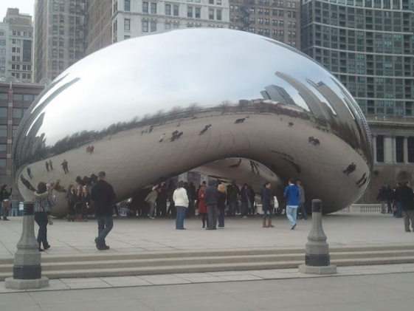 
And for other previous attendees, was there anything I missed?

