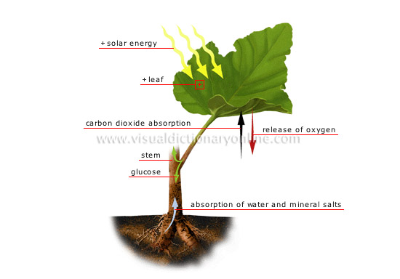

Experimental Protocol : Effect of Fertilizer on Carbon Sequestration (Student Instructions)

Research Question:
Is the ability of radish plants to sequester carbon limited by soil nutrients such as nitrogen, phosphorus and magnesium?

Experimental Design.
Radish seedlings will be planted in three different experimental conditions.
After approximately two weeks of growth, 3-5 of the healthiest plants from each bottle will be harvested and massed to determine the GREEN MASS and BIOMASS of the plants. Then, % change in biomass and the approximate amount of carbon sequestered will be calculated and graphed.

Experimental Bottle Set-Ups:

Hydroponic Bottle # 1. The Control. The variables for the control are radish seedlings, planting medium, water, fertilizer, light.

Hydroponic Bottle #2. The variables for Bottle #2 are radish seedlings, planting medium, water, light but NO Fertilizer

Hydroponic Bottle #3. The variables for Bottle #3 are radish seedlings, planting medium, water, light, NO Fertilizer with Enhanced CO2 using CalCarb.

Materials:
Each class lab team should gather the following materials:

- Three hydroponic bottle set-ups.
- 3 handi-wipe wicks
- Radish seedlings – 7-8 per hydroponic bottle set up.
- Distilled or filtered water. You will have less problems with mold if you use distilled water but filtered water works fine.
- Fertilizer solution made with distilled or filtered water.
- Laboratory mass balance – to milligrams
- Soilless Planting Mixture. Most potting soil has fertilizer already in it so you will use a hydroponic soil-less planting mixture that has no fertilizer.
- Plant light source – Plant GRO Lights, 100 Watt bulbs or a sunny window.
- CalCarb solution in Spray Bottle Mist Bottle. CalCarb is a spray that farmers and gardeners use to increase the amount of CO₂ that plants get. Gardners and farmers who grow extreme size pumpkins and other extreme size vegetables use this type of CO2 enhancement product. You can find information on CalCarb at any of these sites.

http://xtreme-gardening.com/videos/
http://xtreme-gardening.com/calcarb/what-is-it/

http://www.parsource.com/products/fertilizers/calcarb-foliar-spray

Part 1: Planting

1. Set up hydroponic bottles by rolling up a handiwipe wick and pushing ¾ of the wick into the water reservoirs in EACH bottle.

2. Label Bottle #1 – Control,
Label Bottle #2 – No Fertilizer
Label Bottle #3 – NO fertilizer /Enhanced CO₂

3. In Bottle # 1 ONLY, fill reservoir ¾ full with fertilizer solution.

4. In Bottle #2 and 3, fill the water reservoirs ¾ full with distilled or filtered water but NO FERTILIZER.
MAKE SURE THAT ALL THREE BOTTLES HAVE THE SAME LEVEL OF WATER IN THE RESEVOIR.

5. Fill the top of the EACH bottle (the growth chamber) approximately 2/3 full of planting mixture.

6. Get your germination tray with the radish seedlings from your teacher. Gently remove the healthiest seedlings from the tray. Try not to tear the roots. If you do, do not plant that seedling. Plant 7-8 seedlings in the bottle growth chamber. Use a pencil to create a hole then gently plant the seedling. Carefully spread some more planting mixture around the roots of the seedlings. Make sure the roots are covered by at least 1 inch of planting mixture.

7. Water the growth chamber with 25 ml of distilled or filtered water. If you don’t have enough, you can use tap water from now on.

8. Place near a light source. Make sure plants are equidistant from the light source. It might be a good idea to rotate the plants to ensure that they get the same amount of light.

9. In two days, spray CalCarb solution on the underside and tops of the leaves - ON BOTTLE #3 ONLY. Do this every 3-4 days throughout the experiment. This process will introduce higher amounts of CO₂ to the plants in this bottle. Its important to spray the underside of the leaves because they contain more openings (stomata/stoma) where CO₂ enters the leaf. MAKE SURE you shake the spray bottle before spraying. A white powder may appear on the leaves but it is not harmful to the plants.

Cross-Section of a Leaf showing Stoma:

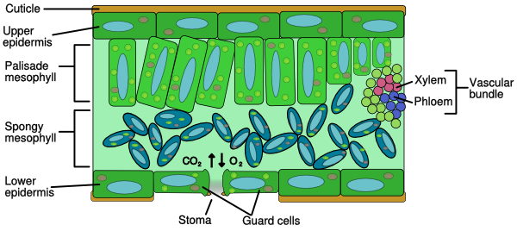

Part 2: Observations
1. Observe your radish plants every 2-3 days. Make note of any changes by writing, drawing and/or taking photographs.

2. Make sure there is ample water in the reservoirs by testing the moisture in the perlite/vermiculite with your finger. If dry, add 25 ml of distilled or filtered water to ALL three bottles. Once you see roots growing into the water reservoir, you will not have to test for water anymore. However, if the water reservoir gets low, add more water.

Part 3. Harvesting the PLANTS - Data Collection.
Your teacher will give you a separate data table to fill-in and questions to answer.

Approximately 10-14 days of growth after planting, its time to harvest your plants. You may see that some plants are taller and more robust than others in the bottle. There could be several reasons for this. For example, a faster growing plant may shade the other smaller plants from the light. Less light means less growth. Additionally, some of the smaller plants may have broken roots or a fungus that may slow down their growth. Choosing the 3-5 most robust and healthy plants will eliminate this source of error.

1. Carefully remove 3-5 of the healthiest plants from the Control bottle to mass. Pinch plants off at a node right above the roots. Don’t include the roots when you mass the plants. The reason for doing this is because the roots will be tangled up in the handiwipe wicks. By pinching the bottom of the plant stem off at the node right above the roots, you will eliminate this problem. RECORD the number of plants you are massing in your DATA TABLE.

2. Gently pat the plants dry with a paper towel and weigh the plants on the lab balance. This will give you the GREEN MASS of the plants, which includes BOTH the plant’s carbon compounds and its water. Radish plants are approximately 45-50% water – the rest are carbon compounds. Record the GREEN MASS in your data table in ROW C. Repeat steps 1 through 3 with bottles #2 and # 3.

Part 4. Making Calculations in Your Data Table – BIOMASS, % CHANGE in BIOMASS and Sequestered CARBON.

Now that you have determined the GREEN MASS of your plants, you are ready to do some simple calculations that will give you data that you can graph and analyze.

Calculating BIOMASS.
You now want to determine the BIOMASS of your seeds and your harvested plants. All living things are made primarily of water and carbon compounds with small amounts of vitamins and minerals. Because we want to know how much carbon is being sequestered in the radish plants as they grow, we need to find the approximate mass of the carbon compounds – without the WATER! This measurement is called a plant’s BIOMASS.

Finding the BIOMASS of the radish seeds is easy – it’s just a direct measurement. Radish seeds have very little water in them, so when we mass them, we are measuring their BIOMASS. You already determined the average biomass per radish seed when your teacher massed out 100 seeds and divided that mass by 100.

Finding the BIOMASS of the harvested plants requires another step. You can determine BIOMASS of the plants in one of two ways:
1. You could let your harvested plants dry out. This would remove the water while leaving carbon compounds behind.
OR
2. You could do a simple calculation. Scientists have determined that radish plants are approximately 45-50% water. So, calculating 50% of the GREEN MASS will give an approximate BIOMASS for the plants.

% CHANGE In BIOMASS:
Determining % change is a very simple but important calculation. The % CHANGE in BIOMASS calculation will give you a measure of how much BIOMASS (g) the plants have gained since first starting out as a seed. Calculating the % change allows you to compare the amount of growth between the three experimental bottles.
The general formula for finding % change is as follows:

The final measurement - beginning measurement X 100
Beginning measurement

For your radishes -
The final measurement = the BIOMASS of the harvested plants

The beginning measurement = the BIOMASS of the SEEDS.
To calculate this, you need to multiply the average mass of a radish seeds X the number of plants you massed. Example: If the average biomass of a radish seed is 0.20g and you massed five plants, then you multiply 0.25g X 5 plants = 1.25 g. This gives you the biomass of the seeds.

Calculating Grams of Sequestered CARBON
Recall that a plant grows by taking in carbon dioxide and water and using both to make carbon compounds. The BIOMASS gives us a measurement of carbon compounds, BUT not CARBON by itself. How much CARBON did these plants actually absorb from the atmosphere and sequester in their cells and tissues? Scientists have determined that approximately 40% of the BIOMASS of radish plant is comprised of only CARBON. Thus….

BIOMASS (g) X .40 = # of grams of CARBON sequestered

______________________________________________________________

When you feel that you are ready to move on, FOLLOW steps A-F below as you in-put your data and carry out your calculations. Note that each lettered step below matches a box in the DATA TABLE given to you by your teacher. Make sure that you correctly and completely fill –in each of the boxes under the Control, No Fertilizer and No Fertilizer/Enhanced CO2 columns.

First, write down the average biomass of one radish seed ___________g

- Fill-in the number of plants you massed.

- Find the beginning BIOMASS of your radish plants by multiplying the # of plants you massed X the average biomass of a radish seed.

- Fill-in the GREEN MASS of the plants if you haven’t done so already. Recall that plants are approximately 45-50% water, so the GREEN MASS include both carbon compounds and water.

- Calculate the approximate BIOMASS of the plants. Multiply the GREEN MASS X .50 This will give you the approximate BIOMASS.

- Calculate the % CHANGE in BIOMASS. The formula is as follows:
BIOMASS of harvested plants - BIOMASS of the seeds X 100
BIOMASS of seeds

F. Calculate the number of grams of carbon sequestered in the harvested plants
BIOMASS of harvested plants (g) X .40 = grams of CARBON

G. Optional Calculation.

Part 5: Graphing, Data Analysis and Questions.

Follow the graphing and analysis instructions on the Data Table Sheet. Then answer the Stop and Think Questions.

