Assignment: Seeing a City, Part I

This assignment is an exercise in exploring and describing an urban environment.

Task:

Below are two maps of Beloit. At some point before the next class period you should walk the assigned path in groups of no more than two or three. Take something small with you to write on (small notebook, half a sheet of paper, notecard) and a pencil. But nothing too large or obvious. You should spend most of your time walking and observing, using the notebook to write down things you don’t want to forget.

Upon your return to campus, you should go to the computer lab and begin to write down your observations of your walk. Your observations can be about things you see, things you smell, hear, etc.

On one sheet of paper, single-spaced, type up and expand upon your observations for each of the two walks. Your reflection of your walk can include a list of things you saw, reflections on things you noticed, first impressions of the areas through which your walking, comparing and contrasting to other types of city environments.

Criteria for Evaluation:

* The degree to which your reflection and descriptions of your walks demonstrate careful attention to your surroundings and thoughtful explanation of your observations.

Map 1
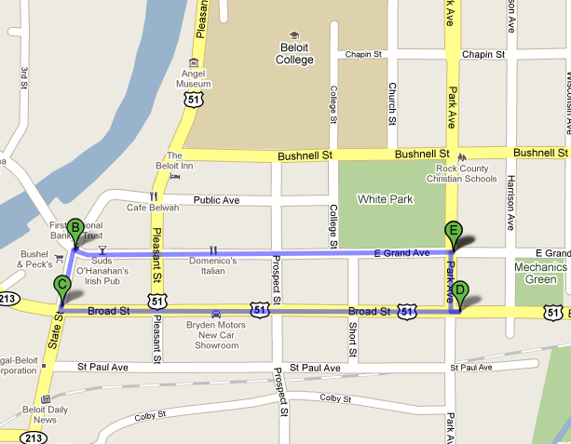
Map 2
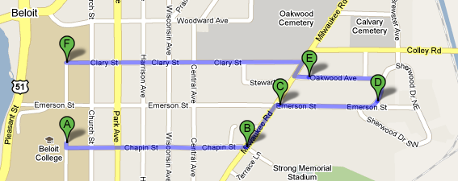

Assignment: Seeing a City, Part 2

Take the two walks that you did previously, preferably in the same groups you did 12 weeks before. Please try to walk with the same individuals you did the first time.

Send me, 24 hours before the next class, a one-page description of your observations for each walk. Thus you will submit two one-page descriptions.

Assignment: Reflecting on Seeing a City, Part 3

In front of you are 4 pages of paper. For both the downtown walk and the residential walk you should have a description from August and one from November. Your task during the class period is to reflect on the differences between the August documents and the November documents. You should respond to the following questions in your reflections

- What is different about your observations about the downtown and residential areas of Beloit as embodied in your descriptions?
- Does the difference (or lack of difference) between the August and November documents surprise you? Why or why not?
- Why do you think there is a difference between your description of the city of Beloit between August and November?
- To what extent has the FYI seminar influenced how you perceive things?
- To what extent are the differences between the two documents instead a reflection of how you have changed over the term?
- Are there any additional skills or tools that you brought to the table?

