Name:_______________________________________ Date:_______________________

Richmond’s Urban Heat Island
"The urban heat island effect is both the clearest and the best documented example of
inadvertent climate modification by humans.”
- Tim Oke (1987)

Key concepts in this lab:
Local Climate and Microclimate
Land Use / Land Cover
Data Analysis and Display

Materials needed:
Microsoft Excel
Internet Access
Google Earth

Introduction: People have inadvertently modified local climate and microclimates within communities since the dawn of civilization. One of the most common results of these modifications is that urban air temperatures are often warmer than temperatures in surrounding rural areas. This phenomenon is called the urban heat island (UHI) effect, which is most commonly defined as the difference between urban and rural temperatures. Virtually all urban developments have measurable urban heat islands, including Richmond, KY. In this lab, we will use real air temperature data from two stations in Richmond to examine its UHI. We will also examine some of the UHI’s causes and impacts.

Part 1 - Causes: A number of factors contribute to UHI development. Most result from replacing natural land cover with artificial ones, and activity in the city. For the three factors listed below, provide 1-2 reasons why these things could contribute to the UHI. (2 points each).
A. Physical properties of construction materials

Construction materials tend to have low albedo, which allows them to absorb much of the solar radiation that hits them. Also, many construction materials tend to maintain their heat for long periods of time and slowly release this energy throughout the night.

B. Decreased evapotranspiration

Evapotranspiration is a cooling process since it absorbs latent heat energy from the surrounding environment. If this energy is not consumed as latent heat, it contributes to sensible heat in the local energy balance.

C. Anthropogenic heat sources

Direct sensible heat inputs from automobiles, factories, appliances, and even body heat contribute to the warmth in urban areas.

Part 2 – Site Description: We will be working with data from two weather stations in Richmond. Station #1 is located behind City Hall (37.7487°N, 84.2952°W) and is representative of Richmond’s urban environment (figure 1a). Station #2 is located approximately 7 miles east of downtown at EKU’s Meadowbrook Farm (37.7147°N, 84.1560°W) and is representative of the rural environment outside of Richmond (figure 1b). Please visit the following websites to view additional pictures of each site.
City Hall http://people.eku.edu/yowd//uhisite/city.htm
Meadowbrook Farm http://people.eku.edu/yowd//uhisite/farm.htm
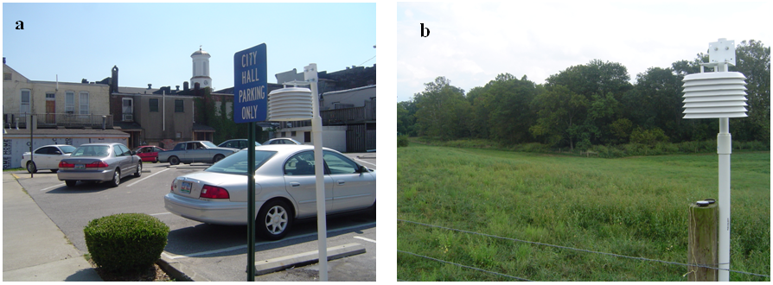Figure 1: Urban station at City Hall (a), and rural station at Meadowbrook Farm (b).

After viewing the site photos, open Google Earth and type each station’s coordinates into the “Fly To” area. Take special note of the land use/land cover in the vicinity of each station and consider how each station’s surroundings will affect local temperatures.

1. What features near City Hall do you see that will contribute to the urban heat island effect?
It may be helpful to contrast this area with the site at Meadowbrook Farm. (6 points)

Natural land cover has been replaced by artificial ones that will absorb lots of solar energy and release that stored energy throughout the night. Building geometry allows for multiple reflections of solar energy and admittance of longwave radiation, thus creating multiple opportunities for energy to be absorbed. Impervious surfaces will drain quickly and very little vegetation is present; both contributing to decreased evapotranspiration. Human activity will directly contribute anthropogenic heat to the area.

2. Meadowbrook Farm is in a rural area and does not contain features that will contribute to the urban heat island effect. However, you will notice that the image on Google Earth looks distorted. Why? (i.e., what is different about the remotely sensed imagery in this area compared to adjacent areas further west?) Hint; think about how the imagery may have been collected, its intended purpose(s) and resolution. (4 points)

Google Earth contains a hodgepodge of imagery collected from various sources. The imagery for the city of Richmond is at a higher spatial resolution than the imagery over Meadowbrook Farm. A possible reason that Richmond is at a higher resolution is that the heterogeneous nature of urban areas dictates that we need higher resolution imagery to address issues in those areas.

Part 3 - Data Analysis: Data from the two weather stations discussed in the previous section are available on this course’s Blackboard page.

Step 1: Download the file titled Richmond_UHI.xls from Blackboard and open it in MS Excel.
Step 2: Create hourly data for each station. Average the 10-minute data such that each hour is the average of the six observations collected from 00:10 to 1:00.
Step 3: Compute hourly UHI intensity for each hour (UHI = urban-rural) and complete the following:

1. Create a table showing the average hourly temperature for each station and the hourly UHI intensity. The first column should list the time, and the next 3 columns should list urban temp, rural temp, and UHI intensity. Print this table and attach it to your lab. (5 points)

Date and Time (EST) | City Hall (ºF) | Meadowbrook (ºF) | UHI Intensity (ºF)
11/25/05 1:00 | 18.401 | 17.822 | 0.579
11/25/05 2:00 | 17.483 | 16.412 | 1.071
11/25/05 3:00 | 16.991 | 14.369 | 2.622
11/25/05 4:00 | 16.787 | 12.977 | 3.81
11/25/05 5:00 | 16.358 | 11.879 | 4.479
11/25/05 6:00 | 16.064 | 10.907 | 5.157
11/25/05 7:00 | 15.947 | 10.328 | 5.619
11/25/05 8:00 | 15.659 | 10.331 | 5.328
11/25/05 9:00 | 17.873 | 14.957 | 2.916
11/25/05 10:00 | 20.624 | 20.399 | 0.225
11/25/05 11:00 | 21.959 | 22.37 | -0.411
11/25/05 12:00 | 24.788 | 24.902 | -0.114
11/25/05 13:00 | 27.68 | 27.479 | 0.201
11/25/05 14:00 | 29.54 | 29.477 | 0.063
11/25/05 15:00 | 31.223 | 31.505 | -0.282
11/25/05 16:00 | 32.129 | 32.516 | -0.387
11/25/05 17:00 | 31.76 | 32.522 | -0.762
11/25/05 18:00 | 30.89 | 29.738 | 1.152
11/25/05 19:00 | 30.299 | 25.238 | 5.061
11/25/05 20:00 | 30.044 | 22.418 | 7.626
11/25/05 21:00 | 29.543 | 20.9 | 8.643
11/25/05 22:00 | 27.647 | 19.814 | 7.833
11/25/05 23:00 | 28.031 | 20.225 | 7.806
11/26/05 0:00 | 27.38 | 19.511 | 7.869

2. Plot bar graph of hourly UHI intensity and attach it to your lab. (5 points)

3. Plot line graph of hourly UHI intensity and attach it to your lab. (5 points)

4. Do you think either graph is more informative and/or easier to interpret than the other? Explain your response with 1-2 complete sentences. (5 points)

Answers will vary.

5. What was the lowest hourly UHI intensity on this day? What time did this occur? (4 points)

-0.762ºF at 1700 EST

6. What was the greatest hourly UHI intensity on this day? What time did this occur? (4 points)

8.643 ºF at 2100 EST

7. What was the mean (average) hourly UHI intensity on this day? (2 points)

3.171ºF at 1700 EST

Part 4 – Impacts: Cities artificially alter local climates affecting atmospheric, economic, and biological processes. For each of the four items listed below, briefly explain how/why the UHI affects these things. (Short answer, 2 points each).
A. Heating and cooling costs

Warmer urban temperatures will cause cooling costs to be higher and will decrease heating expenses.

B. Human comfort and health

Heat kills more people than any other weather-related hazard. The UHI often raises mortality rates during heat waves. Symptoms of some illnesses, especially those of the heart and lungs, are also worsened during heat waves. Limited studies indicate that crime rates, particularly violent crimes, increase when people become irritated from extended exposure to uncomfortable temperatures.

C. Plants and/or animals

Individual species may be affected differently depending on their own biology, but general impacts include: increased/extended growing season, earlier flowering dates, and altered species range.

D. Long-term temperature records

Replacing natural land covers with artificial materials in the vicinity of a weather station often causes artificial trends of increasing temperatures to appear in a station’s record, which may not be representative of climatic trends that have occurred on a larger scale. Thus, failure to account for urban bias can lead to misinterpretation of climate data.

Part 5 - Critical thinking: As urban areas continue to expand there is a heightened awareness that scientific knowledge of the urban heat island must be more effectively communicated to appropriate professionals such as architects, engineers, and urban planners. What do you think is/are the best strategies to promote communication between these various groups? Why might one way of doing so be more or less effective than another? Write your answer using 3-5 complete sentences. (6 points.)

Answers will vary….student responses will be interesting to read!

