Contractional Strain: Calculations Name:

In this exercise, you will explore strain within the context of a contractional fault system. The goal is for you to understand how strain is accommodated within such a system. The image for this exercise is taken from Dixon, John M. and Liu, Shumin, Centrifuge modeling of the propagation of thrust faults, in Thrust Tectonics (Ken R. McClay, ed.), 1992.

After completing this exercise, you should be able to
- Describe and calculate the bulk strain within a foreland fold-and-thrust belt, if the undeformed geometry is known.
- Explain how that strain is accommodated by a suite of common structures.

Exercise 1: Calculating the bulk strain
Look at Figure 1 (see next page). This is a figure from a paper about physical modeling of contractional deformation. It is a line drawing of 5 stages of a single experiment. The thicker layers are made of a stiffer material than the thinner layers, which allows the shortening to be accommodated differently within the different layers. If you think about the deformation you have seen on field trips or in photographs, you will recall that this behavior happens in rocks, as well.

You may complete this exercise on your own or in groups. If you work in a group, you are welcome to divide up the calculations, so that each person does less work.

- Choose or create a unit of measure. Anything you like. (Each person in the group can choose a different unit, or you can agree on one.) Strain is non-dimensional, so it won’t matter what units you use to measure it.

- Calculate the bulk shortening for each stage of the deformation, using the top image as a reference point for the undeformed state. To calculate the bulk shortening, estimate the average length for both the deformed and the undeformed state. Compare your four answers: do they make sense? That is, do your estimates form a natural progression from least deformed to most deformed? (If not, figure out where your calculations went wrong.)

- Calculate bulk thickening for each stage of deformation, in the same way. Compare your answers again, to make sure that they make sense.

- Has there been any change in cross-sectional area during deformation? If so, approximately how much?

- Is the strain 1D, 2D, or 3D?

- Calculate overall thickening in one of the thick layers, from the beginning to the end of the whole deformation (meaning, you don’t have to calculate it for each stage of deformation). That’s due to a process called Layer Parallel Shortening (LPS).

Exercise 2: Strain accommodation
What specific kinds of structures accommodate the shortening and thickening you observe? Can you “guesstimate” which type of structures accommodate the most strain? Don’t forget that LPS accommodates some of the shortening.

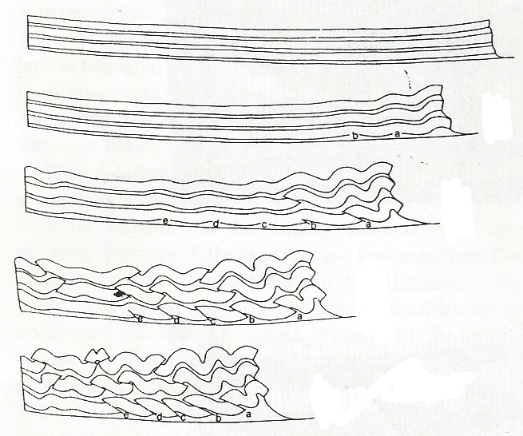
Figure 1. Line drawings from experimental contractional deformation. From Dixon and Liu, 1992.

Extra Credit: Comparison to extension
Compare these images to images from physical models of extensional deformation, here: http://serc.carleton.edu/NAGTWorkshops/structure/activities/6662.html
(See the downloadable files at the bottom of that page.) How is extensional deformation different from contractional deformation? How is it similar?

