
Taking the Pulse of Yellowstone’s “Breathing” Volcano: Problem-Based Learning in America’s First National Park

INSTRUCTOR’S NOTES

Topics: Volcanoes, earthquakes, ground deformation, geysers, hydrothermal systems, plate tectonics, hot spots, GPS, GIS (Google Earth), Yellowstone National Park, infrastructure placement

Goals:
Students will be able to:
  - Discuss the hazards associated with volcanic processes.
  - Explain the sources of energy behind volcanic processes.
  - Describe why and how volcanoes are monitored.
  - Explain the role that geodesy has played in advancing scientific understanding of volcanic hazards.
  - Describe how volcanic processes alter the surface of the earth.
  - Analyze data spatially and temporally using Google Earth.
  - Use Earth science data to inform societal decisions about infrastructure development.

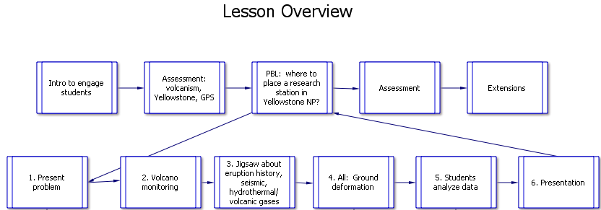
PBL = Problem Based Learning

For connections to Benchmarks for Science Literacy and Earth Science Literacy Principles, see Appendix A.

Summary:
In this activity, students learn about volcanism in Yellowstone National Park, focusing on its history of eruption, recent seismicity, hydrothermal events, and ground deformation. They learn how scientists monitor volcanoes (using Mount St. Helens as an example) and then apply that as an open-ended problem to Yellowstone; their problem is to identify a site for a research station.

Levels: Appropriate for range of introductory Earth science courses including National Parks, Physical Geology, Natural Hazards, and Environmental Geology

Teaching Time: At least three class sessions (~1 hour each).

Organization: This activity consists of three parts:
- Introductory pieces (engaging your students and finding out what they already know);
- A Problem-Based Learning section in which students learn about volcanism in Yellowstone and select a site for a research station;
- Concluding pieces in which you assess your students and have the opportunity to extend their learning.

Procedure:
(Note that clicking on the following steps takes you to expanded sections with details.
- Engage your students—Use suggested resources and activities to draw your students into the marvels of Yellowstone and these lessons using videos, images, or an activity that uses an iPhone or iPad as a seismometer.
- Find out what they already know about monitoring volcanoes, earthquakes, hot spots, Yellowstone National Park, national parks in general, and GPS. This will help you tailor instruction and will let students see how much they learn.
- Present the problem—Hand out the Student Instructions, which guide students through this set of lessons. Divide students into teams of three. They will work in groups to find a location for a permanent research station that will be somewhere they deem to be safe and sensible. Set them to work on the problem.
  - Learning to monitor volcanoes—Have them view a presentation about how scientists monitored Mount St. Helens before its 1980 catastrophic eruption—and saved lives by raising the alarm about an impending eruption. You can do this in class as a lecture, individually, or in teams of students. If you “flip” your instruction, this could be a homework assignment.
  - Jigsaw activity—Have the students work through presentations (again, this can be done in class or as homework, depending on how you run your classes) to understand and analyze data regarding the area’s history of eruptions, seismicity, and hydrothermal events. Students each become an expert in one of the three topics. For this and the next step on ground deformation, you can ask students to work on paper maps or to use Google Earth.
  - Team learning about ground deformation—have all students, in their teams, learn about how parts of Yellowstone’s topography is changing on a measureable scale.
  - Selecting a site for a research station—have student teams apply what they have learned in the jigsaw activity and about ground deformation and agree upon a place for a research station. This can be done with paper maps or Google Earth. Their instructions also call for them to develop guidelines for determining when the station must be evacuated.
  - Presenting and supporting their decision—students will develop a product of your choice that expresses and explains where they propose placing a research station and why.
- Assess—you and your students evaluate what they have learned in this activity.
- Extend—if you have the time and interest, expand upon this lesson.

Materials:
Student Instructions--one copy per student or per group
Student computers with Google Earth, PowerPoint viewer, and internet access
Computer files of presentations and Google Earth data.
Presentations are:
Monitoring Volcanic Activity
Taking the Pulse of Yellowstone’s “Breathing” Caldera—Eruptive History
Taking the Pulse of Yellowstone’s “Breathing” Caldera—Seismicity
Taking the Pulse of Yellowstone’s “Breathing” Caldera—Hydrothermal
Taking the Pulse of Yellowstone’s “Breathing” Caldera—Ground Deformation
Data files are:
Map overlay – for all students
200 recent earthquakes – for Seismicity
200 top earthquakes – for Seismicity
Geysers – for Hydrothermal
Heat – for Hydrothermal
GPS deformation – for team as a whole

Introduction:
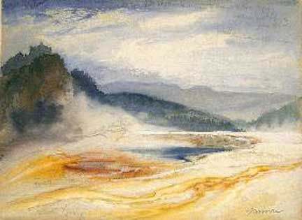
Yellowstone pulses. A geophysicist, Bob Smith, described it as a “living, breathing caldera”, in interviews in the late 1970s. This lesson, set amongst the geological and biological marvels of Yellowstone National Park offers you a way to teach your students about volcanism, geysers and other hydrothermal features, seismicity, plate tectonic hot spots, geological monitoring, and how the work of scientists informs decisions made by non-scientists. You will give your students a broad problem to work on in small groups and guide them as they make a decision and present it.
Image 1. Great Springs of the Firehole River. Thomas Moran, 1871.
This example of Problem-Based-Learning (PBL) could be simple and sweet—three classes—or more comprehensive and open-ended—a full-fledged unit over a week or two.

We do think though that some pieces are critical for its success; even those have options to meet different time constraints and different students’ needs. In the diagram on the page one, the essential pieces are shown by rectangles. And within those, you can expand or contract the activities. Delicious add-on features are shown as diamonds.

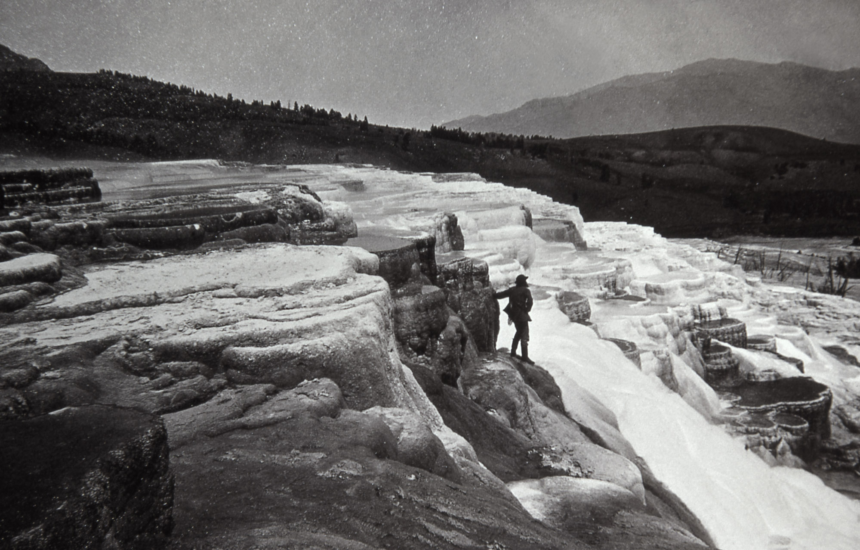
In this PBL, the problem (next section) takes advantage of real-time and recent data collected to monitor geological changes and events in this first national park in the world. Yellowstone is a national and international treasure that is sure to engage your students; it is exotic and wild, where the ground smokes and water shoots into the sky while majestic, primeval bison graze and wolves stalk those bison and elk. In this Hadean place, scientists use high-end, elegant and sophisticated technology to measure natural features (e.g. temperature of hot springs) and events (e.g. earthquakes) and to analyze data for changes and trends.
Image 2. Hot Springs on Gardner River. William Henry Jackson, 1871.

Students will use Google Earth to compare locations of geological features such as earthquake epicenters and hot springs. Using their analyses, they will recommend a location for a research facility as well as guidelines for deciding when danger necessitates evacuation. Finally, they will present their recommendation verbally, in a brochure, or in a white paper.

In Appendix B, we supply general articles or websites for you to read if you want to bolster your own background on Yellowstone. Other resources are listed on the presentations your students will view. The latter are either appropriate for students or they have been used as sources for the presentations.

The Problem Your Students will Tackle:
In brief, your students have been hired to find a safe site for a research station in Yellowstone National Park, safe enough to avoid geological hazards for at least 100 years. Researchers must have access by road, yet the station cannot be a blight on the landscape. Students can assume that the site will occupy 8,000-16,000 meters² (2-4 acres). A corollary task, to help them focus on changes in the park through time, is to develop a safety protocol that spells out circumstances that would require scientists to evacuate their camp. This scenario is fleshed out on the students’ instructions.

Engaging Your Students:
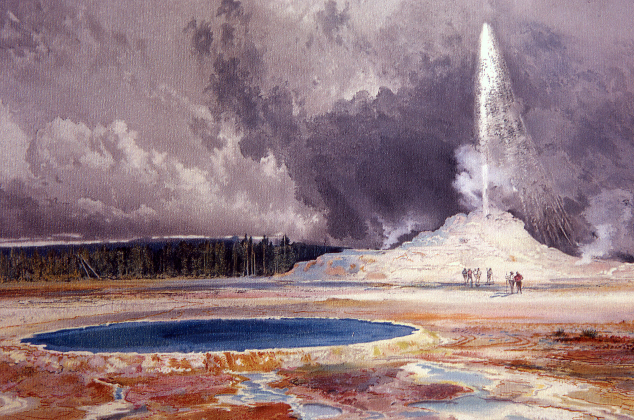
Yellowstone is marvelous, and you can use the marvels and their influence on American history and culture to engage your students so that they are eager to work on this problem. The park is the scene of repeated catastrophes, and death and destruction is always a powerful angle. The park represents the classic American family road trip. Visitors can see the greatest concentration of geysers, hot springs, bubbling mud pots in the world. They can see bison, wolves, bears, elk, moose, coyotes, and other animals. Ken Burns, in his series, “National Parks”, caught the nations’ attention in 2010 by highlighting its role as the world’s first national park. (It is also a UNESCO Biosphere Reserve and a World Heritage site, bringing in international visitors.) Artists and art lovers know it through Thomas Moran and Alfred Bierstadt paintings. History buffs love it because of its ties to exploration of the West during the Hayden Survey of 1871. Paintings and photos from that survey influenced Congress to create the National Park System. People who love architecture enjoy the buildings at old Fort Yellowstone and the Old Faithful Lodge. And even people who have none of those interests but who have seen Yogi Bear cartoons are tuned in to Jellystone National Park.
Image 3. Castle Geyser, Upper Geyser Basin. Thomas Moran, undated.

We suggest that you use one or more of those connections to intrigue your students in the park, its features, and thus the problem. You could show your students some of the resources listed below or do an activity with your students. You can use them to engage your students at the beginning of the lessons--and at the beginning of each class period. And, you could also use them like a movie trailer to build anticipation.

The resources fall in several categories. For you to introduce the lessons, we suggest some of the best below. If they are videos, the duration is listed to help you manage instructional time.

A comprehensive view of Yellowstone--geology, wildlife, history, and national parks, as video clips:
Video, 1:36 Inside Yellowstone: Introduction by Kelli English, a ranger
Video, 2:20 Yellowstone: Land to Life trailer
Video, 19:00 Yellowstone: Land To Life
Video, 2:25 Teachers' Domain: A Visit to Yellowstone

A volcano, hydrothermal, or geology connection:
Video, 2:30 Sunrise Earth: Yellowstone’s Geysers
Video, 3:23 How the Earth Was Made: Creation of Yellowstone
Video, 6:00 Yellowstone InDepth: Yellowstone's Restless Giant
Video, 120:00 Supervolcano
Webcam, streaming video of geysers Eyes on Yellowstone

A wildlife connection:
Video, 1:59 Shelton Johnson on a Transcendent Moment in Yellowstone
Video, 2:59 Planet’s Best: “Yellowstone National Park”
3D image of buffalo walking along a road--very cool!

A death and destruction connection:
Video, 120:00 Supervolcano

An art connection:
Moran watercolors from the electronic exhibit American Visionaries: Thomas Moran
Electronic exhibit The Influence of Art on Yellowstone and companion art-based lessons: Choices and Documentation and The Art of Thomas Moran.

A history connection:
Video, 3:27 Yellowstone Becomes the First National Park

A quirky, charming connection:
Video 1:59 Shelton Johnson on a Transcendent Moment in Yellowstone
Video 5:49 Nature: “Explorers of Yesterday and Today”
Video 7:17 Yogi Bear cartoon, Episode 1
Video 8:24 Rudyard Kipling and the Grand Tour of Yellowstone.

To streamline the introductory engagement, choose one or two short videos that will interest your students—perhaps one of the comprehensive ones or quirky ones.

Preliminary Assessment
After you engage your students and before you dive into instruction, you will want to know what they already know, what they know little about, and in what ways they misunderstand things. Taking the time for this preliminary assessment will save you time in the long run and will focus your instruction. It can also act as a baseline for identifying what your students learn from the lessons.

Formats for assessing their prior knowledge could include:
- Think-Pair-Share in which students think about the question, share their responses with a classmate, and report the combined response. This engages all students.
- Concept maps—electronic or with sticky notes on paper. Concept maps tell you what your students know now and let students to see how their knowledge evolves. This engages all students if done individually or most students if done collectively in small groups.
- Whole class discussion. Quick and dirty, but students can hide behind their reluctance to participate.
- Writing from a prompt—an image, a video, a quotation, or a question. Engages all students but will be time-consuming for you to read their input.

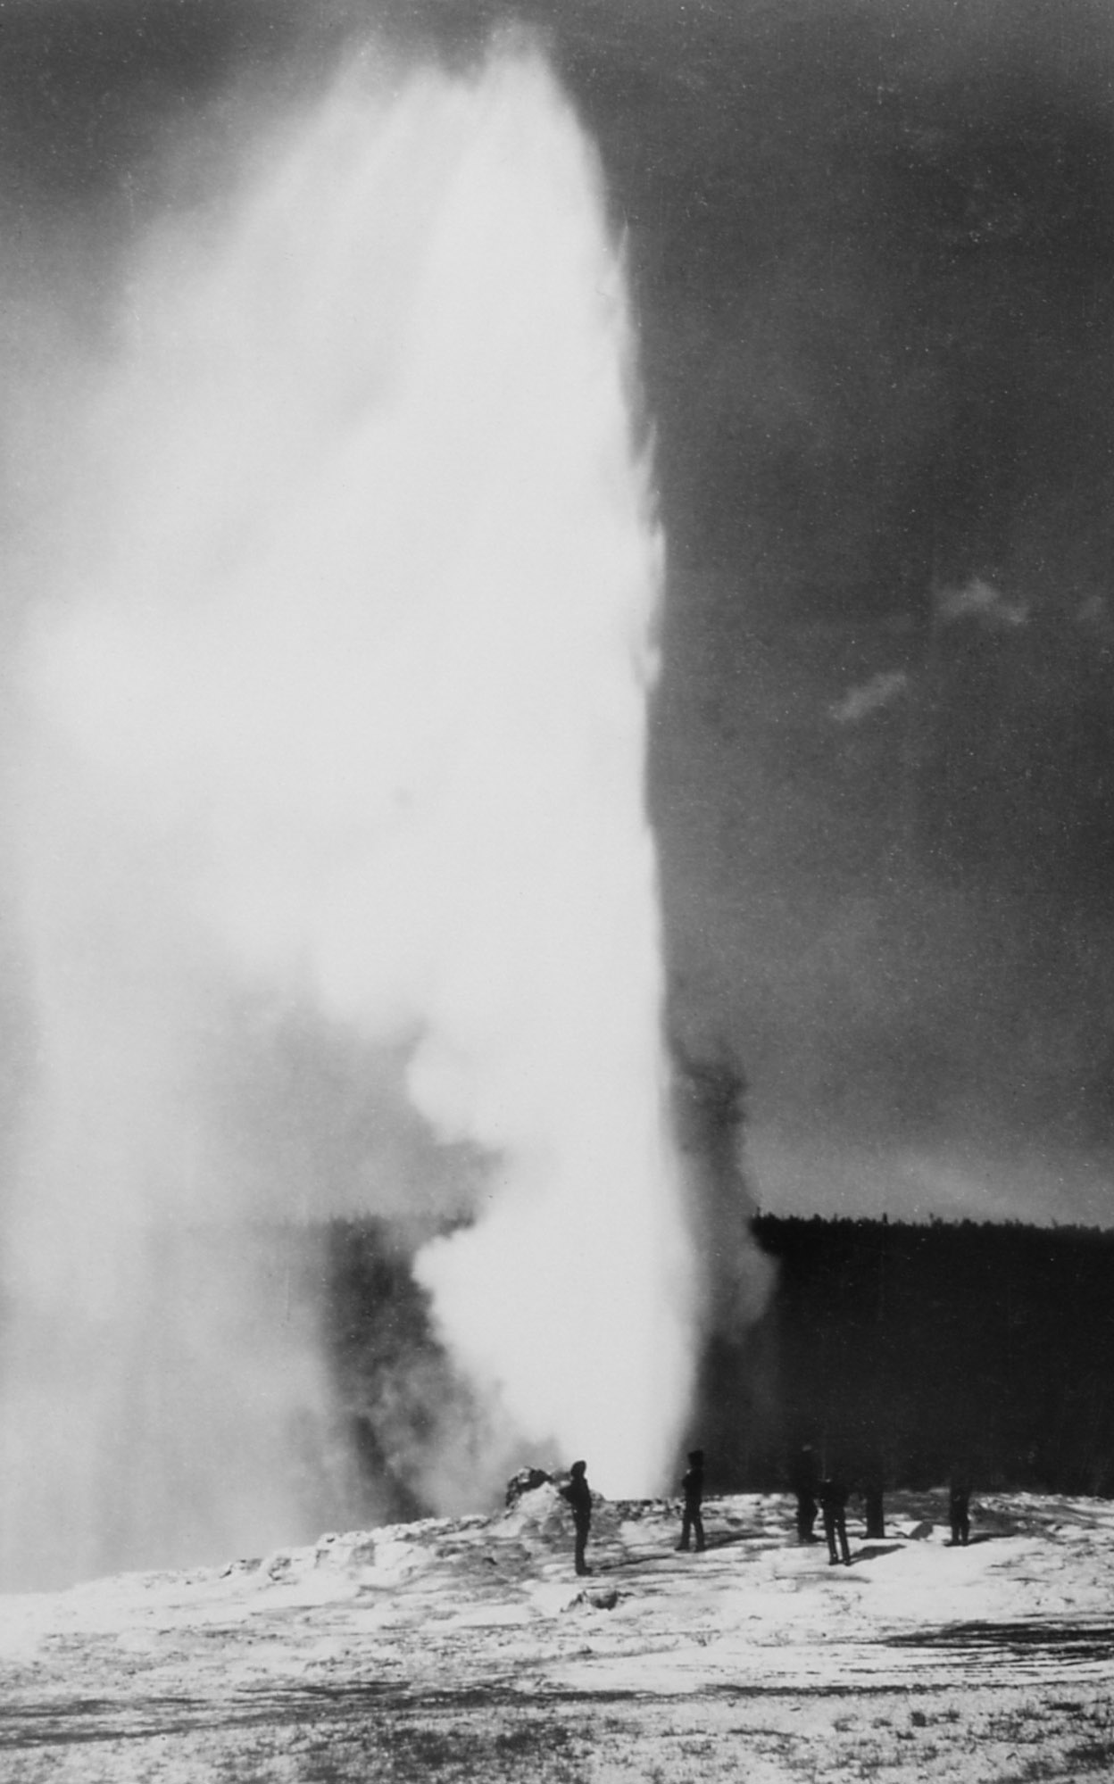
Preliminary assessment for these lessons should include something about volcanoes, earthquakes, hot spots, Yellowstone National Park, national parks in general, and GPS. You don’t need to evaluate all of these at one time. You can, for instance, open a class with a short video and/or question to learn what your students know about a topic and focus them on your class. Circulate as students work on the assessment. For Think-Pair-Share, discussion, or writing questions could be from among the following:
Image 4. "First" Picture of Old Faithful Eruption. William Henry Jackson, 1872.

- What do you know about America’s national parks?
- Have you ever been to one? What was your experience? How did it feel? What was interesting about it?
- Have you been to Yellowstone? What was memorable about it?
- If you haven’t been to a national park, are there some that you’d like to go to? What interests you about them?
- What do you know about Yellowstone National Park? In the video we watched [pictures we saw…], what caught your attention?
- What do you know about volcanoes? Does Yellowstone fit your image of a volcano?
- What do you understand about how scientists predict when volcanoes will erupt?
- Have you ever experienced an earthquake? What was it like? What happened?
- Describe what you understand about hot spots.
- Describe how you understand GPS units to work.
- When I showed you art from Yellowstone, how did it make you feel? What was your gut reaction to the scenes? To the way it was drawn…painted…photographed?

If you have students build concept maps, logical topics are:
- Predicting volcanoes;
- Hot spots;
- Yellowstone National Park; and
- Navigation and GPS.

To streamline the preliminary assessment, do Think-Pair-Shares about Yellowstone, predicting volcanoes, earthquakes, and GPS.

Problem-Based Learning
1. Presenting the Problem
The “Taking the Pulse of Yellowstone’s ‘Breathing’ Caldera” Student Instructions provide an overview of what students will be able to do (the “performance objectives”), the problem that they will solve as a team, general instructions for how to do the project, and then details. Of course they’ll still need you to direct them, and you will need to make some decisions in advance (e.g. Oral presentation or written?). The decisions are spelled out below.

Parks
If your assessment reveals that your students know little about national parks in general and Yellowstone National Park in particular, you will probably want to step back and show them a few videos to give them some background. You’ll be able to lower their discomfort and enhance their success by showing them one or more of these:

Video, 7:03 Tools for Exploring Yellowstone - Have it Your Way
Video, 1:36 Inside Yellowstone: Introduction
Video, 2:25 Teachers' Domain: “A Visit to Yellowstone”
Video, 19:00 Yellowstone: Land To Life

2. Volcano Monitoring
a. Assessment
If you have not already assessed what your students already know about why and how we monitor volcanoes, you will want to do it now. If your students are well-versed in it, skip ahead to the next section, the jigsaw part of this problem.

You could ask your students, “Why would knowing when a volcano will erupt be important?” Or, you could ask them whether they, their family, or friends live on or near a volcano? If so, what do they worry about? (Examples could be lahars, pyroclastic flows, ash falls, and lava flows.) What do their parents or grandparents remember about Mount St. Helens erupting? You could ask, “Why might people like to visit volcanoes?” (Examples could be recreation such as hiking, fishing, 4-wheeling, hunting, and rock climbing.) “What other volcano hazards have you heard about—say if you fly on airplanes or simply live on Earth?” (Examples could be ash in plane engines, volcanic aerosols effect on climate, or the emission of greenhouse gases.) Finally, “What do you understand about how scientists know when volcanoes will erupt? What information do they use or could they use?”

b. Monitoring Volcanic Activity
If you learn that your students’ knowledge of volcanic hazards is skimpy, this would be a good time to discuss volcanic hazards. Students are usually familiar with eruptions and lava flows, but are less likely to know about hydrothermal features, gas emissions, or volcanic mud flows. You can discuss them as the subject comes up during the presentation on monitoring volcanic activity:

Science of Prediction: Monitoring Volcanic Activity

The presentation teaches how scientists monitor volcanic activity and how such monitoring detected the impending eruption of Mount St. Helens in 1980. We recommend that you show this presentation using the notes to guide your comments. Alternatively, have your students work through the slides, with the notes printed for them. To streamline this, print out the presentation or post it electronically and assign students to read this as homework.

Two brief print resources for you on volcanic hazards are:

USGS Types and Effects of Volcano Hazards
USGS Fact Sheet What are Volcano Hazards

Other resources on volcanic hazards and monitoring are compiled in Appendix B.

3. Jigsaw to Address the Problem of Siting a Research Station
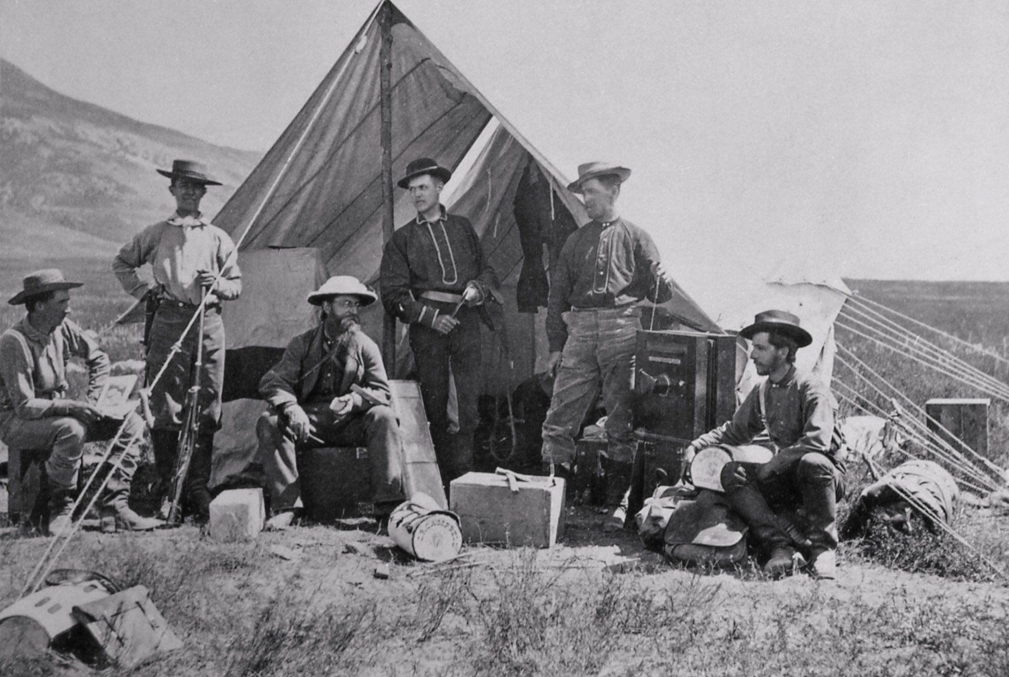
a. Divide your students into teams of three. The teams will divide and conquer information and data about Yellowstone on the topics of eruptive history, seismicity, and hydrothermal systems/volcanic gases. These are the same topics they learned about with respect to Mt. St. Helens in the presentation, “The Science of Prediction: Monitoring Volcanic Activity”. Each team will have a student who studies the eruption history of Yellowstone. Another student will have studied Yellowstone’s seismicity. And the third will be an “expert” on hydrothermal systems and volcanic gas emissions in Yellowstone. Consider letting the students decide who learns what. (The last topic, ground deformation, is something all students will work on within their teams.)
Image 5. Hayden Expedition in Camp. William Henry Jackson, 1872.

b. Gather all of the students learning the eruption history together to learn about the history of eruptions at Yellowstone. Do the same for the seismicity students and for the hydrothermal/gas students. We have provided a brief presentation on each of these subjects. Let them work through the presentation and discuss what they think will be most important to take back to their teams. The presentations and student instructions provide questions for students to think about and discuss while in these “expert” groups.

Taking the Pulse of Yellowstone’s “Breathing” Caldera—Eruptive History
Taking the Pulse of Yellowstone’s “Breathing” Caldera—Seismicity
Taking the Pulse of Yellowstone’s “Breathing” Caldera—Hydrothermal

c. Then put the teams back together, with a student from each of the expert groups. Encourage the team members to compare notes on what they have learned about Yellowstone. They will use this knowledge, and what they will all soon learn about ground deformation, to site their research station.

4. Ground Deformation
Have your teams now work with the ground deformation data. As before, we have provided a presentation on ground deformation.

Taking the Pulse of Yellowstone’s “Breathing” Caldera—Ground Deformation

Students will learn about how scientists used to use land surveying instruments but now use two complementary satellite-based methods to measure how the land is deforming—or the caldera is “breathing”.

You can easily expand this section by having students work through a lesson on navigation and GPS.

Where AM I: the Evolving Technology of Navigation
www.unavco.org/cws/modules/cws/modules/yellowstone/

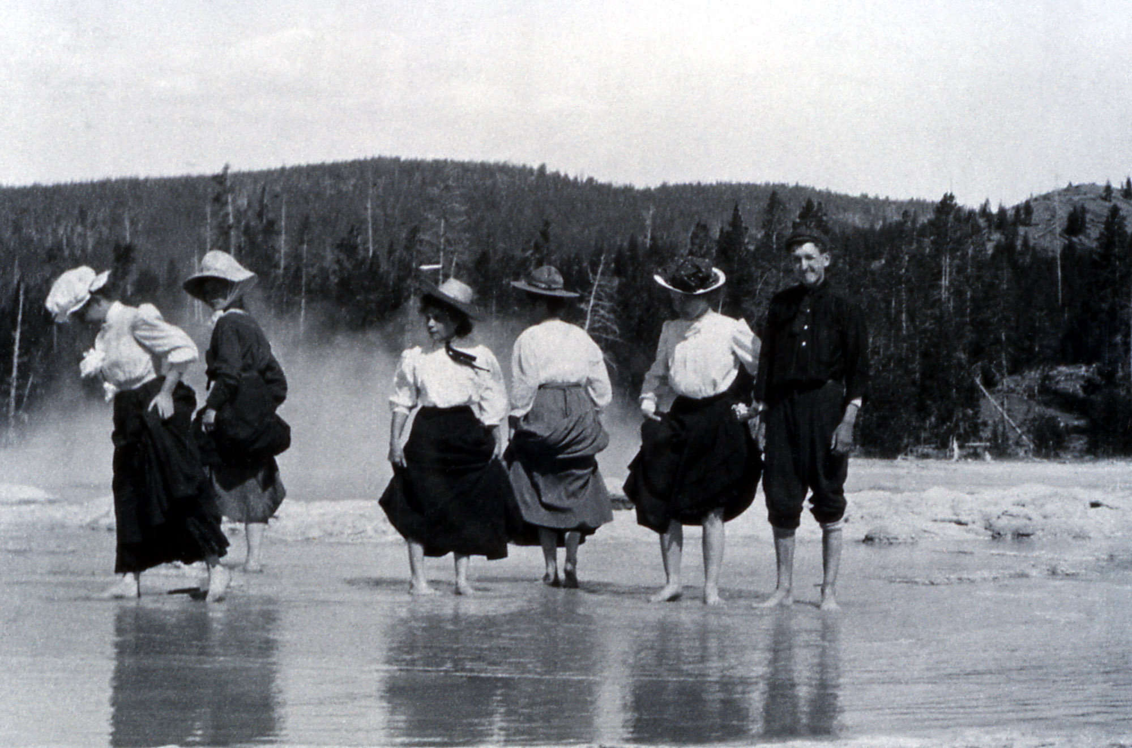
In this, students research the history of navigation leading to the development of GPS. They will then design a timeline to illustrate and communicate their findings.

We suggest that, in preparation, you review the presentation, “Introduction to Reading GPS Time Series Plots” as background. This it will help you understand how the GPS data is processed as well as how to use it. The Yellowstone GPS data set uses only vertical data. However if you plan on using other EarthScope activities (e.g. Cascadia, on plate tectonic in the Pacific Northwest), this presentation is good background material.
Image 6. Tourists Wading in Great Fountain. Photographer unknown, 1908.

5. Making a Decision: Placing the Research Station
Teams will look at all of the components they’ve studied—eruptive history, seismicity, hydrothermal activity, and ground deformation—as well as purely practical matters such as proximity to a road. They will do this using Google Earth. It may help them to use Google Earth’s “polygon” feature to identify areas of interest. We have also supplied a brief set of instructions on how to use Google Earth.

Google Earth won’t solve the problem for your students, but it will allow them to stack layers of information to inform their decision. They will still have to think, analyze, discuss, and convey their decision.

6. Presentation
You will want your students to present their decisions. Where do they recommend putting the research station? And, what are their guidelines for requiring evacuation of the station? This is a chance for students to

- speak in public, with an oral presentation;
- write a persuasive piece as a white paper, with their reasoning;
- combine writing with graphic arts in a print or multimedia format; or
- combine any of these as if presenting to their clients.

In all of these, expect your students to restate the problem, summarize and explain the data, state their recommendations in light of the data, and emphasize their main points in a conclusion.

Assessment
Formative assessment: The preliminary assessment is covered above. Additional formative assessment comes as you monitor student conversations and ask questions to gauge understanding.

Summative assessment: The primary final assessment will come from the presentation of results and analysis. We recommend developing a simple rubric to aid in grading whatever final project you assign. You can also engage the students in a final debrief and encourage metacognition by asking them to describe what they have learned. Ask them to reflect on how they think or feel differently about Yellowstone, volcanoes, national parks, and so on? What do they think about the processes they followed while working on the problem?

If you asked them originally to make a concept map, ask them to revise it using a different color so that they can see how much they’ve learned. Similarly, if you gave them a writing prompt, give them the prompt again and, after they’ve written, hand back their original responses so that they can see how they have changed.

Extension Ideas:

Students can:
- research hazards at St. Augustine volcano.
- prepare a volcanic hazards map for Yellowstone.
- discuss possible mitigation techniques for Yellowstone’s hazards such as signage, emergency drills, emergency supplies etc.
- compare the volcanic hazards at Yellowstone to those of other types of volcanoes such as Kilauea, Mt. St. Helens, Mt Rainier, Mt. St. Augustine, Mt. Fuji etc.
- compare Yellowstone’s hot spot to Hawaii or Iceland.
- explore art associated with Yellowstone. Sort the Excel spreadsheet to collect art resources.
- explore literature. Letters from Yellowstone is a well-written and intriguing book, written as a series of letters, about a young woman botanist who explores flora at the end of the 19th Century in the park. Of course there’s also a love story as well (a chaste one). Smith, Diane. 1999. New York: Penguin Books. 226 pp.
- plan a trip to the park as an exercise in planning, geography, and mathematics. They can map out a route or travel itinerary, research places to stay, and develop a budget.

Appendix A
Earth Science Literacy Principles

Big Idea 1: Data and 1.1 Predict hazards
Observations Lead to 1.3 Collect multiple kinds of evidence
Understanding 1.4 Use indirect measurements
1.5 Understand the past to forecast the future
1.6 Improve data and observations to refine understanding

Big Idea 2: Ancient Earth 2.1 Earth’s materials record its history
2.7 Change can be gradual or catastrophic

Big Idea 3: Earth as a System 3.2 Energy and matter cycle through Earth’s systems
3.4 Interactions of Earth’s systems occur on a wide range of temporal and spatial scales
3.6 Earth’s systems are dynamic

Big Idea 4: Dynamic Earth 4.1 The geosphere changes
4.2 Earth is cooling; heat flow drives internal motions
4.3 Convection drives plate tectonics
4.4 Tectonic plates move
4.6 Rocks cool from magma and get recycled
4.7 Landscapes evolve, reflecting tectonic processes

Big Idea 5: Water 5.1 Water is everywhere
5.3 Water’s properties affect everything
5.5 Water shapes landscapes

Big Idea 6: Life 6.5 Microorganisms rule
6.9 Life is everywhere, even extreme environments

Big Idea 8: Natural Hazards 8.1 Earth processes can be dangerous
8.4 Hazards can be sudden or gradual
8.5 Local hazardous events can have global effects
8.6 Earth scientists’ predictions are improving
8.7 Humans’ actions can reduce risk
8.8 Earth science literacy is vital to reducing risks

Big Idea 9: Humans’ Impact 9.9 Earth science literacy promotes sound stewardship, policy, and cooperation

Back to lesson plan

Appendix B
General Articles about Yellowstone

General article about Yellowstone: “Yellowstone National Park”, with photos and video clips embedded about the history of the park.

Virtual Tours: Norris Geyser Basin, Old Failthful, etc., plus historic buildings. Series of slides with explanatory text

Yellowstone National Park Orientation: Nine slides with text and images about Yellowstone and its role as the first national park

Yellowstone Resources and Issues: A 2011 updated book with chapters on history and culture, geology, and ecosystem stuff. Downloadable. Good images. Written for adults. Some of the same content and images as the electronic field trip “On the Scene of the Yellowstone Hotspot”, which is at middle-school level

Greater Yellowstone Science Learning Center about wolves.

National Park Service on wolves: Report on the State of the Wolves 2010, with data on packs and kills. Does not mention Druid and Slough packs by those names. Link to wolf management page. Map of wolf territories

National Park Service on bison.

Volcanic Hazards and Monitoring

EARTH: “Tracking Yellowstone’s Activity”

Mt Rainier National Park, “Living with a Volcano in your Backyard” curriculum

USGS Volcano Hazards Fact Sheet, “Volcanic Gases”

USGS Fact Sheet 100-03, “Tracking Changes in Yellowstone's Restless Volcanic System”

USGS Fact Sheet 2005-3024, “Steam Explosions, Earthquakes, and Volcanic Eruptions—What’s in Yellowstone’s Future?”

USGS Volcano and Hydrologic Monitoring Techniques

USGS Fact Sheet 172-9, “Invisible CO2 Gas Killing Trees at Mammoth Mountain, California”

Back to lesson plan

Image Sources

Image 1. Moran, Thomas. Great Springs of the Firehole River. Watercolor. 1871. Yellowstone Digital Slide File, YELL 8536. http://www.nps.gov/features/yell/slidefile/history/moranandotherart/Page-1.htm Retrieved 24 March 2012.

Image 2. William Henry Jackson. Hot Springs on Gardner River. Photograph. 1871.
Yellowstone Digital Slide File. http://www.nps.gov/features/yell/slidefile/history/jacksonphotos/Images/03120.jpg Retrieved 24 March 2012.

Image 3. Moran, Thomas. Castle Geyser, Upper Geyser Basin. Watercolor. No Date. Yellowstone Digital Slide File. http://www.nps.gov/features/yell/slidefile/history/moranandotherart/Page-1.htm Retrieved 24 March 2012.

Image 4. William Henry Jackson. “First” Picture of Old Faithful Eruption. Photograph. 1872. Yellowstone Digital Slide File k# 64,176. http://www.nps.gov/features/yell/slidefile/history/jacksonphotos/Page-2.htm Retrieved 24 March 2012.

Image 5. William Henry Jackson. Hayden Expedition in Camp. Photograph. 1872. Yellowstone Digital Slide File k# 64, 285. http://www.nps.gov/features/yell/slidefile/history/jacksonphotos/Page-1.htm Retrieved 24 March 2012.

Image 6. Artist unknown. Tourists Wading in Great Fountain. Photograph. 1908. Yellowstone Digital Slide File. http://www.nps.gov/features/yell/slidefile/history/1872_1918/visitoractivities/Page.htm Retrieved 25 March 2012.

Original K-12 lesson by Denise Thompson, Orting High School, WA. Revised 2012 by Nancy West and Shelley Olds. Restructured for use at undergraduate introductory level by Beth Pratt-Sitaula
Achenbach, J. August, 2009. “When Yellowstone Explodes”. National Geographic. http://ngm.nationalgeographic.com/2009/08/yellowstone/achenbach-text/1 Retrieved 20 March 2012.

