GEL 3300 – Extra Credit Problem Set
Due April 24, 2012 before 5 pm
April 23 before 5 pm if you want it graded and returned before the exam

The objective of this problem set is to help you review and prepare for the calculation portion of the final exam. For this problem set you will need: a ruler, a protractor, a compass (to make circles), and a calculator.

- On page 3 are 3 images: 1) Before any deformation, 2) after 1 type of deformation, and 3) after a different type of deformation. Using a ruler and a protractor, fill in the following data tables.

Using images 1 and 2
Line | Length before deformation (L₀) | Length after deformation (L₁) | Angular shear along line | Shear strain along line | Stretch (S) along line | Orientation with respect to vertical on the page (˚)
A
B
C
D

Which line represents (or is closest to) S₁?

Which line represents (or is closest to) S₃?

Did S₁ and S₃ change orientation during deformation?

Is this deformation coaxial or noncoaxial?

Using images 1 and 3
Line | Length before deformation (L₀) | Length after deformation (L₁) | Angular shear along line | Shear strain along line | Stretch (S) along line | Orientation with respect to vertical on the page (˚)
A
B
C
D

Which line represents (or is closest to) S₁?

Which line represents (or is closest to) S₃?

Did S₁ and S₃ change orientation during deformation?

Is this deformation coaxial or noncoaxial?

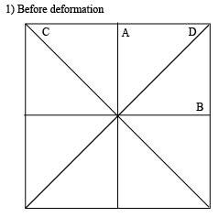
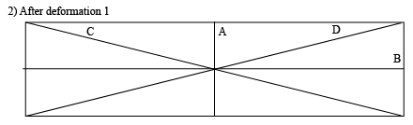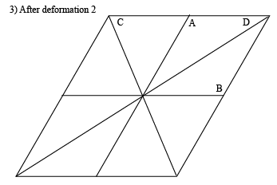
- Everyone’s favorite, surface stresses on a dipping surface!
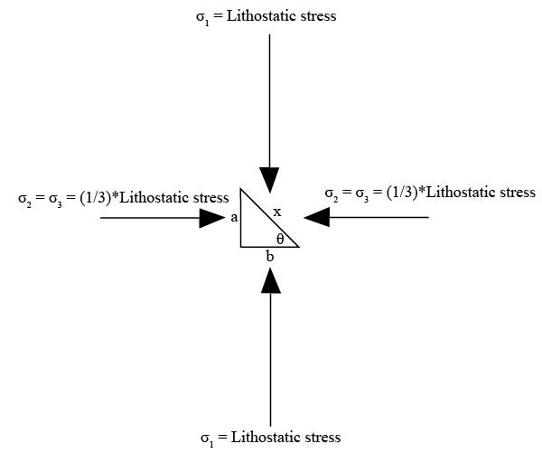

For the above image, answer the following questions.

What is Lithostatic stress (given a volume (x*y*h) and a density (kg/volume) of rock, and gravity)? [I’m just looking for the definition of lithostatic stress here]

What is the length of a in terms of x and θ?

What is the length of b in terms of x and θ?

Normal tractions (T) are equal to normal stresses. What are the tractions on surfaces a and b?
T_{a} =

T_{b} =
We don’t know the traction down on the dipping surface yet because it is not a normal traction (σ₁ and σ₃ are not perpendicular to surface x). To calculate this traction we must do a force balance. Let’s simplify to 2 dimensions, so area (A) will be equal to length.

If traction (T) = Force (F)/Area (A), what does F = ?

What is the force on surface a?
F_{a} =

What is the force on surface b?
F_{b} =

Write the following force balance equations in terms of tractions and areas.
F_{a} = F_{L}

F_{b} = F_{d}

What are the tractions (T_{L} and T_{d}) on the dipping surface x?
T_{d} =

T_{L} =

What is the overall traction on the dipping surface x (magnitude of the vector sum of T_{L} and T_{d}; see image below)? [Suggestion: use the distributive property to factor ρgh out of the square root]
T_{d_overall} =

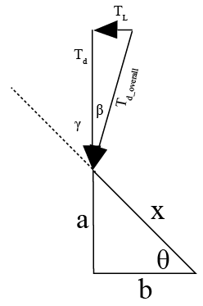
What is the angle between T_{d_overall} and σ₁ (vertical)? (You’ll need to use an inverse tangent) We’ll call this angle β.
β =

What is the angle between T_{d_overall} and the dipping surface (γ+β), in terms of θ and β?

Construct a right triangle for which T_{d_overall} is the hypotenuse, which makes the angle (γ+β) with the dipping surface. The side opposite the angle γ+β is the normal traction (T_{N}) on the dipping surface, and the side adjacent to the angle γ+β is the shear traction (T_{s} or τ). What are the magnitudes of these tractions?
T_{N} =

T_{s} =

You have now gone through all of the steps involved in calculating surface stresses on an inclined surface. To help remember the important parts, rewrite your equations here:

σ₁ =

σ₃ =

T_{d} =

T_{L} =

T_{d_overall} =

β =

T_{N} =

T_{s} =

Now, using those equations, calculate T_{N} and T_{s} for the following set of inclined surfaces (on next page). Each answer should have a constant of ρgh attached.

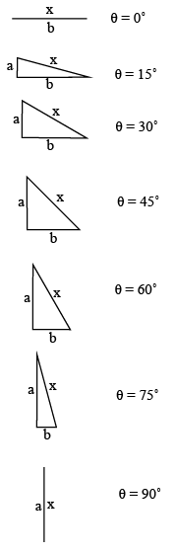

At what angle to σ₁ is shear stress (σ_{s} = T_{s}) the greatest?

Why is there no shear stress when θ = 0˚ or 90˚? (Hint: what are the lengths of sides a and b for these angles?)

- Complete the following table, and draw the Mohr circles and corresponding failure envelope for the following experimental data. The graph paper image on the next page should be enough to draw at least the upper half of all the circles at a reasonable scale (each small square is 5 MPa).

Compressional strength test (these are the values at failure)
σ₁ (MPa) | σ₃ (MPa) | σ_{mean} (MPa) | σ_{differential} (MPa) | σ_{deviatoric} (MPa)
80 | 0
 | 24 |  | 152
256 |  | 150
 |  | 200 |  | 136
 | 84 |  |  | 166

What are the fracture angles with respect to σ₁ for each step?

Is the failure envelope linear? If so, what is the equation approximating that line?



