Case Example: Crandall Canyon Mine Disaster, Utah

On Monday, August 6, 2007, a serious coal mine collapse occurred at the Crandall Canyon Mine in the Wasatch Mountains of eastern Utah. The collapse occurred at a mining level 500 m below the surface. The initial collapse killed six miners, and a secondary event 10 days later killed three of those who were attempting to rescue the six who were trapped by the initial collapse. Seismometers in the region recorded a M 3.9 earthquake that occurred at the time of the collapse.

The mine owners argued that a natural earthquake had triggered the collapse. Geologists were skeptical and quickly analyzed the earthquake first motions to determine whether, in fact, the vibrations had been caused by the collapse, and not vice versa. This is an important questions to answer, because it determines who, if anyone, is at fault.

In order to start this out, you need to know a little about what’s called room and pillar mining. Coal occurs in sedimentary layers, and, if the coal-containing layers are horizontal or shallowly dipping, the miners can’t just remove the entire layer, or nothing will be left to support the overlying layers of rock, and the mine will pancake. So, coal is mined by the “room and pillar” method (see map of the mine below), where huge pillars (the squares and parallelograms below) are left behind, and coal is only taken from the areas between the pillars. Some mining companies engage in “retreat mining”, where they go back into a room with pillars and remove part of each pillar to get more coal out of the ground. In retreat mining, controlled collapse is allowed (shown as “mined out” areas on the mine map below).
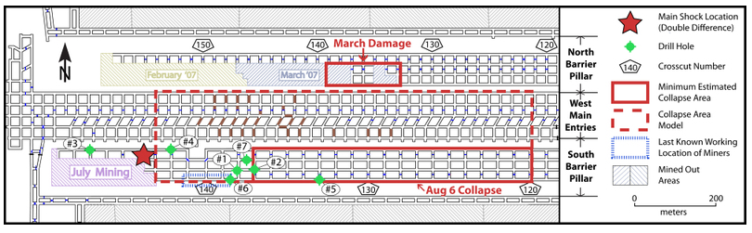
Univ. of Utah Seismograph stations (http://unews.utah.edu/wp-content/uploads/crandall_map_aug_07.jpg)

If a pillar in a mine fails, it fails as a result of vertical loading due to the weight of the overlying rocks (see cross section diagram below right). Would you expect that the pillars would fail by development of shear fractures or by development of extension fractures? Why? [Remember that there is a miner in the “room” breathing air that is connected all the way up the mine ventilation shafts to the Earth’s surface!] Sketch a potential failure surface in its correct orientation on one of the pillars below, and describe whether it would be an extension fracture or a shear fracture and why you oriented it the way that you did.
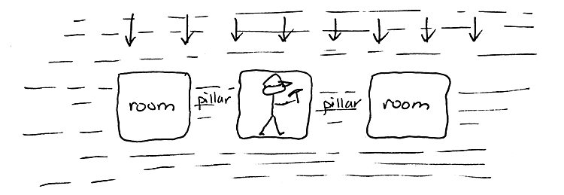

Given what you know about the strength of rocks and the definition of stress (and how stress differs from force), explain why reducing the cross sectional area of a pillar makes the pillar more likely to fail. Be specific, and use proper terminology. [Hint: remember that reducing the cross sectional area of the pillar does not change the strength of the rock in the pillar.]

If you were a mining engineer, would all levels (i.e., depths) of your mine have the same pillar-to-room ratio? If so, why? If not, why not?

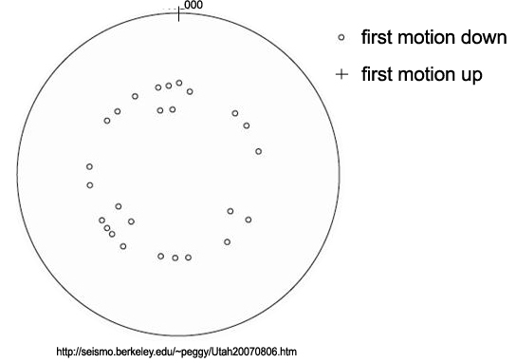
Seismometers throughout the American West recorded first motions from the vibrations associated with the collapse. The plot at right shows the nature and distribution of the first motions. Use the first motions to argue for whether the vibrations at the time of the disaster were caused by slip on a fault (which then triggered the collapse) or by collapse of the mine (which then triggered the ground vibrations).

BONUS The Worldwide Standardized Seismic Network was established in the early 1960s in part to monitor underground nuclear testing by the USSR. In an underground nuclear test, a bomb is buried in a cavity, and the explosion is triggered remotely (presumably limiting the amount of radiation that escapes to the atmosphere). Seismologists realized that they could use first motions to distinguish an underground nuclear explosion from a natural earthquake generated by slip along a fault. What would a focal mechanism from an underground nuclear explosion look like, and why?

