Activity Two

– GIS development using ArcGIS (Exploring some basic concepts and skills)
(after ESRI: Intro. to GIS I)

*If at any point you get stuck please read the instructions and/or review the lecture slides and your notes then another then give it a second try, if you get stuck again please ask for help. ArcGIS is a massive software package half of the fun and frustration is playing with it and learning how to make it work for you! This course was designed to give you the tools/skills needed to start playing, learning, and building GIS it into your curriculum.

Please write your answers on the answer sheet at the end of this activity…

Step 1: Insert your IGEIN USB Jump Drive
*All of your work will be saved on your USB drive, please take of it…

Step 2: Start ArcMap
A) Start > Programs > ArcGIS > ArcMap
B) You should know see a dialog box asking you to open a new map or select an existing map
C) Please choose the existing map from your USB Drive: Data_IGEIN_Workshop > My IGEIN Projects > Activity2_selecting&more

Skill 1 – Identify
A. Use the identify tool to answer the following questions…
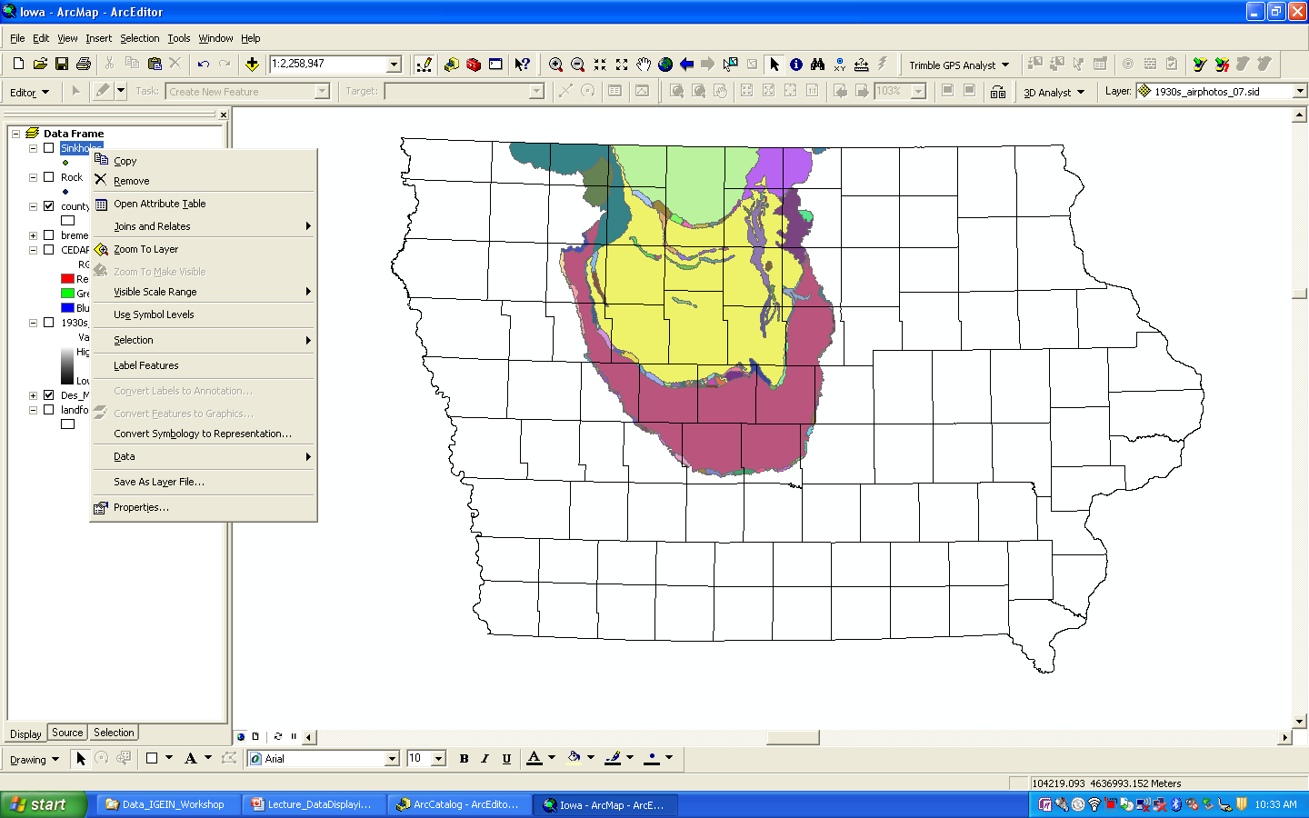

Question: Which county was more populated in 1850 Dubuque or Polk County?

Skill 2 – Find
A. Use the find tool to find a specific feature or attribute…

Use the finder tool to locate and ‘flash’ Adams county…
Question: What are the geographic coordinates for the four corners of the county (in degree minutes and seconds)

Skills 3 and 4 –
Please use the measurement tool to make 3 (east – west) measurements of the widest portions of the Des Monies lobe…

You should notice that it is currently not possible to see the extent of the Des Moines lobe, I’ll try to walk you through two ‘easy’ ways to do this
A. Can you think of anything to do within the order of the table of contents (TOC) that could help you out?
B. Transparency variance: Use the power of right click the layer census_2k_cnty_hist_pop_1860-2k… properties > display tab > transparency field set to 50 or 60% and click OK
Question: Based on three measurements calculate the widest average extent of the Des Moines Lobe in miles

Skill 5 – Map tips and hyperlinks…
This skill is often already embedded within the data layers that you are using (especially if it is downloaded from the IA DNR) you just have to turn it on. This step will add pop up window of common attributes (e.g. when you move the mouse over an Iowa county it’s name will appear) or you could add a hyperlink to each county/feature that would lead the user to it’s webpage.
To turn this feature on or off just… Use the power of right click the layer census_2k_cnty_hist_pop_1860-2k… properties > display tab > and select the boxes for map times and/or hyperlinks.

Skill 6 – Using the Selection Tools
See handouts for additional information and try some of these methods out…
p. 4-8 to 4-17. Don’t spend a lot of time on this maybe 10 to 15 minutes

Step 3 – Please Do Not save your work and exit out of the ArcMap window…

Answer sheet
1) Skill 1A = __________________________ county.

2) Skill 2A = NE =_____________________, SE = __________________________
SW = _____________________, NW = _________________________

3) Skill ¾ B = _______________________ miles

