Georeferencing SOLUTIONS

Authors: Davis, A.¹, W. L. Mills²
¹ Furman University, Greenville SC, davis.amelie AT gmail.com
² Purdue University, West Lafayette IN, wmills AT purdue.edu

Goal:

As a result of this lab you should be able to understand the process of georeferencing and be able to carry it out.

Learning objectives/outcomes:
- Understand what the rectifying process does
- Know how to georeference any scanned map or aerial photo
- Perform a basic historical Land Use change analysis

Statement of problem

Premise for exercise
You learned in earlier labs the importance of projections. Sometimes however data will come in a format with unknown projection and no way of knowing what it is. This data is most often aerial photos or paper based maps. In order to use the information in these maps you will need to match it up spatially with your GIS data which already has spatial information associated with it. This process is known as georeferencing. You will practice georeferencing on scanned aerial photos of the Muskegon watershed in Michigan.

We recommend you read quickly through the entire lab exercise before beginning.

Data
You need to download data from http://eweb.furman.edu/~adavis2218/Mecosta_MI_data.zip to download the data. Save it to the C:\temp\ folder and unzip it. Open the georectify.mxd document and look at the properties of the following files to fill in the blanks below.
File name:  - Description:  - Data model:  - Data type:  - Units:  - Coordinate system:  - Any previous coordinate system: | allroads_miv2a  - roads data for Michigan  - vector  - line shapefile  - meter  - NAD_1983 Hotline Oblique Mercator Azimuth  - GCS_North_American_1983
File name(s):  - Description:  - Data model:  - Data type:  - Units:  - Coordinate system:  - Any previous coordinate system: | 271_1938.tif, 271_1972.tif,  - Scanned aerial photography of Mecosta County, MI in 38, and 72.  - Raster  - Aerial Photo  - Not applicable  - Not applicable  - Not applicable

Processes
- Add control points (Georeferencing toolbar)
- Rectify (Georeferencing toolbar)

Lab exercise

Part A
Georeferencing allows you to use photos and maps that would not have been available to you in ArcGIS. Let’s say that you were hired to create a timeline of how the landscape has changed in and around the town you live in. You enlist the help of a historian who finds old paper maps of the area as historical aerial photos printed on photo paper. These maps and photos are invaluable because they give you information on where the roads were, if they were paved or not, how much forest there was, where houses were concentrated, etc. You then need to scan the maps and photos (as .jpg for example) and import them into ArcMap. However ArcMap does not know where to locate them in space relative to the data you already have in GIS-ready format such as roads and current orthophotos. You will need to reference this data that is ‘floating’ in space to the data you know is correctly located in space.
In this section you will learn how to georeference an aerial photo. This process also applies to scanned maps.

- Open the Georectify_Thu.mxd ArcMap document. Select View > bookmarks > Region_zoom. Examine the features.

- Right click on the 1938 aerial photo called ‘271_1938.tif’, and select ‘zoom to layer’.
As you can see it is not lining up with the Michigan roads data even though it is of the same geographical area. Georeferencing will ensure that they overlap

- Turn on and off the various .tif images for the 2 different time periods: 1938 and 1972.
Do they all depict the same geographical area? Explain your answer in 2-3 sentences.
Yes, can recognize the town and the bend in the river south of town.

Do they all have the same extent? Explain your answer in 2-3 sentences.
No, the area depicted in the 1972 aerial photo is much larger than the one depicted in the 1938 photo. The town that takes up most of the 1938 photo is located in the top left corner of the 1972 photo.

- Go to the View menu > Toolbars > Georeferencing.

- In the Georeferencing toolbar make sure your target is Layer: ‘271_1938.tif’. This means you are going to rectify that image so that it matches your spatially referenced layer which in this case is your roads layer: allroads_miv2a.shp.

- You must now identify locations on the image and “connect” them with the same location on allroads_miv2a.shp. One of these connections, or pair of control points, has been identified for you and is shown in Figure 1 with the red circles. You will identify more control points.
Compare the aerial photo and the roads shapefile (the streams and ponds are provided to help you visually) and find 4 other ‘good’ control points. A good control point is generally a road intersection which you can easily find in both the spatially defined layers and the layer that is being georeferenced. The control points should be scattered through the image you are trying to georeference (here the aerial photo), i.e they never should be clustered in one side of the photo or along a same line. Using rivers or lakes is generally avoided because a particular aerial photo may have been taken during flood or drought conditions, both of which could change the location and shape of the feature. Then use and the print out which was provided to you and draw circles around the 4 control points you picked in the top and bottom images in the images. Each match should be labeled with the same number (2 through 5).
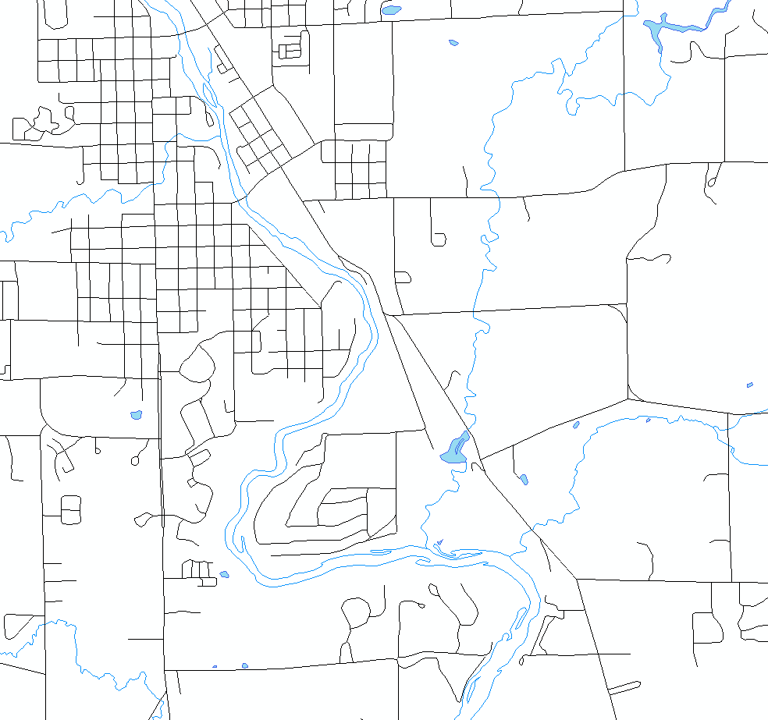
1`
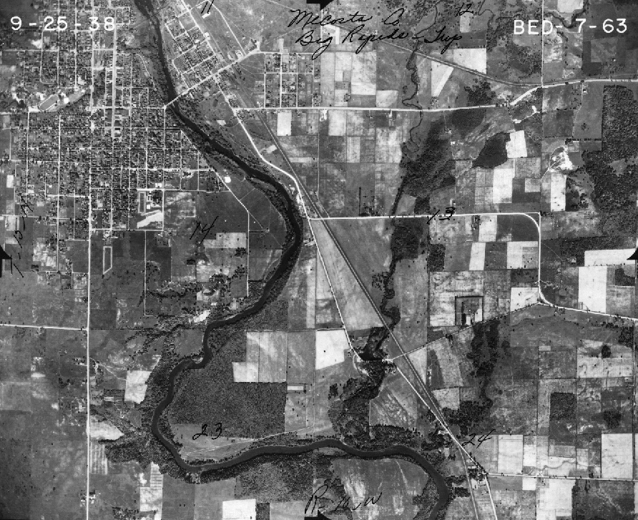
1
Fig 1. 1938 Aerial photo of Mecosta County, MI (below) and corresponding roads (top)

- Go back to the ArcMap document. You are now going to add your first pair of control points. The first point should be the intersection of two roads outlined by the red circles in Figure 1.
Go to view > bookmarks > region_zoom and from the dropdown menu of the Georeferencing Toolbar, select Fit to Display. This will move the 271_1938 image to roughly coincide with the roads layer.
- Select the Add Control Points tool from the Georeferencing toolbar (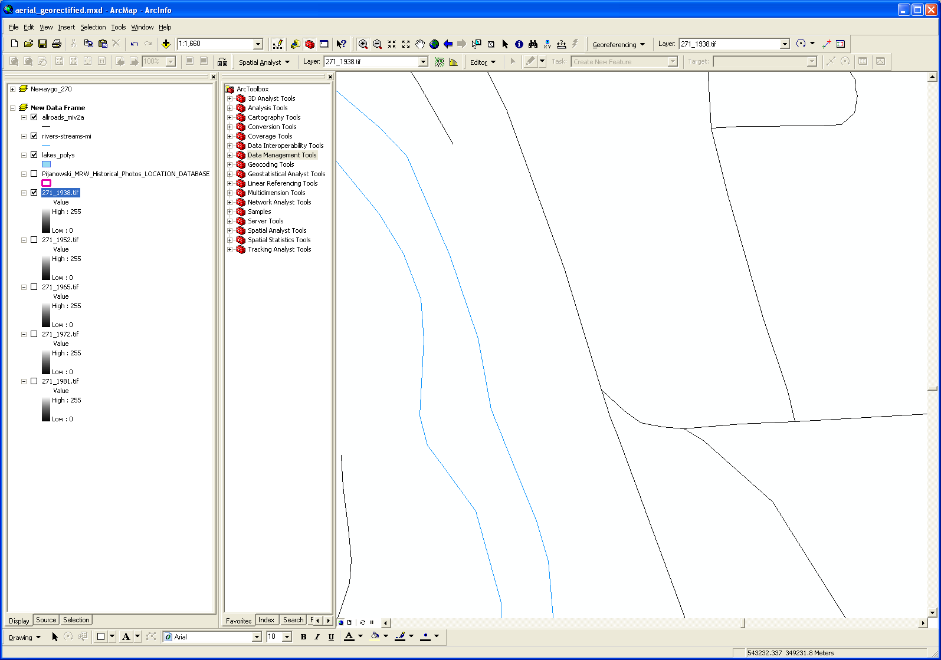 ). With the ‘cross’ cursor, click FIRST on the intersection on the image, i.e. the aerial photo then on the road location.

- Select the Zoom tool and zoom and use the Pan tool to locate the other pre-selected points. Select the Control Points tool to add the next set of control points.

- Add the other 3 control points you identified earlier. You will probably need to zoom in and out on the image and move to various parts of the image as you select the points. If you make an error, open the View Link Table on the Georeferencing toolbar () to see a list of control points, click on the last point to select it and push to the Delete key. The point will be deleted and you can select another point. Remember that you always add control points by first clicking on the image that needs to be georeferenced (in this case the aerial photo) to the layer which is already correctly located in space (in this case the roads layer).

- Exam the View Link Table ()after the fifth point and check the RMS value. You should get a value less than 10 (I got a 4.9 RMS). You only need 4 points to calculate an RMS value so you can delete the point which gives you the largest residual. This should improve your RMS.

- If you find you have to redo a lot of your control points, once you’ve deleted the ones that gave you the largest residuals, go to the georeferencing toolbar and select ‘Reset Transformation’. This will move the image back to where it would be if those points had not been added, so that you can add new points more easily.

- When you are satisfied with your control points, write down your RMS for the 271_1938.tif rectification. What does your RMS value mean?

RMS will vary by students (most should get below 5 but if not definitely below 10)

Meaning (2-3 sentences): Interpreting the root mean square error
When the general formula is derived and applied to the control point, a measure of the error—the residual error—is returned. The error is the difference between where the from point ended up as opposed to the actual location that was specified—the to point position. The total error is computed by taking the root mean square (RMS) sum of all the residuals to compute the RMS error. This value describes how consistent the transformation is between the different control points (links). When the error is particularly large, you can remove and add control points to adjust the error.
Although the RMS error is a good assessment of the transformation's accuracy, don't confuse a low RMS error with an accurate registration. For example, the transformation may still contain significant errors due to a poorly entered control point. The more control points of equal quality used, the more accurately the polynomial can convert the input data to output coordinates. Typically, the adjust and spline transformations give an RMS of nearly zero or zero; however, this does not mean that the image will be perfectly georeferenced.
Source: ESRI ArcGIS Desktop Help, last visited May 21, 2010.

- Select Rectify from the Georeferencing Toolbar and save the rectified image to the C:/temp/ directory. Select ‘TIFF’ as the format. Name the file 271_1952_rect.tif. Keep the defaults for the other choices.

- Once the rectification process is ended add your newly created .tif file to your ArcMap document and uncheck 271_1952.tif in the TOC. Create a screengrab showing the rectified image with the road network overlaying it. You can choose to keep the rivers and lakes layers if you wish. Did you have any distortions in your final map? How could you make sure you had less distortion if you were to redo this process?
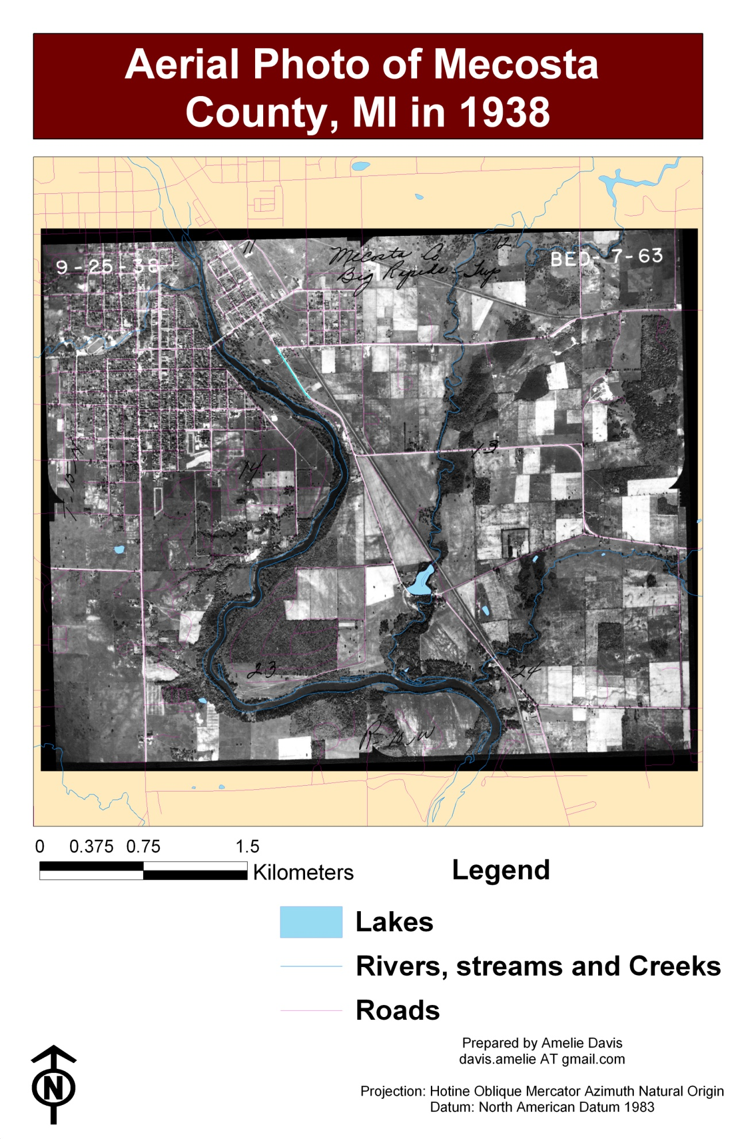
Distortions and Improvements? Distortions will most likely stem from one or a couple of control points that are poorly located. Typically it is best to disperse the points throughout the image but not add them at the extreme edges. I would improve by deleting some control points and adding more since it gets easier to find good control points once I become more familiar with the region.

If you load these points as a text file in the georeferencing toolbar > view link table > load; you will get the same maps I did:
7.487590 6.045886 544656.178007 350033.693602
6.696091 0.735176 544320.214525 347236.520814
1.273895 3.935710 541460.214133 348845.539251
4.131280 6.224551 542903.241889 350094.144949

- Rectify the 271_1972.tif file. Remember to change the target Layer in the georeferencing toolbar to the aerial photo you intend to rectify.

Date | RMS = | Map (Screengrab is OK)
1972 | Should be < 5 | 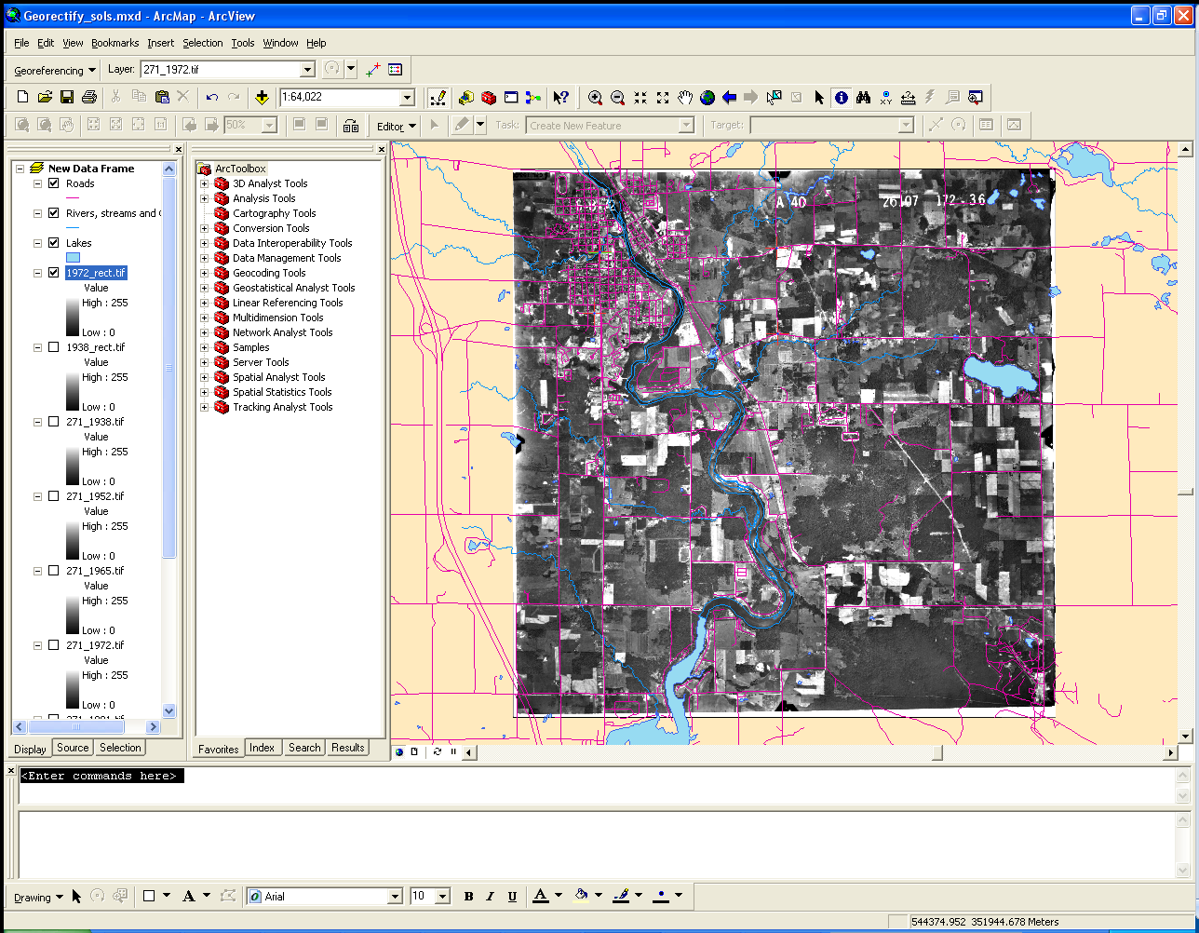  Load these points and georectify to get the same map I did.  1.462846 7.749144 541448.814952 349959.664846  4.436634 7.830644 544656.361816 350034.768047  1.366134 6.736657 541341.897223 348844.398169  4.450023 6.390062 544674.226332 348470.768227

Note:
_ Sometimes scanned images will not be scanned in the orientation which matches your reference data i.e. the data which is correctly located spatially (here the roads data), you would then have to use the tools of the Georeferencing toolbar under the ‘Flip or Rotate’ menu.
_ Additionally you can save your control points when you are in the ‘View Link Table’ menu and load them later to either add more or have a record of what you used.
_ In the data folder you downloaded there are aerial photos for 1952, 1965 and 1981as well. Those can be georectified for added practice or if interested in having more information for the land use change analysis that follows.

Part B
Georeferencing is necessary so that you have access to spatial information you otherwise could not use. In the example above you now have a time series of what the landscape looked like, i.e. the photos that you georeferenced can be used along with current orthophotos and other data so study the changes that have occurred in the landscape over the year. Georeferencing allows you to be able to compare an exact location (with an error margin) on multiple photos and maps. This is not always done for different years but can be done just comparing maps to see the differences between them: what got left out, what was better represented in one versus the other, which representations or roads follow the aerial photo better, etc…
In this section you will use the aerial photos you just rectified to perform a quick spatial analysis of land use change in a portion of Mecosta County.

- Activate the data frame called ‘Grid’. You may have to ‘repair the broken links’ by linking back to the folder you just unzipped.
Add the 2 aerial photos you just rectified to this dataframe.
- You will now estimate the percentage of the image which is in the different classes for the region of the aerial photo which is delimited by the polygon shapefile named 271. The land use classes we are interested in are:
_ water
_ forest
_ agriculture
_ shrub
_ wetland
_ barren land
_ urban (roads are not considered urban, they should be classified as other)
_ other.
Some portions of the images will be missing or will have pen marks on them, ignore those.
Open the box271.xlsx document. Click on the worksheet labeled ‘wholeimage’ and fill in the tables. You must also assess how certain you are of the percentage you assigned to each class by attributing it a 1 through 4, one being the least certain and four the most certain. This should be individual work. We ask that you not confer with other lab mates. If you are having trouble with this please ask the instructor.

Do this for the 1938 and 1972 aerial photos that are located under the Grid data frame.

- Turn off 271.shp and turn on grid2_2 in the ArcMap document. Next click on the worksheet labeled ‘4_boxes’. For each of the 4 grid boxes estimate the percentage of the 4 different land use classes for the different aerial photos and fill the table in the excel document. Check that the sum of your rows is equal to 100%.

Based on your estimations, which quadrant experienced the most land use change between 1938 and 1972 (considering all land use classes as a whole, i.e. which quadrant had most of its land modified between 1938 and 1972)?
Quadrant 2

Considering all four quadrants, which land use class gained the most and which lost the most area (use the totals)?
Urban seems to have gained to most area at the expense of agriculture

Part C
One way to use the information in raster images is classification. You will be introduced to a simpler version of classification in this exercise. Classification of rasters allow you to do spatial analyses of land use change for example. Using this technique you could summarily document which areas went from forest to agriculture to urban and at what time periods those changes occurred.
In this section you will use a different method to rapidly classify the aerial photos you just rectified.

- In the ArcMap document, turn off the grid2_2 layer and turn on the pts_217 layer. In the excel document, click on the worksheet named ‘rdm_pts’. Assign classes for each of the points which are labeled on your aerial photo for the different years. You may wish to zoom in. Also indicate your level of certainty with the class assignment. Classes are Forest (F), Urban (U), Water (W), Agriculture (A), Wetland (E), Barren (B), Shrub (S), and Other (O). The level of certainty still ranges from 1 (extremely uncertain) to 4 (extremely certain).
- Identify 2 points (by their ID number) which went from Agriculture to Urban sometime over the 20 year time period the images were taken.
Pts 1, 7 and 9 for example

- Are there any land use change successions that you find surprising (Urban to Forest for example?) If yes identify them below and discuss whether you think it is an error in classification or in registration (the georeferencing) or if you think it is correct.
Seems like some areas are experiencing reforestation (ag to forest) especially between points 34 and 35 as well as 47 and 55.

PLEASE EMAIL YOUR WORSHEETS TO davis.amelie AT gmail.com AT THIS TIME.

Assessment
Why do you first select a control point on the aerial photo and then select one on the roads layer and not vice versa?
The aerial photo is the one that need to be overlaid properly onto the roads layer which we know is located in space where it should be, so we select a point on the aerial photo and tell the computer where that point needs to be relative to the roads layer.

Define an aerial photo. Cite your sources.
Photo taken from the air, i.e. from above a feature. Used as a survey of what land use/ land cover can be. They are a remote sensing tool. (Campbell, 2002)

Using the internet i.e. most likely Google earth and/or Google maps find the name of the city which is depicted in northwestern portion of the 1972 aerial photo for box 271.
City? Big Rapids, MI
How did you find the information? Based on the information in this lab we know that the area depicted is Mecosta County, MI. Some students type that in to Google Earth and look for that characteristic bend in the river on the south of town.
Some students use the identify or select tools and find the name of the creeks or lakes that are within the extent (Ryan Creek and Higginson Creek or Rogers Dam Pond), then search for that in Google Earth (along with Mecosta Co, MI).
Same for any road intersection in the extent.
Lastly some students notice the name of the city written on the top right of the 1938 photo.

Why is the process of georeferencing necessary and what exactly does it do? Explain in 1 - 2 paragraphs.
Raster data is commonly obtained by scanning maps or collecting aerial photographs and satellite images. Scanned map datasets don't normally contain spatial reference information (either embedded in the file or as a separate file). With aerial photography and satellite imagery, sometimes the location information delivered with them is inadequate and the data does not align properly with other data you have. Thus, to use some raster datasets in conjunction with your other spatial data, you may need to align, or georeference, to a map coordinate system. A map coordinate system is defined using a map projection (a method by which the curved surface of the earth is portrayed on a flat surface).
When you georeference your raster dataset, you define its location using map coordinates and assign the coordinate system of the data frame. Georeferencing raster data allows it to be viewed, queried, and analyzed with other geographic data.
The general steps for georeferencing a raster dataset are
- Add the raster dataset that you want to align with your projected data in ArcMap.
- Add control points that link known raster dataset positions to known positions in map coordinates.
- Save the georeferencing information when you're satisfied with the alignment (also referred to as registration).
- Optionally, permanently transform the raster dataset.
Source: ESRI ArcGIS Desktop Help, last visited May 21, 2010.

