Handout 1 - Background

Modeling Philosophy - Our goal in this exercise is to initially discuss two potential causes of coral-reef decline since the mid-1970s and to then run a model to examine how these might work in the natural world. We could take the concepts covered in lecture and construct a Conceptual Model that graphically shows these relationships (e.g., Figures 1 and 2). There is no math involved and the ideas are considered only in broad strokes. Similar functions can be shown by a series of “plumbing diagrams” that show the connections between agents and the magnitude of those interactions. In some instances, this is as far as the modeling process goes. Or.... models can be even more loosely organized than the two figures provided here. Every time you take observations, thoughts, etc. and organize them into some sort of framework (Based on last time, how much time do I need to set aside for the next exam?), you are actually modeling.

In our case, we will use a quantitative model that addresses the relative magnitudes of each process. As in the real world, each step is based on some sort of probabilities in which "certain things are more likely to occur" rather than "each thing will occur in some quantitatively predictable manner". As a result, the model that we will be using is not based on a rigid set of equations that control its outcome. The results will not be identical even if you start with the same conditions. This is what nature does in the real world; whether it's randomness, something we have failed to think about, or pure spite - nature is not tidy, and a good model will reflect this and hopefully embrace it.

You will be asked to run the model under a variety of conditions and examine the suite of outcomes that occur. You will run it first under conditions that simulate pre-Homo stupidus, and then will begin to add unnatural pressures. As you work your way through the exercise, you should notice that:

- the model may not create identical outcomes every time you run it with the same set of inputs; that's nature
- the model often responds in a non-linear fashion (i.e., we often see something akin to an “on-off switch” rather than a gradual build-up to a particular response) - again, that's nature
- once we see an adverse shift in community structure, we can rarely return the system to “normal” by simply backing off on the stress to the levels that triggered the decline - that's economics and polity

In class, we will walk through the model to the point where you should be able to change the parameters on your own and observe the patterns that result. The following reviews what we will go over, and will hopefully serve as a reference as you start to use NetLogo to model overfishing and/or nutrient overloading as triggers for reef decline.

You should come to class with NotLogo downloaded and installed on your laptop if you have one. The download site is: http://ccl.northwestern.edu/netlogo/download.shtml

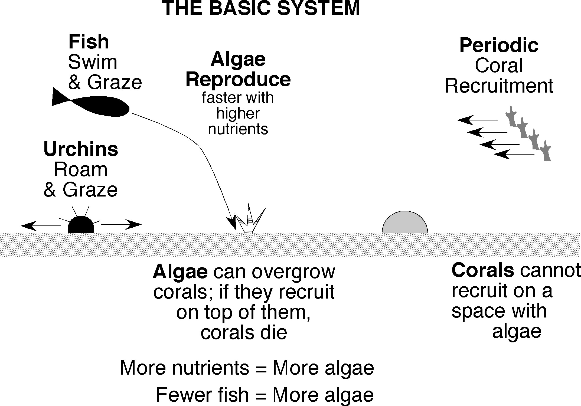

Figure 1. Conceptual model of the interaction of corals, algae and grazers on a “healthy” reef. The role of anthropogenically induced stresses in the model is taken by overfishing and excess nutrients.

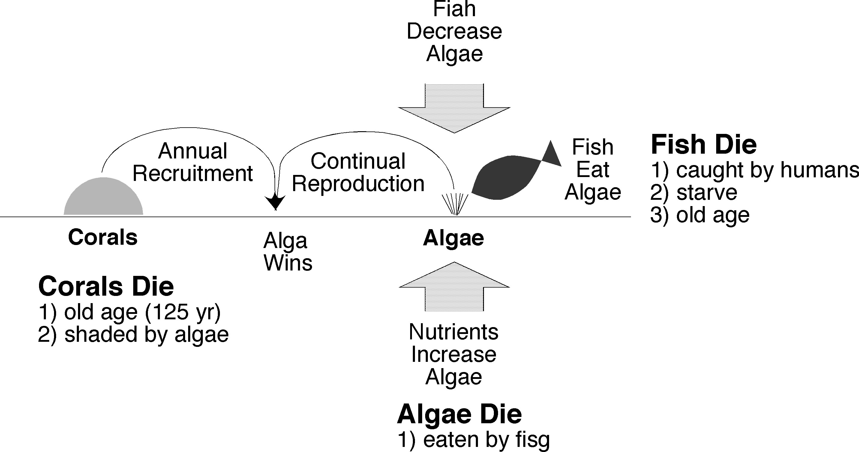

Figure 2. Alternate conceptual model that shows the interactions among the agents and the conditions under which they thrive or die.

